
K&M Tire

Administrative Assistant
4/17/2025

Table of Contents
1. K&M Tire 5
2. Ace Hardware Billing - Johnstown’s Ace Hardware 7
2.1 Ace Hardware Incoming Loads 7
2.2 Ace will inform K&M of all Outgoing Loads 8
2.3 Billing Process for Ace Hardware 8
3. Amazon Sign – On and Ordering Instructions 11
3.1 Shopping on Amazon Business Prime 11
3.2 Adding or Removing a Person from Amazon 15
3.3 Adding employees to other locations groups on Amazon 18
3.4 Changing addresses on Amazon 20
3.5 Adding items to Amazon list 23
4. Balancing Accounts Receivable Balance Register 24
4.1 Accounts Receivable Balance Register 24
4.2 Daily Email 24
5. Balancing the Daily Sales Update Report 26
5.1 Daily Sales Update Report 26
5.2 Daily Email 26
6. Madden CO 28
6.1 Ordering Tire Chalk for locations 28
6.2 Viewing locations tire chalk inventory 31
7. Banking for Affiliate Companies 34
7.1 Receiving and Depositing Funds 34
8. City of Delphos Council Meeting Minutes 35
9. Daily Update Meetings with the President0.1 36
9.1 Purpose and Structure 36
10. Diaper Bundle 37
11. Delivery Schedule 39
11.1 Scheduling A Delivery 39
11.2 Scheduling a Drop Trailer 44
12. Direct Ship – Tires 51
12.1 Direct Ship Billing for Tires 51
12.2 Extra Tips 54
12.3 Credit Authorizations 54
12.4 Adding freight charges 54
13. Events 55
13.1 Gathering the Corporate Christmas Party Attendee List 55
14. Food For Poor 56
14.1 Sponsored Children 56
14.2 New Sponsored Child 56
14.3 Letters received 57
14.4 Writing a letter 58
15. Front Desk – Best Practices 60
15.1 Greeting Visitors 60
16. GoTo Meeting 62
16.1 GoTo Meeting – Join 62
16.2 GoTo Meeting – Schedule 63
17. Invoicing for Items Being Put on Transfer Truck 68
17.1 Creating an Invoice for Transfer Items 68
18. Daily Mail Routine 70
18.1 Mail Times 70
18.2 Morning Mail Procedure 70
18.3 Mail Disbursement 72
19. Mail Machine Routine 79
19.1 Procedures 79
19.2 Refill Red Ink on Postal Machine 85
19.3 Trouble Shooting 87
19.4 Certified Mail 87
19.5 How to fill out certified mail forms 89
20. Monthly Newsletter 93
20.1 Newsletter Purpose and Structure 93
20.2 First Day of Each Month (Sending) 93
20.3 First Day of Each Month ( Composing) 93
20.4 Outstanding Employee Nominations 94
20.5 Completing The Newsletter 94
21. Morning Error Log Report 97
21.1 Analyzing the Error Log 97
21.2 Error Log Email 103
22. Office Supply Order – Passwords – Websites 105
22.1 Quill Rewards 111
22.2 Ordering printer supplies 113
22.3 Yearly Quill Calendars 115
22.4 Getting Calendar quotes from Quill 118
22.5 Ordering Logoed Paper Items Through Litho Printers 119
23. Scheduling a Car Rental for Ken 122
23.1 Information Needed to Schedule 122
24. Scheduling a Conference Room 123
24.1 Scheduling and Inviting 123
24.2 Scheduling a Conference Room for Others 123
25. Scheduling a Flight on K&M Plane 124
25.1 How To Schedule 124
26. Sending out FedEx Express 126
27. Trade Show & Dealer Trip GL Balancing 129
27.1 Trade Show & Dealer Trip 129
28. Uniform Tracking & Disbursement 130
29. Verizon Monthly Tracking 137
29.1 Sorting Through the Usage with Cost Report 137
30. Wedding SOP 145
Appendix A: Revision History Tracking 146

K&M Tire
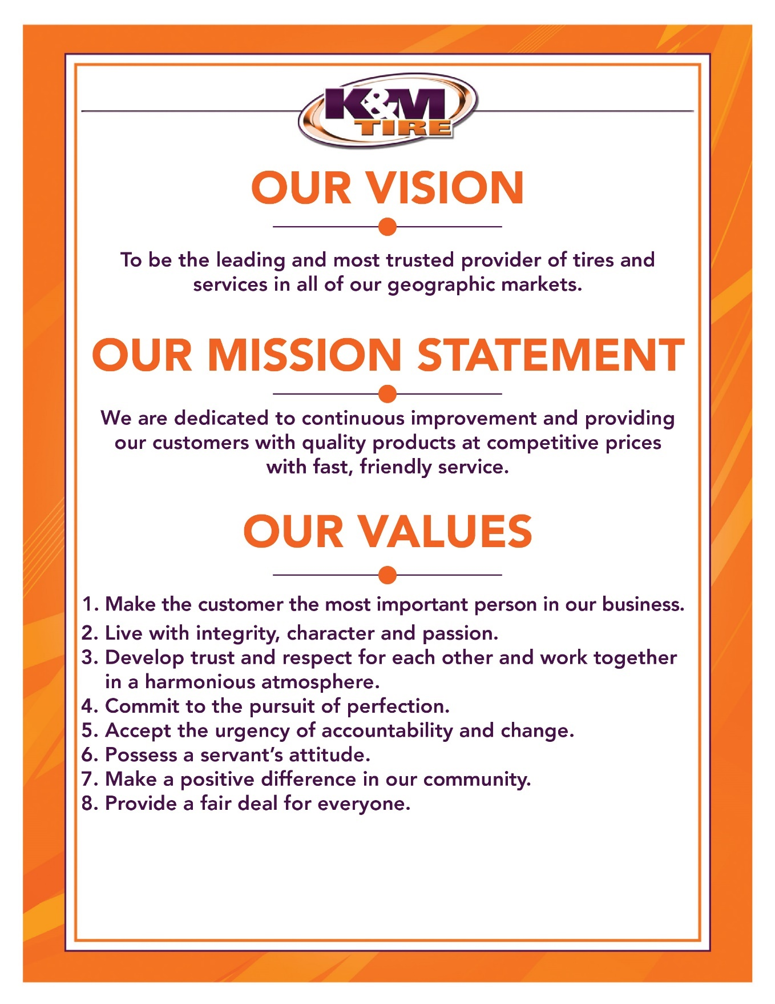

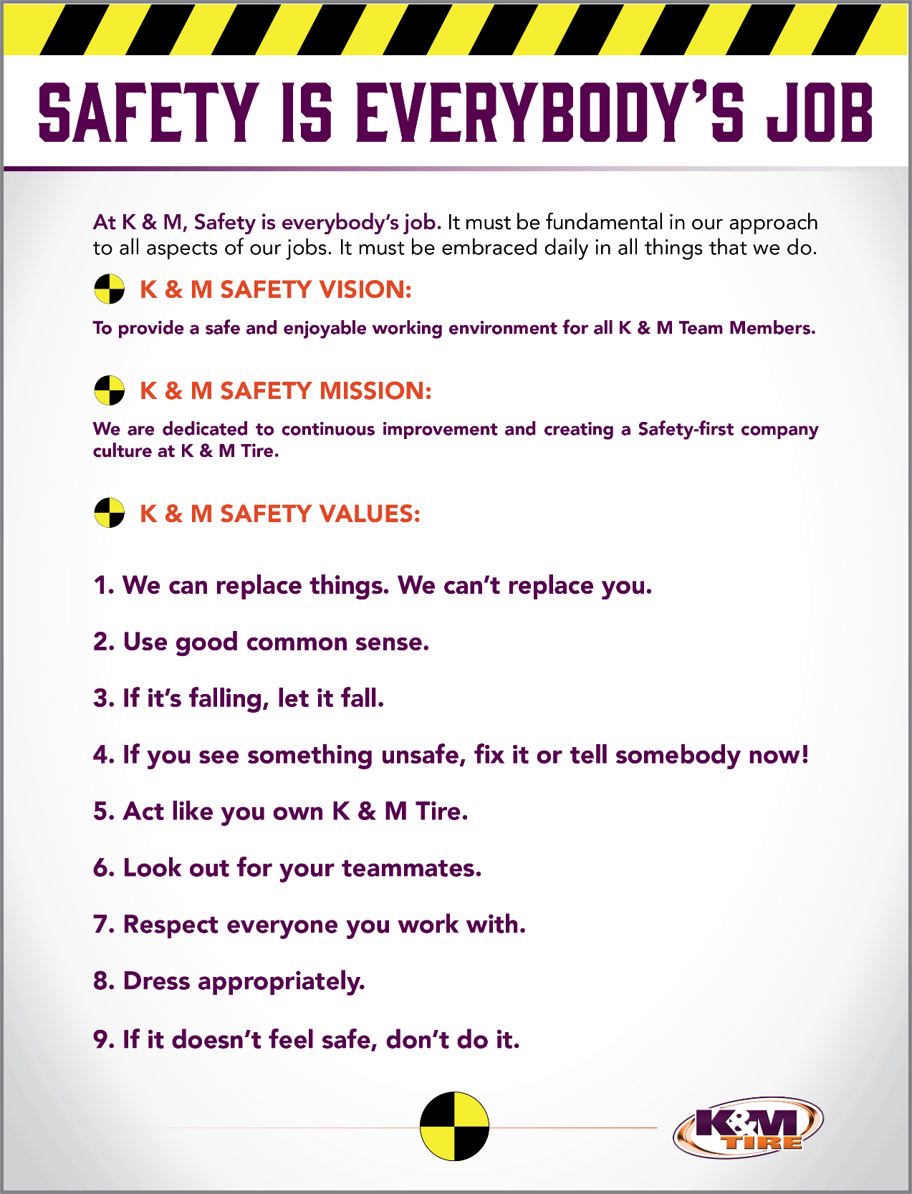

K&M Tire US Footprint
Click on the below link to see the footprint map
http://kmtire.com/km-cgi/distmap

Ace Hardware Billing - Johnstown’s Ace Hardware
This document is designed to provide a step-by-step process for Loading and Unloading Ace Hardware’s product at the Johnstown, NY Warehouse. This will also cover the billing process and how the product will be staged. Contained in this document are requirements, examples and critical contacts. All Safety procedures for driving a forklift and for entering a trailer with a forklift MUST be followed.

Ace Hardware Incoming Loads

- Ace will inform K&M of Incoming Loads
- Ace Hardware will send a notification of all loads coming in and all loads going out 24 hours in advance of needing completed. An email should be sent to the Johnstown Warehouse Manager, Johnstown Assistant Manager, and the Senior Regional Facilities Manager.
- A load sheet will be included with incoming loads to be used as a verification for product SKU and quantity.
- Quantity will equate to the number of skids coming off the trailer.
- Ace Hardware will have a trailer staged at a certain door to be named when the product is unloaded.
- K&M Warehouse employees will start unloading the trailer within a 24-hour time frame and place the product in the painted lanes on the floor that are identified by unique numbers. Each trailer will have a lane, and that lane should not be shared with another trailer’s product.
  - The current load will be brought in and staged in the chosen lane.
  - Lanes 100-120 and 200-240 (as shown on pg. 6 layout) will be used for storage.
  - The lane that is used for each trailer should be documented in ..\Johnstown warehouse_Ace Hardware Supplies.xlsx shared product inventory database as soon as the trailer is unloaded.
- The employee unloading the trailer will then mark the BOL as incoming, document the lane number, number of skids and the product SKU number. The Warehouse Manager will send a copy of the BOL with the information to the Senior Regional Facilities Manager and the Administrative Department. The Manager of Real Estate and Facilities will enter the information into the product inventory database.
- All products being moved will be palletized and no single product will be put on the trailer without a skid.
  - If the trailer count is over or under the given count, the Warehouse Manager should immediately contact Ace Hardware’s Thad Tallman-Warehouse Manager at Office phone number:(518) 580-9870.
- If any skids break apart due to shifting loads during transfer call Thad Tallman and Ace Hardware will send someone out to sort and straighten the skids prior to putting them away.
  - Upon completion of unloading the product, the Johnstown Warehouse Manager or Johnstown Assistant Manager should scan a copy of the load sheet to the Senior Regional Facilities Manager and the Administrative Department for records.
- The load sheets should be kept on file for tracking, comparison and payment.

Ace will inform K&M of all Outgoing Loads

- Ace Hardware will send a notification of all loads coming in and all loads going out 24 hours in advance of needing completed. An email should be sent to the Johnstown Warehouse Manager, Johnstown Assistant Manager, Senior Regional Facilities Manager and the Administrative Department.
- The information given by Ace Hardware should identify the Lane that the product is currently in, the quantity of skids, and the trailer the product needs loaded on to.
    - This information should be kept on file by Real Estate and Facilities and the Administrative Department for records.
- After the Warehouse Employee loads the product in the correct trailer, the trailer door should be properly secured.
- The shared product inventory database should then be updated by WH Manager or Assistant WH Manager with the lane the product was removed from, the trailer number, and the number of skids loaded on to the trailer.
- Once a lane has been emptied of a product, that lane can now be used to stage another incoming load.

Billing Process for Ace Hardware
The Facilities and Administrative Department will perform the billing process for Ace Hardware on a as needed basis for both Incoming Pallets and Outgoing Pallets at a charge of $5 per skid moved. Ace Hardware’s payment should be made at the beginning of the month for all billings done in the previous month.
- Receive Bill of Lading from warehouse manager
- Email to the Senior Regional Facilities Manager and CC the Administrative Department asking for approval to bill Ace Hardware
- Include the Ace Hardware Invoice # and Date in the Subject line (use this as a cross reference to confirm the correct BOL is being billed when approved)
- Follow up as needed every 2 days until approved.
- Log into MaddenCo
- 1-Tire Dealer System, ENTER
- 8-Point of Sale Menu, ENTER
- 4-Counter Billing, ENTER
- Store Number will be ‘22’ Field Exit, ENTER
- Enter customer # 9000006 for Ace Hardware Corporate
- F6-Starts a new invoice.
- F6 again Assigns an invoice number, ENTER.
- It will then ask for your Sell Salesman. This is your salesman number you were assigned by IT when you started at K&M. If you do not know what it is, IT can help you with that. Field Exit and ENTER.
- Product Code will be “3PL” Field Exit, ENTER
- The quantity will be how many skids/pallets you are loading or unloading, Field Exit
- The price will be 5.00, Field Exit
- Update the line next to the location number in MaddenCo
- Add Either ‘Inbound Shipment’ or ‘Outbound Shipment’ Field Exit, ENTER

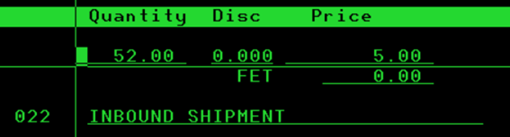

- F3 to review your invoice.
- Add message to invoice. On the line under “OPT” place an “M” for memo, ENTER.
- Add Date (listed on bill of lading), SKU #, and Aisle #, ENTER

- F6 to add additional line items for billing.
- Verify invoice accuracy.
- If all is correct, F3 again.
- It will ask if you want to close the invoice. It defaults to Y for Yes, ENTER.
- ENTER again will close and print the invoice.
- Invoice is automatically emailed to the customer.
- Reply to all to including the Senior Regional Facilities Manager to let them know billing is complete.
- Save both invoices as one document titled as the “Madden Co Invoice Number” under F: Langhals Companies/ Billed Invoices/ Ace Hardware – K&M
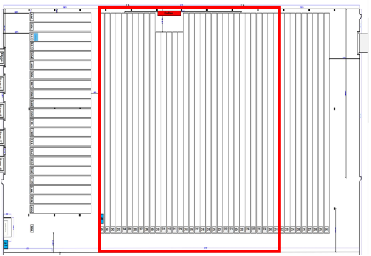

Amazon Sign – On and Ordering Instructions
As K&M works towards decreasing the use of our uniform company for misc. items (ex: rugs, toilet paper, paper towels, and mops) we need another option to receive the items we currently receive from them. In an effort to make purchasing office supplies, cleaning supplies and necessary items more convenient for each location to run smoothly and efficiently K&M has partnered with Amazon Business Prime. Amazon Business Prime offers lower rates to business, delivery in 2 days, the convenience of being able to purchase items any time day or night and having them delivered right to your door is a huge asset to you. You will no longer have to run out for supplies or cut your staff short to send somebody else on that errand. The below steps will guide you through setting up your account and placing as order, please follow the below steps.

Shopping on Amazon Business Prime
- Shopping on Amazon Business Prime (www.amazon.com)
- K&M users will include: Admin, Warehouse Managers, IT, ROM’s, Projects Manager, Fleet Manager, & Director of Training & Development
- You will receive an email inviting you to start ordering from Amazon Business (see below)

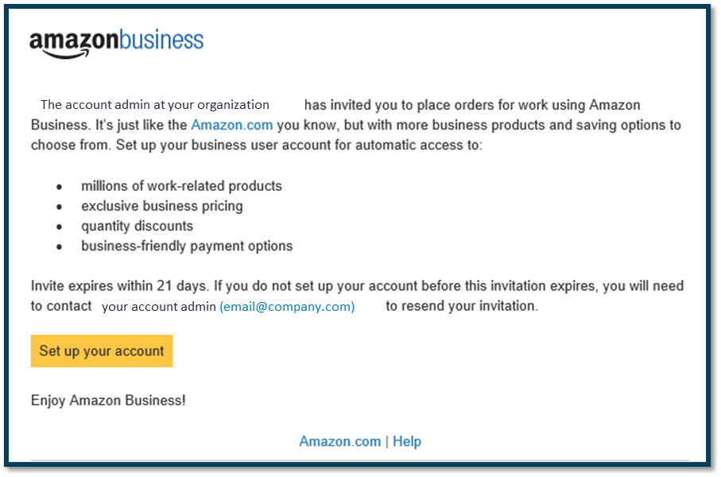
- Invitations are tied to the users email address. The recipient cannot change the email address they use to register for the account. Your K&M email will be your username going forward.
- The links on the invitation email to sign up are only valid for 21 days. Once they expire you will have to contact the Administration Dept to request a new invitation email be sent.
- Your ship to address and your preferred drop off spot at your location has already been noted for each K&M location.
- Account invitations are valid for 21 days from send date. After 21 days, they will expire and need to be resent
- The invite will have a link in it to click on and it will walk you through the setup of your Username and Password
  - Click on Set up your account. (See above)
- You could have any one of the 3 below Scenario’s. Choose the one that best fits you.
  - Most commonly it will be Scenario #1

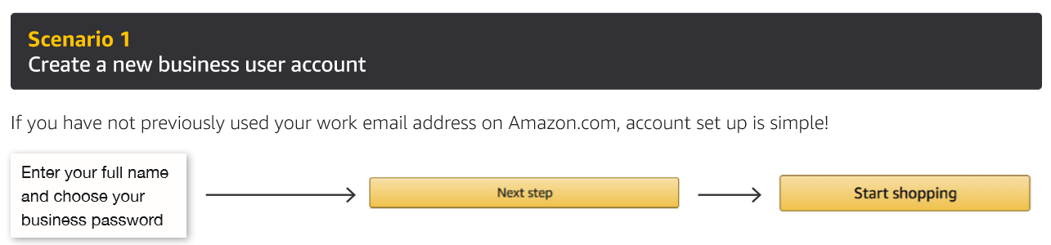

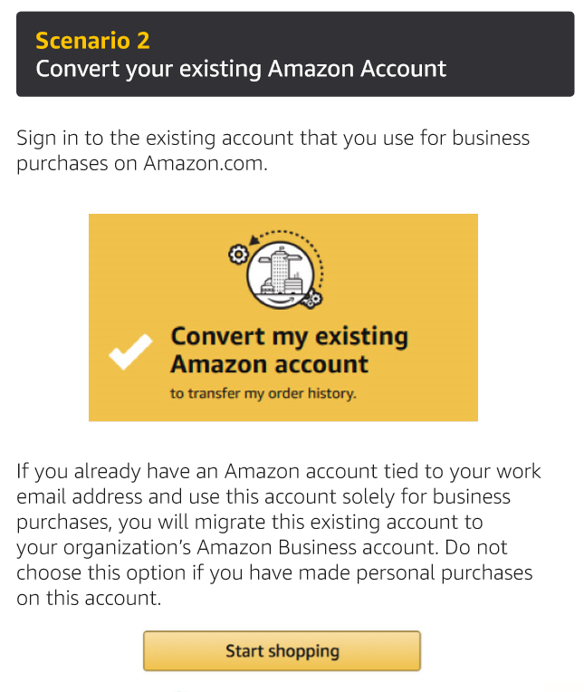
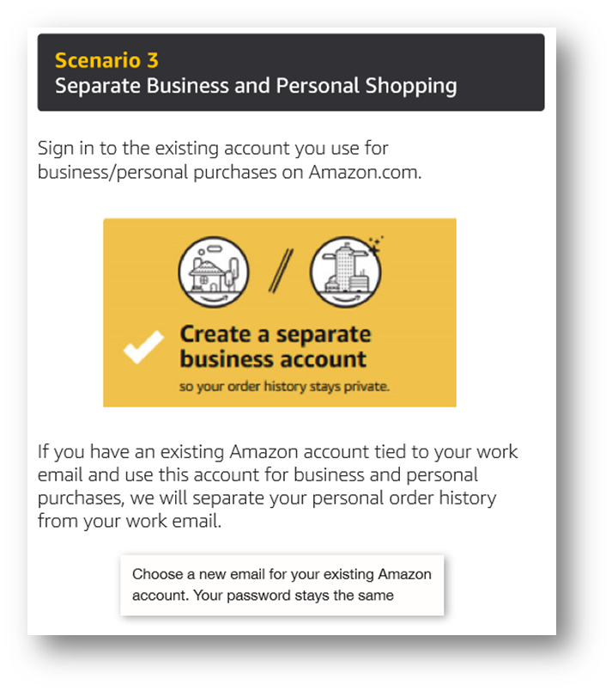

- Once you have created your Username and password you can start shopping. For your convenience we have created a list for you to shop from, if you choose any items that are not on the preapproved list it will require your supervisors’ approval. When you receive the message that your order is pending approval there is a comment box to add that the items have been approved and by who.
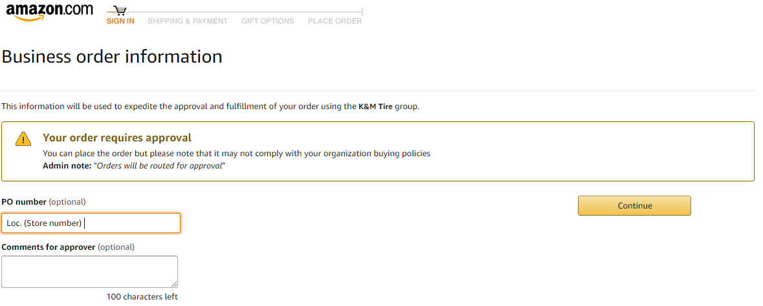

  - In the top right corner, you will see “List”
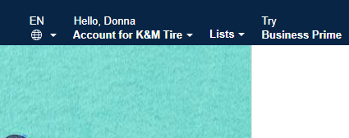

  - When you click on list, the already created list to choose from will pop-up on the left-hand side of the screen.
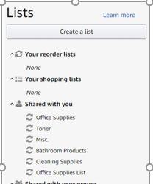
  - Choose the items and quantity you need to order and add to cart.
  - ALL items added to the cart that are not on the already built list contact admin department before proceeding to checkout.
  - Once your order is complete Proceed to Checkout
  - It will show the below “Warning” You can add a comment in the box if you choose too, then select continue. This will help determine the need of the item or why it was chosen in place of an item in the already approved list.

  - All orders require an approval.
    - Orders will be approved as quickly as the approval emails are received, and you will be notified by email that it has approved
    - There are multiple approvers, so in the event that one is out of the office it will be approved by one of the other approvers
- If you are only assigned to 1 location you will not have to choose a delivery location it will already be chosen for you. (All of your delivery preferences have already been loaded into the account)
  - If you have been assigned to multiple locations you will need to pick the ship
to location
  - Submit your order
  - All orders will be invoiced to K&M instead of paying with your credit card
  - Accounts Payable will pull the invoices from the website and pay them.

Adding or Removing a Person from Amazon
To Delete:
- Sign on to Amazon with K&M email.
- Click on “Accounts for K&M Tire”

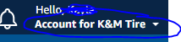

- Click on “Business Setting”
- Under “Members”- Below click on “People”.

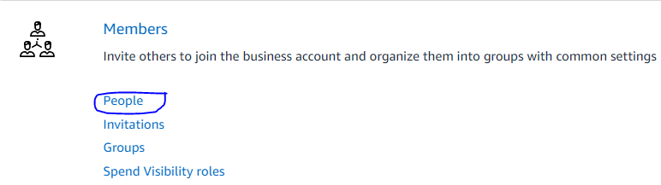
- Once you are on the group page. Click on “This Group and Subgroups” to see all people on the list.

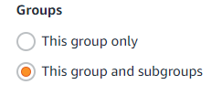
- Search the employees name you are wanting to delete.

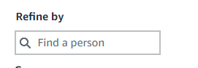
- Under “Action”- Click “Remove from Group”
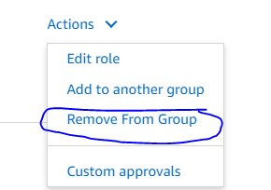
- Make sure green box says successfully removed.
- When adding people to Amazon be sure we do not go over 100 people. You can find the number of people that is on the Amazon account under “This group and subgroups”- under “Displaying” as shown below highlighted yellow:

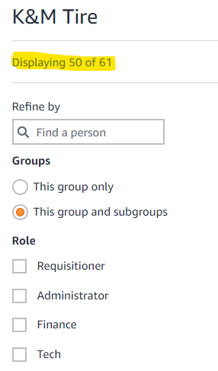

- Every 6 months check the “Location Cheat Sheet” to make sure the managers listed on Amazon account are up to date and delete the ones that are no longer with the business. This will help with keeping a low number on the account.

  - Location Cheat Sheet: F:\Administrative Assistants\Public\Location Cheat Sheet.xlsx

To Add:

- Sign on to Amazon with K&M email.
- Click “Accounts for K&M Tire.”



- Click on “Business Setting”
- Click on “Members”- then “People.”

- Click on “Add people”
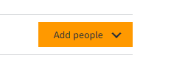
- Click on “Share an invite link.”
  - Copy the Amazon link and paste it in an email. The email below tells the person the steps when ordering on Amazon.

Hello,

Please see the below link for the K&M Tire Business Account. Click on the link, enter your K&M email address, and then create your password.
https://www.amazon.com/ab/invitations/accept/2020364pz10av0HRkCTqc8FEohiwg?ref_=b2b_eam_inv_lnk.
You will be able to sign in and order supplies for your location. There are two pre-approved lists for supplies and cleaning supplies to select from. If you select items that are not on the list, then you will need to get approval from your supervisor before placing your order.

Put your location number in the PO box before you submit the order.

Adding employees to other locations groups on Amazon
- At the top right-hand side click on “Account for K&M Tire”
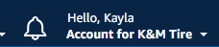
- Click on “Amazon Business Settings”
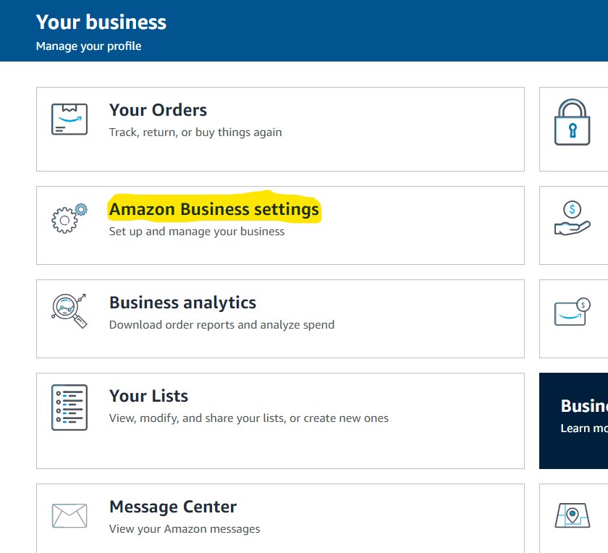

- Under “Members” click “Groups”

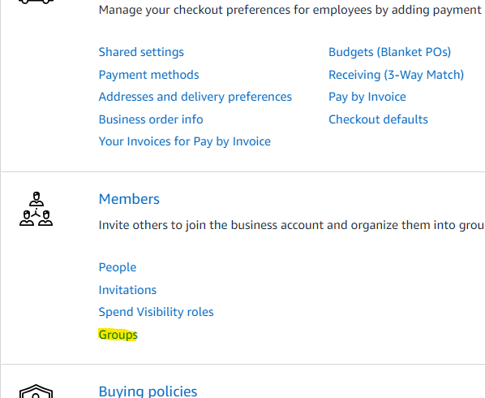

- When you are on the page with each location. Find the location you are wanting to put the employee in and click on it.
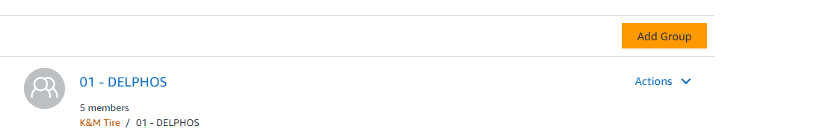

- On the location page. Click on “Add People” on the right-hand side of the page.
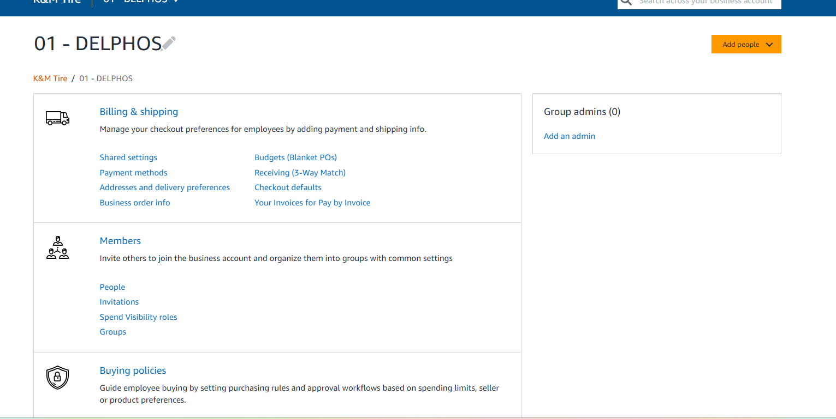

- On the drop-down menu click “Invite by email”
Input the employees’ K&M email address.
*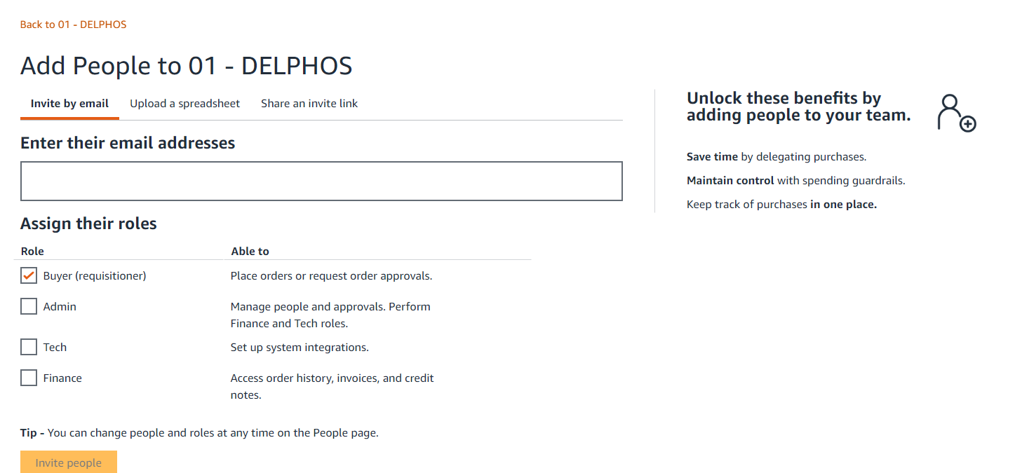

The manager will automatically have access to orders for that location.

Changing addresses on Amazon
- On the main page click on “Account for K&M Tire” On the drop-down menu click “Amazon Business settings”
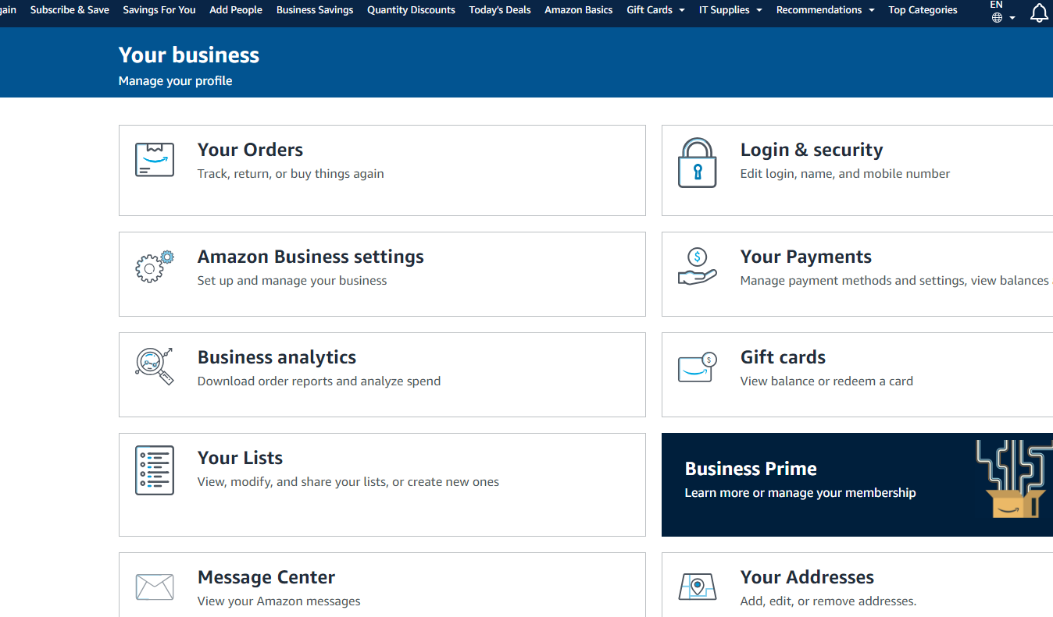
- On the Amazon Business settings page click “Address and delivery preferences”.
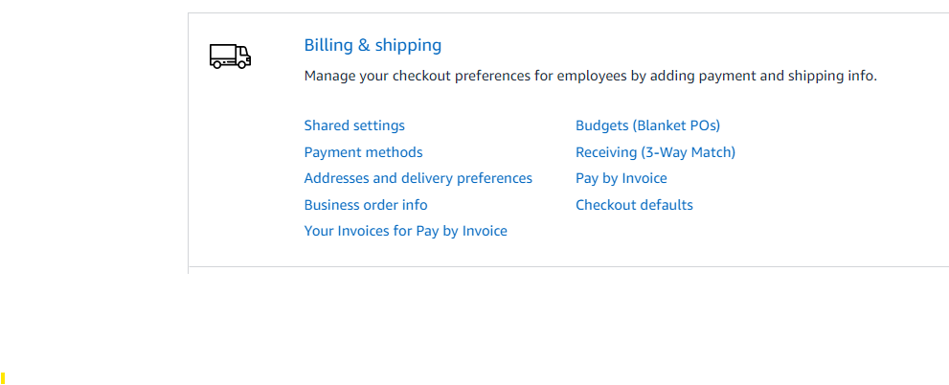

- On the “Address” page click on the location that needs to be changed.
Example:
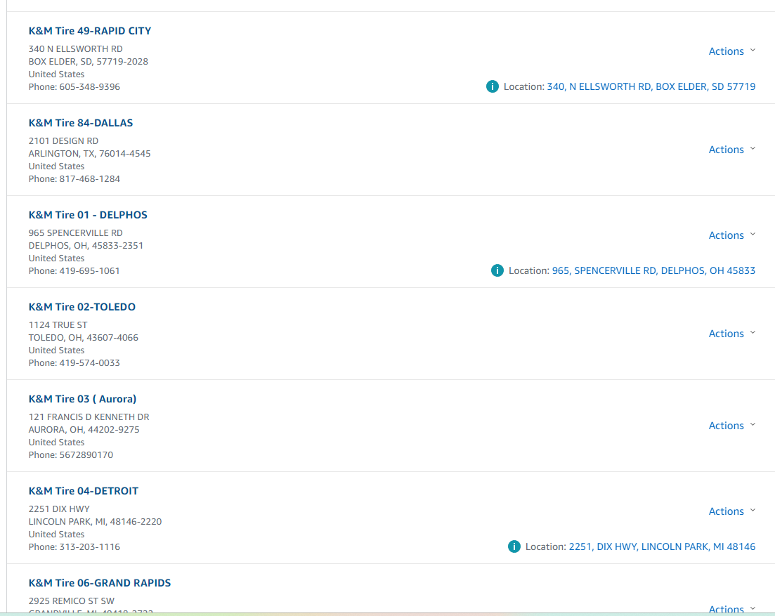

- On the right hand-side click “Action”- “Edit Address”
  - This option can be used to remove Addresses too.

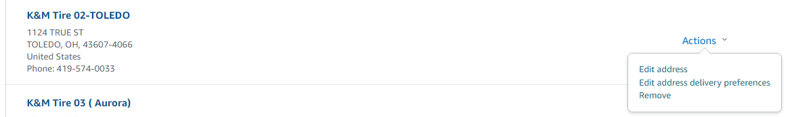

- Once, on the edit page change all information needed.
  - This is where you can add instructions for deliveries.
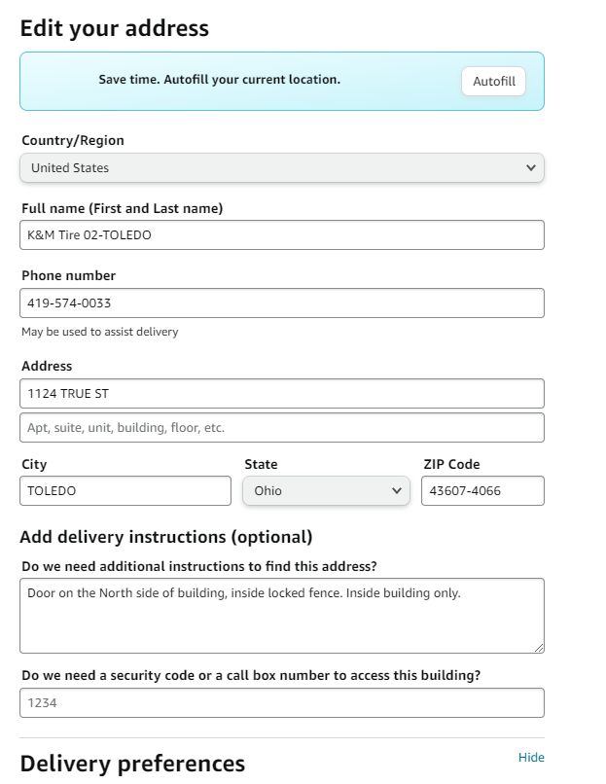

Adding items to Amazon list
- On Amazon main page in the search bar type in the item you are wanting to add to the list.

- Once you are on the item. On the bottom right-hand side of the page click on “Add to List”
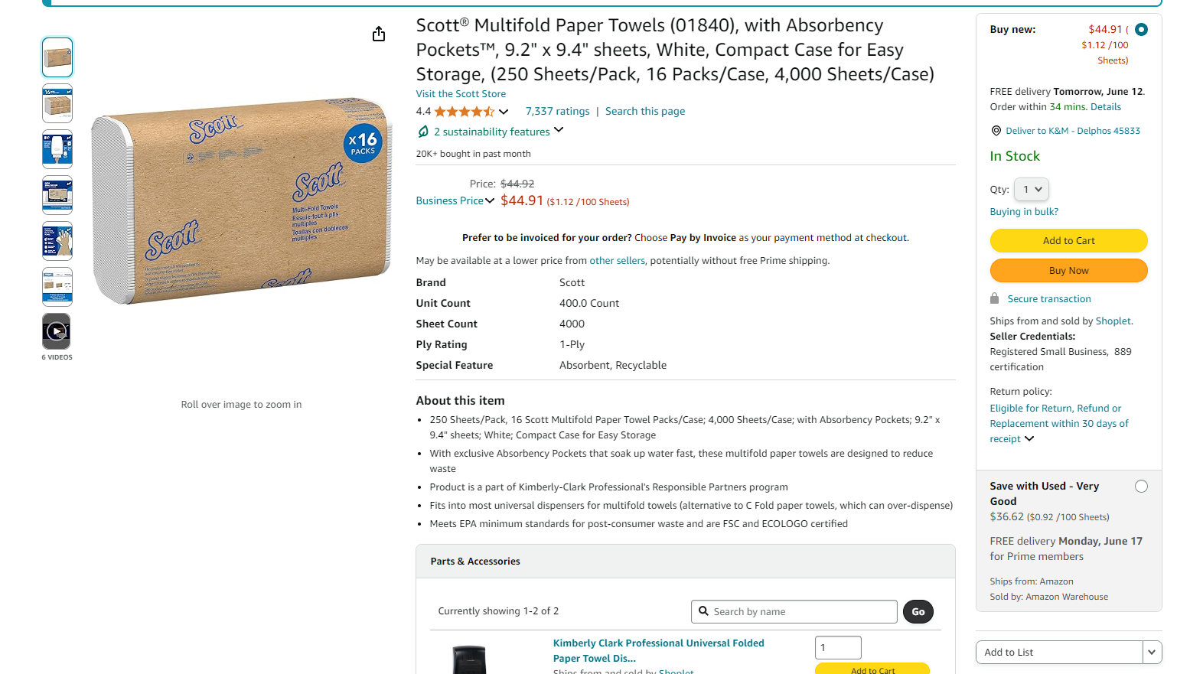

- On the drop-down menu- Put item in the appropriate category.

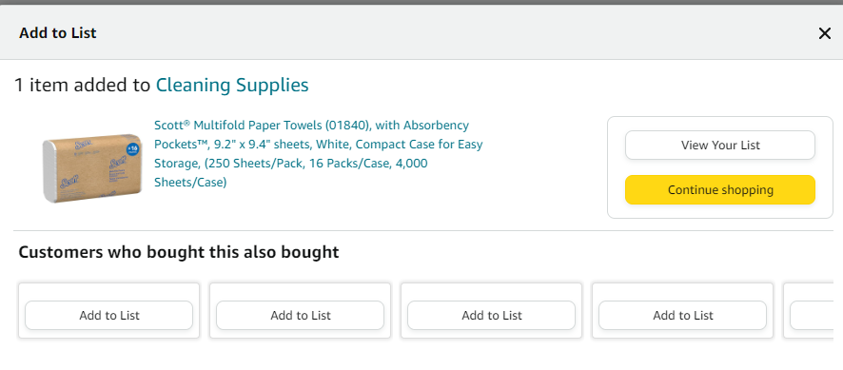

Balancing Accounts Receivable Balance Register

Accounts Receivable Balance Register
- The Accounts Receivable Balance Register provides the total receivables owed to us from our customers and the difference posted to that total day. When this does not balance from day to day it means something did not post correctly regarding our customer’s accounts.

Daily Email
- The Accounts Receivable Balance Register is emailed daily from the Accounts Receivable Dept. (The MaddenCo file name of this report is TARUPBAL128784). This report, along with a lot of other reports, are generated from Maddenco during the nightly update.
- On the first of the month, two reports should be received. The second report is from the service charges that we run and post to customer’s accounts.

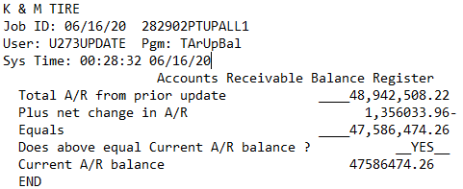

- Once the report is received it should be balanced first thing in the morning to uncover a potential problem as quickly as possible.
- On the “Total A/R from prior date” write the total from the “Current A/R Balance” from the previous days report.
- Next, add or subtract the “Plus Net Change in A/R” and write that total on “Equals” line. This amount should always match the “Current A/R Balance”.
- If it matches write “Yes” and this completes this task for the day.
- If it doesn’t match write “No” and scan/email to the Controller and cc: Executive Vice President along with a copy of the previous days report. Subject line of the email: Daily A/R Balance Register Report OUT OF BALANCE.

    - If those amounts do not match, this is an issue because something didn’t post correctly. When it is off, it means a customer’s account balance is wrong or our general ledger is wrong and is an important matter that needs looked into within the day.
    - The current month’s “A/R Balance Register” is filed accordingly with the current month’s “Daily Sales Update Report” and current month’s “Error Log” in a folder in the drawer labeled “Morning Report”.
    - 60 days of “A/R Balance Register”, “Daily Sales Update Report” and “Error Log” retention is filed accordingly in a separate folder in the Morning Report drawer and then recycled.

Balancing the Daily Sales Update Report

Daily Sales Update Report
- Balancing the Daily Sales Update Report shows the total of sales from the previous day. This report needs completed to quickly alert us to a posting issue.

Daily Email
- This report is emailed daily from the Accounts Receivable Dept. (The name of this report in MaddenCo is TUPSLS128784). This report, along with a lot of other reports, is generated from Maddenco during the nightly update.

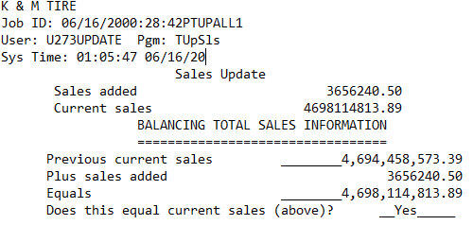

- Once the report is received it should be balanced first thing in the morning to uncover a potential problem as quickly as possible.
- On the “Previous Current Sales” line write the “Current Sales” amount from the previous days balancing report.
- Add (or subtract) the “previous current sales” amount and the “plus sales added” amount and write that total on the “Equals” line. Compare this amount to the “Current Sales” from above the “Balancing Total Sales Information” line.
- If it matches write “Yes” and this completes this task for the day.
- If it doesn’t match write “No” and scan/email a copy of the report to the Sales Manager, Controller and cc: the Executive Vice President along with a copy of the previous report with the subject of: Daily Sales Report OUT OF BALANCE.

    - If those amounts do not match, this is an issue because something didn’t post correctly. When it is off, it could be a customer’s account or our general ledger that didn’t post correctly and is an important matter that needs looked into within the day.
    - The current month’s “Daily Sales Update Report” is filed accordingly with the current month’s “A/R Balance register” and current month’s “Error Log” in a folder in the drawer labeled “Morning Report”.
    - 60 days of “Daily Sales Update Report”, “A/R Balance Register” and “Error Log” retention is filed accordingly in a separate folder in the Morning Report drawer and then recycled.

Madden CO

Ordering Tire Chalk for locations
When ordering tire chalk for other locations. The main location that has a higher inventory will be location 47. When ordering chalk we order from the location hub.
If location 47 would not have chalk these are the locations you can order from:15,53,24,84.

- Log into Madden Co
- Enter 1 -Tire Dealer System and enter.

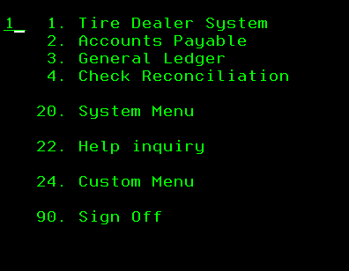

- Enter 7- Warehouse Order Entry Menu -enter.
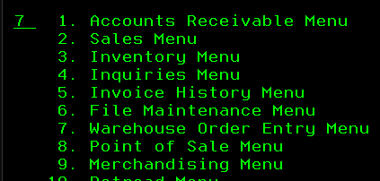

- Enter 1 – Order Entry -enter.

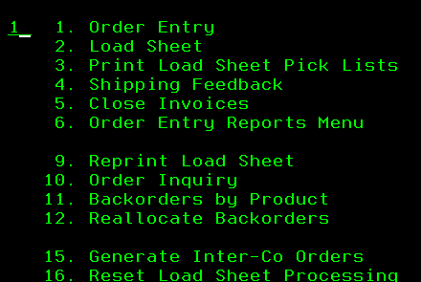

- Enter the Store Number you are ordering the chalk from. Hit + enter.
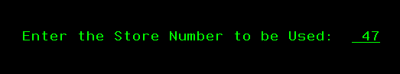

- Hit F6 to add a new invoice. Hit F6 again for the invoice to appear.
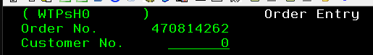
- After invoice appears. Hit F4 to ZZZloc
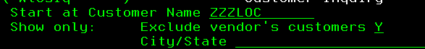

- Find the location that needs the chalk. Put a 1 on the line push enter.
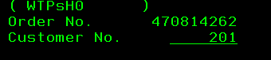

- Hit enter again. Type in your Salesman number + enter and above that will show what location you are ordering chalk from.

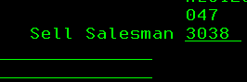

- Under Product enter the item number for the color of chalk needed.
  - 60062Y-Yellow
  - GP14-554- White

- Type in quantity needing ordered + and enter.

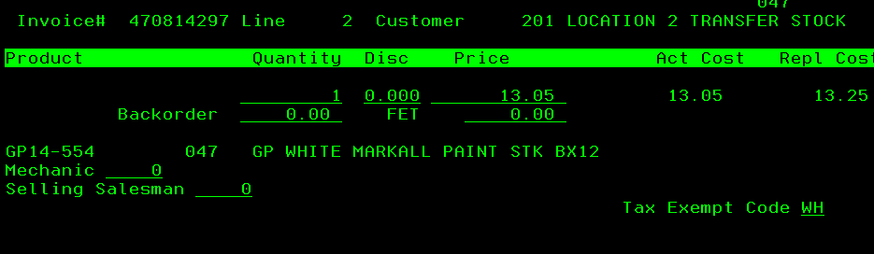

- Hit F7 to add note – ATTN: warehouse manager.

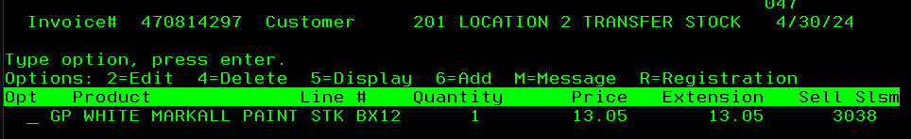

- F3 after completed.
- It is recommended to email the warehouse manager that it was ordered for. Have them let you know if they do not receive it.

Viewing locations tire chalk inventory
- Log into Madden Co
- Hit esc on the starting menu.

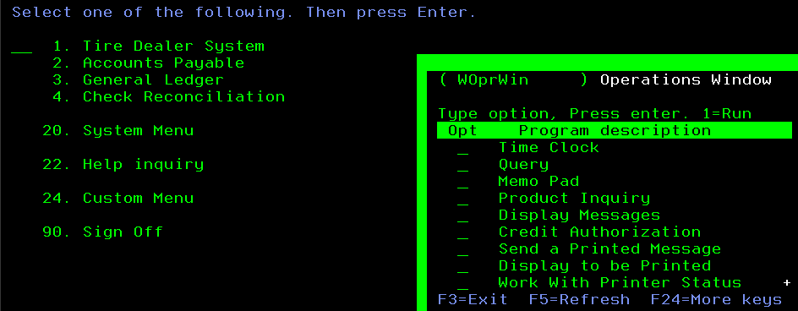

- Tab down to Product Inquiry and type 1 enter.
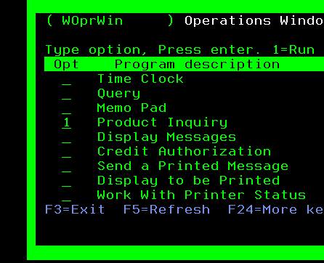

- Product Inquiry- Enter the store number you’re wanting to check + enter.

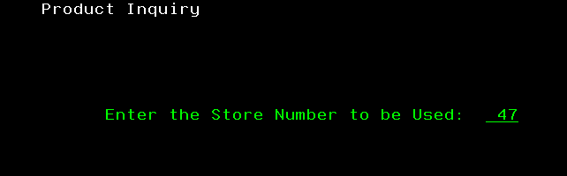

- Customer Inquiry- Hit F3
- Product Inquiry- Tab down to Product Number- type in the color ID number
  - 60062Y-Yellow
  - GP14-554 – White

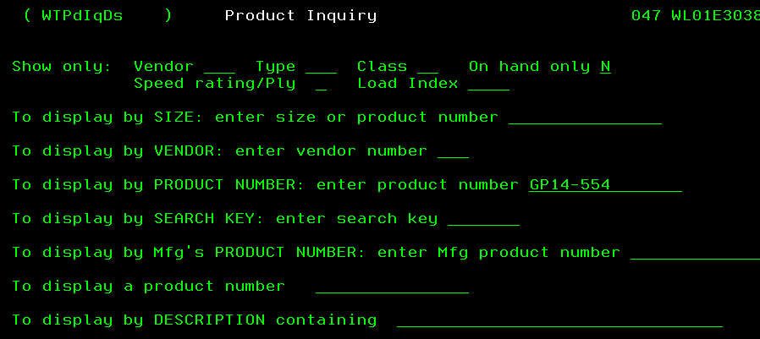

- Product inquiry by Product Number- on the first line type in the letter I enter.

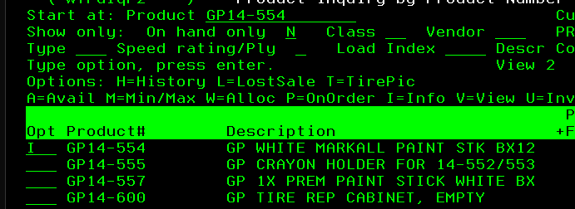

- Product Information- on this page you will see different stores listed. The first line will have the store numbers.
  - On the one hand- will be the inventory they have at the location.
  - Allocated- Is when they have one pending.
  - Available- the quantity you can order.

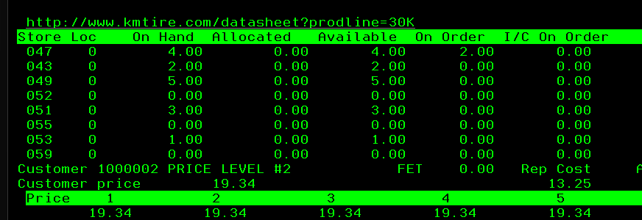

Banking for Affiliate Companies
When checks are received for payment for affiliate companies (ex: C Realty, CZ3 Holdings, KLD Realty, Langhals Air, Langhals Enterprises & LL Realty) they will need deposited. All funds are deposited into their individual accounts at First Financial. (Except LL Realty, they only have an account with Wells Fargo and it is mail in only). See end of procedure for details.

Receiving and Depositing Funds
- Deposits slips for all accounts are located in a lime green plastic file folder in the top file drawer beside Administration Manager’s desk labeled Affiliates.
- Choose the correct deposit slip for the correct account and fill it out.
- Make sure to write “For Deposit Only” in the endorsement area on the back of every check
- Make copies of all checks and the deposit slips. (DO NOT COPY OR SCAN CASH. Our copiers do not allow you to copy/scan cash.) Place the copies in the Affiliate folder it belongs in (top file drawer beside Administration Manager’s desk)
- Email Miranda.burkholder@kmtire.com the details for the deposit, as she is responsible for making all GL entries and balancing all accounts. See sample email below.
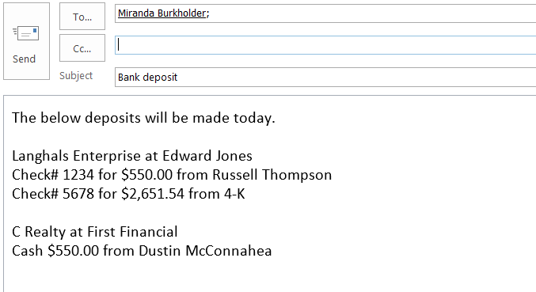

- Put the checks/cash and deposit slip in an envelope and write First Financial on it. Admin will drop the deposit off at First Financial Bank while doing the afternoon bank run.
- In the event a deposit needs done to Wells Fargo Bank, that is a mail in only option to the below address, as regular mail. (Edward Jones can be dropped off-no cash is accepted).
Wells Fargo
PO Box 825
Minneapolis, MN 55480

City of Delphos Council Meeting Minutes
We request the City of Delphos Council meeting minutes monthly to keep informed of new/changes happening in the city of Delphos that may impact K&M Tire in any way.

- Meetings are on the first and third Monday of every month.
- On the third Wednesday of each month email Sherryl George (Delphos City Administrative Assistant) adminassist@cityofdelphos.com asking her to send the city council meeting minutes for the current month. Also, Cheryl would like us to check the city of Delphos website for any announcements or news that might be of interest to K&M Tire. The mayor will be adding the meeting agenda and minutes to the website soon. We will be able to get the information there.
- Once they are received, read through them, and save at the below path.
  - F:\Administrative Assistants\Shared\City of Delphos Meeting Minutes\2023

- Email the President, attaching a copy of the minutes, cc the Executive Administrative Assistant so they are aware this task has been completed.

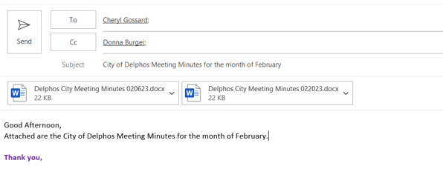
  - If there is anything of concern for K & M Tire, add a message in the body of the email alerting them.

Daily Update Meetings with the President0.1
The purpose of this meeting is to keep alignment between the President and the Executive Assistant.

Purpose and Structure
- Each morning (typically 7:30 am) the Administrative Executive Assistant will meet/call the President. During this meeting, the Executive Assistant and the President will cover:
  - Needs for the President
  - Tasks that need to be completed and their deadlines
  - Updates for on-going tasks
  - Questions that arose the previous day
  - Notice of important information of which the President should be aware
    - Alert President to any information you may be aware of to avert anything being a surprise to them.
- Throughout the day as mail or items needing to be seen or signed by the President are needed, they can be placed in the plastic folders (Signature/Review) from the top file drawer beside the Administrative Executive Assistant desk. Place the folder in the rack on the front of the President’s office door, once the President has reviewed or signed the contents of the folders, she will place the folders back in the rack standing up to alert you that she has completed them.

- If the Executive Assistant would need to be out for an extended time, one of the Administrative Assistants may be appointed to fill in, in their absence, especially for this meeting. In many cases, these meetings will set the tone for the Administrative Assistants’ daily to-do list. The President has multiple meetings almost every day – if anything is needed for these meetings, it is expected that the admin team is sure to have things ready in time. Having these meetings first thing in the morning allows time to ensure expectations are met.

Diaper Bundle
For employees expecting their first child while employed at K&M Tire, a collection is taken up for the expectant couple. We like to purchase and gift them with a 3-month diaper bundle. An email will be sent out to the Corporate and Delphos email asking if anybody would like to contribute to this gift at 60 days prior to the due date, with a reminder email at 30 days. Below is an example of the email.

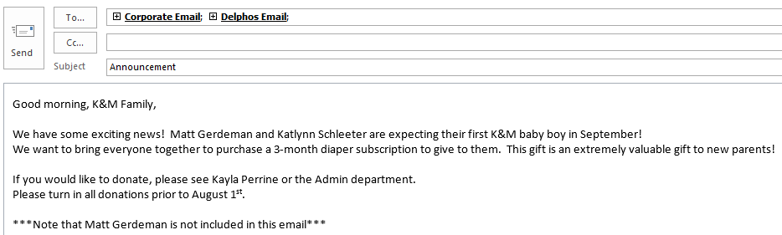

- Reminder email sent at 30 days prior to due date:

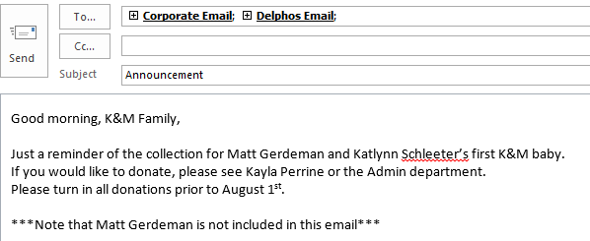

- When people donate, have them sign their name on the person's card.
- Write the person's name and how much money they donated on a cash envelope, and fill in the information onto the spreadsheet.
- The spreadsheet also tracks due dates, dates when emails should be sent, and the total donated. F:\Administrative Assistants\Shared\Fundraisers\Diaper Bundle.xlsx
- All diaper bundles are purchased at the below website.
  - www.incredibundles.com
U: administration.group@kmtire.com
P: firstbaby1
- Once all of the money is collected, make sure the money in the envelope matches the amount on the spreadsheet.
- Fill out the form from AR, and give it to them to deposit the collected money in 5400-1-1(Misc)
- The cost of the diaper bundle is $249.00, if we are short funds, K&M Cares will make up the difference. The President of K&M Cares will have to be notified to have the shorted funds moved from K&M Cares (2890-1-1) to 5400-1-1.

Delivery Schedule

Scheduling A Delivery
- All deliveries will need to be called in. No scheduling via email. All deliveries are required to be scheduled deliveries so our warehouse is staffed to handle the work load.
- It is recommended to ask all information first and to write it down in a notebook (you will be able to refer back to loads if needed) if you have to call the warehouse to see when they can fit the load, you will have all the information.
- Log into intranet. http://intranet.kmtire.local/index.php?area=home
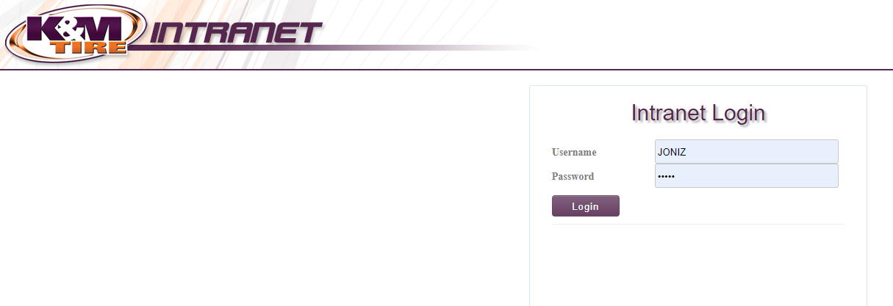
- Left click the (+) beside Warehouse on left hand side of screen. From the drop down choose WH-Delivery Schedule. In order to save delivery schedule in your favorites. You will find warehouse under department on the left hand of the screen. Left click warehouse tab, this will bring down a field of options. Find delivery schedule, left click then on the top of the page to add to favorites. Left click add to favorites.
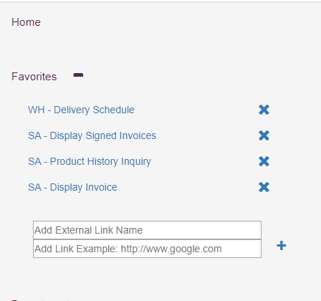

- Left click “Schedule Delivery” 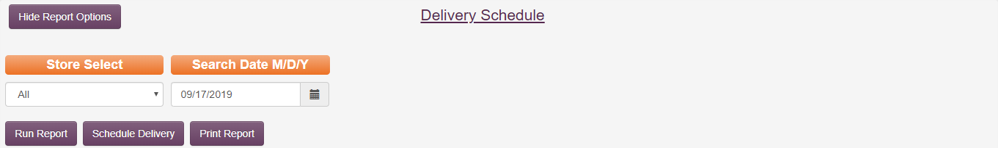

- Ask carrier all highlighted questions.

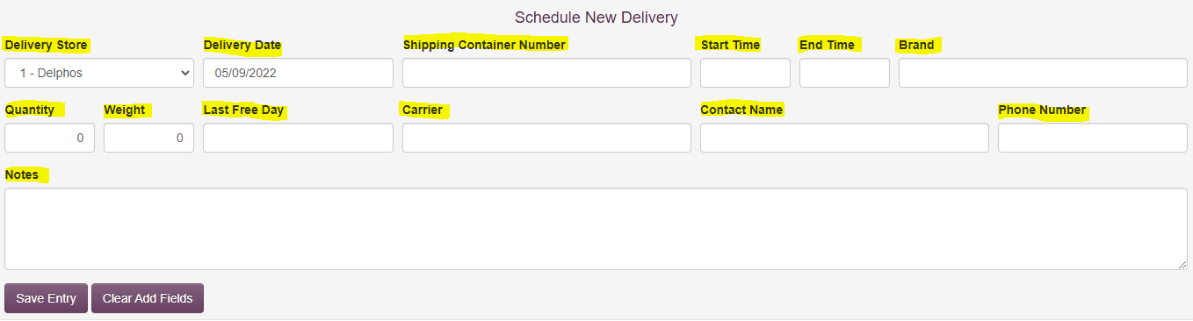

    - Delivery store – ALWAYS will be Delphos, OH – all locations schedule their own deliveries. If you receive a call for another location transfer that call to the correct location warehouse manager.
    - Delivery date – do not double book deliveries, if double booking is necessary call warehouse manager or supervisor and get their approval. (Add to the notes if it has been approved and by who)
    - Shipping Container Number - Be sure to ask for PO number, loading number or container number, IF it is a container there will be a LFD – Last Free Day (container needs to be delivered before last free day or we will be charged storage)
    - Delivery Type -
    - If new delivery is a container be sure to ask for carrier’s email address in order to send an email confirmation.
    - Start time / End time
    - Delivery start times can be at:
    - 6:00 am
    - 8:00 am
    - 10:00 am
    - Delivery end times will be TWO hours after start time.
    - Vendor - (brand) – this will be the brand of tires coming into the warehouse. If this is a live unload be sure to add (live unload) behind brand of tires.
      - Pneumatic is NOT a brand of tires – pneumatic simply means air in tires.
    - Quantity - Total amount of tires.
    - Weight – Total weight of trailer/ tires.
    - Last Free day – Last free day will be provided by the carrier if it is a container. if it is a live unload, you can set last free days five business day from the schedule date.
    - Carrier – trucking company that will be bringing load.
    - Contact name
- Contact phone number
    - Make any necessary notes – especially when rescheduling and/or if you double book and it is ok’d by a manager. Be sure to add all important details in notes when scheduling a container.
    - All loads are driver assist. If the driver is not able to assist, they can pay a lumper fee of $100.00 per load. Acceptable types of payment for lumper fee: ComCheck, Cash or EFS.
- Save entry – Once saved, an email will be sent to Delphos warehouse manager. Refresh screen, look back on scheduled delivery to make sure it was successfully scheduled with correct information.
    - Live unload – is when they unload the truck right away. Tires will either be on skids or will need to be unloaded one by one.
    - Skids – this is when tires are on pallets.
    - Container – when scheduling a container be sure to ask for carrier’s email address to send delivery email conformation. See below example of email that should be sent out:
- Most Containers that need scheduled will be on the pending list.
  - Click on pending tab
  - Look through the containers listed to find the one you are going to schedule
  - Click on View/Edit under the Details column
  - Change the delivery date to what day you are scheduling.
  - Select the start and end time.
  - Select the Vendor from the drop down menu
  - Fill in: Quantity, Weight, Carrier name, LFD, Contact Name, Contact number
  - Make any notes in the note section that applies to the delivery. Example: “Offered first available per warehouse on the date and time. Carrier accepted”.
  - Click on update
  - Click on schedule delivery
  - Run report
  - Check the schedule to see if the container was put on the delivery schedule.
  - Send a confirmation email from quick step drop down (delivery confirmation) It includes the purchasing specialist, purchasing analyst and admin email and add the email address of the contact person who called to schedule the delivery.

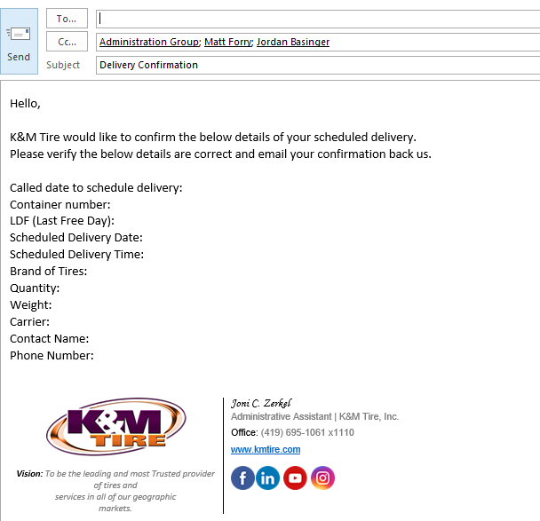

- Brands of tires that will be possible containers
- Containers will be the only ones that will have a last free day (LFD)
    - BKT
    - Double Coin
    - Gladiator – ST
    - Greenball / Kan
    - GT Radial – (Giti)
    - Ironhead TBR
    - Prometer
    - Speedway
    - Supercargo
    - Thunderer
- Other brands of tires
    - Alliance
    - Bandag
    - BS/FS PLT
    - Carlisle
    - Continental / General
    - Cooper
    - Falken
    - Firestone (FS) AG
    - Firestone (FS) Truck
    - Firestone (FS) Tubes
    - Gladiator
    - Goodyear
    - Hankook
    - Kumho
    - Mastercraft
    - Michelin / BFG
    - Mickey Thompson
    - Mitas
    - Nexen
    - Pirelli
    - Roadmaster & Cooper TBR
    - Titan / Goodyear AG
    - Trelleborg
    - Unverferth
    - Yokohama

Scheduling a Drop Trailer
This delivery is a physical truck trailer that is dropped off at the corporate location and is unloaded at the convenience of our warehouse.

- We are notified by email from the carrier asking to schedule a drop trailer. (See below) They request the date needing scheduled, pro#, quantity, weight, shipper, and brand of tire.
  - We currently only do this with Old Dominion Freight Lines (ODFL)

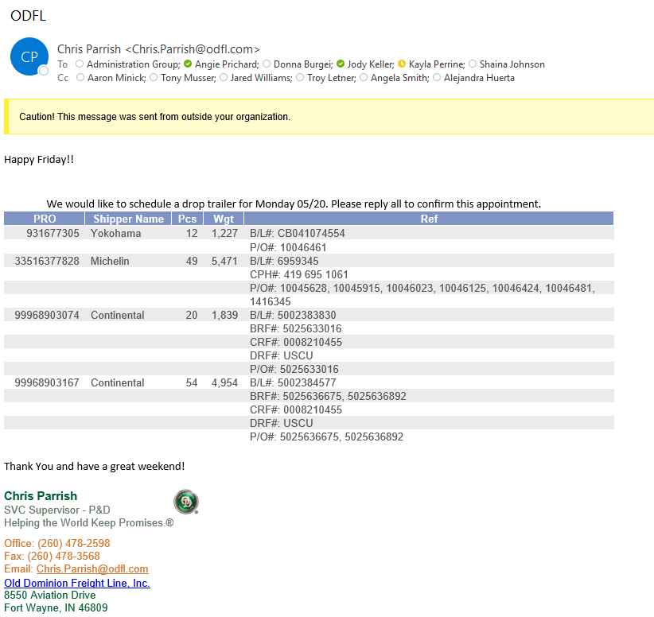

- Log into K&M Intranet.


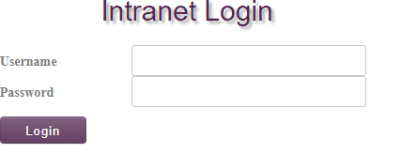
- Select a store – Delphos.

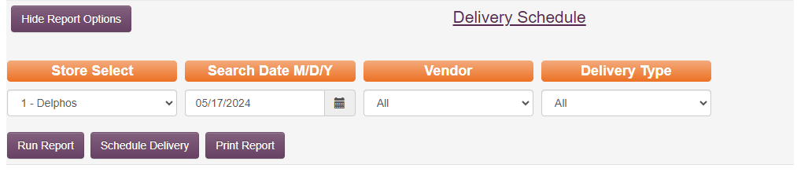

- Run report to refresh the schedule.
- Schedule Delivery
  - Only one drop trailer can be scheduled per day.
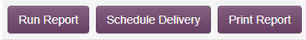

- Fill out the following delivery information.

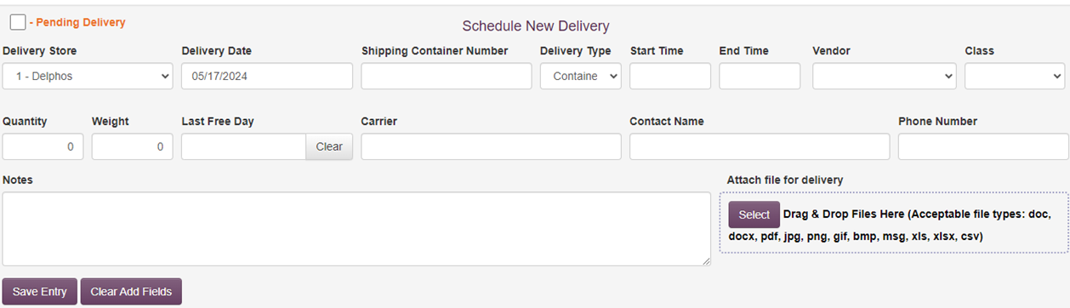

- Delivery date
- Shipping Pro number/Drop Trailer
- Choose Delivery Type from drop down menu. (LTL)
- Start time/end time will always be 2:00pm to 4:00pm. You will schedule for each pro# listed in email. Scheduling each consecutively. 2:00pm, 2:01pm, 2:02pm.

- Choose Vendor from drop down menu. Fill in one of the vendors in email for each delivery.
- Class Leave Blank
- Quantity
- Weight
- LFD (Last free day) always 5 business days from call or email
- Carrier (ODFL)
- Contact name and phone number. (Sender of email)
- Picture change below

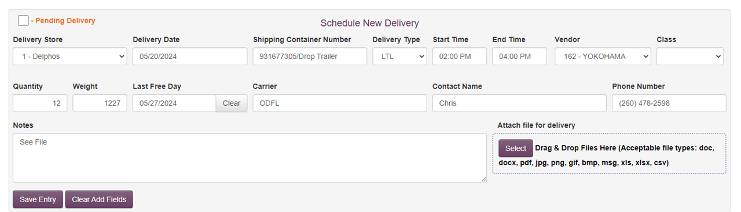

- Save entry, refresh screen, and check schedule to verify the information is saved.
- Added new picture.

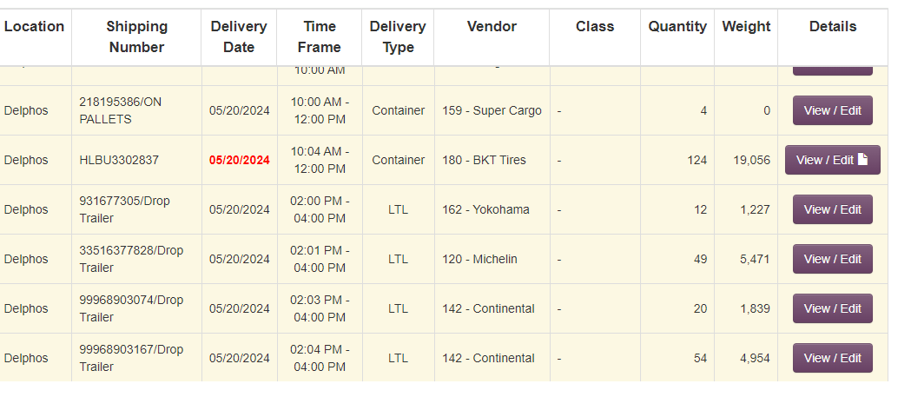

- Clip a picture of the original email and save it to your desktop. Then drag and drop it to the first delivery entry and click on update to save it.
- Added new pictures.
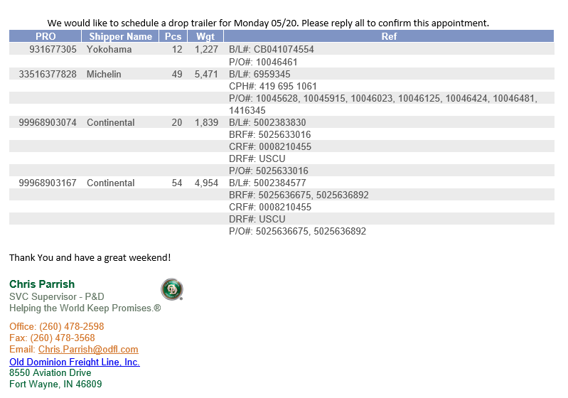
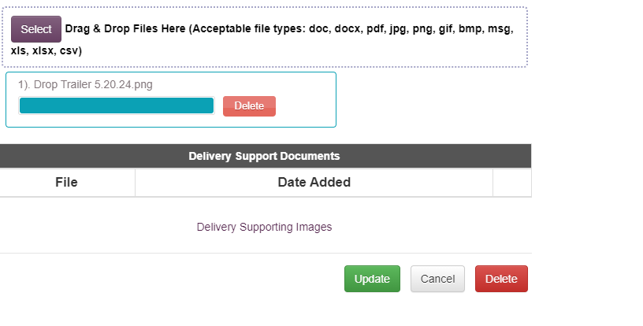

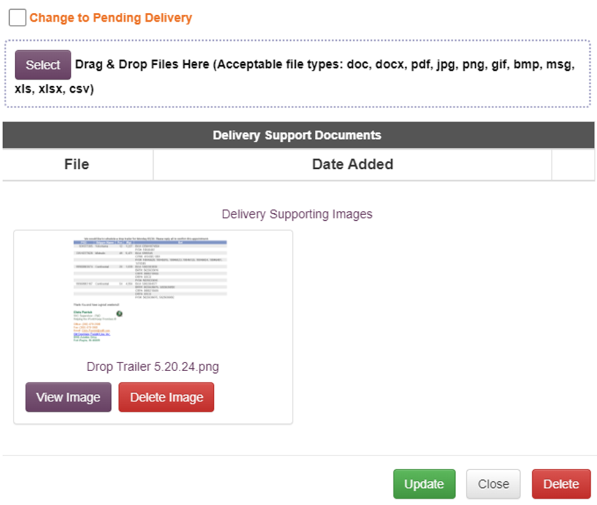

- Send a “reply all” email from our “admin email”. “This drop trailer has been scheduled for the following date”. (See below email)
- Added new picture.

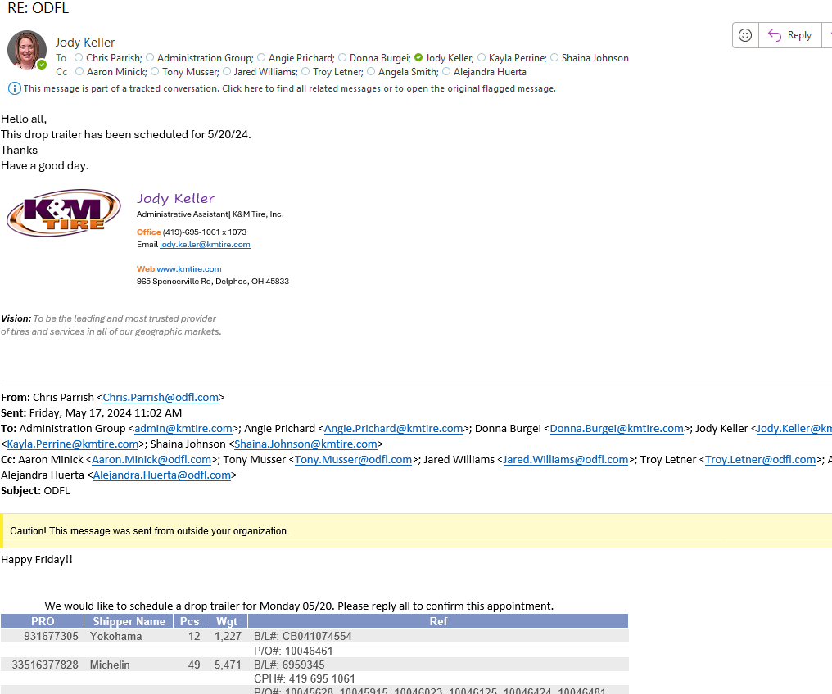

- Save original email and reply all email to our drop trailer folder located in admin email box.
- Added new picture.

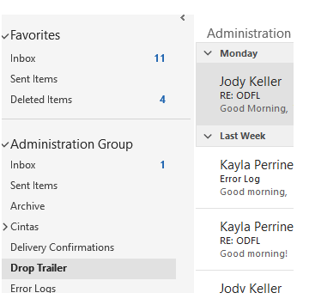

Direct Ship – Tires
The reason we do a direct ship billing is because the tires are shipped directly from the vendor to our customer, at the customers’ request. In these scenarios, our customer does not have an account with the vendor, the purchase is actually made by K&M, and we in turn bill our customer. All Direct Ship orders must be approved by the VP of Sales.
You will receive the vendor invoice from Purchasing & Pricing. They will have written on the invoice the Customer Account #, applicable Discounts and any changes to billing terms.
When starting a direct ship billing you need to login to MaddenCo. Before starting it may help to read tips on the last page. The following steps are as follows; these steps will take you through the direct ship billing:

Direct Ship Billing for Tires
- Log into MaddenCo
  - 1-Tire Dealer System, enter
  - 8-Point of Sale, enter
  - 4-Counter Billing, enter

- Enter the Store Number 50 (All Direct Ships are billed out of Store 50), field exit, enter

- F6

- F6 again to create an invoice number (write this invoice # on the vendor invoice)

- Enter the Customer Number (this is usually written on the top of the vendor invoice)
  - To search for a Customer Number, F4 to type the name (no spaces)
  - Field Exit
  - Enter
  - Choose your customer from the list that appears by putting a 1 on the correct line
  - Enter

- Type in Sell Salesman #415 (It will always be selling salesman #415 – this allows us to pull reports for one salesman number and guarantee all Direct Ships are on the report)
- Change Terms (if needed) this info comes from purchasing
- Sometimes it will not let you go to the next screen; it will require you to type in a PO # (this is located on the original paper)
- Even if the account does not require a PO#, almost all Direct Ships will need one. This information should be written on the vendor invoice by the purchasing department.
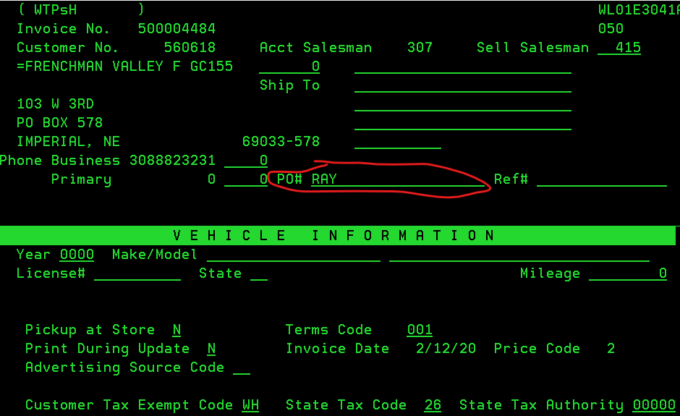
- Enter

- Product – enter then K&M part number
  - The part number will be based on 1) who the vendor is; and 2) the vendor part number. (Vendor part number is found on the vendor invoice)
  - The K&M part number will be the vendor part number plus an indication of who the vendor is.
    - For BKT add a “B” to the beginning of the vendor part number
    - For KUHMO add a “K” to the beginning of the vendor part number
    - For CARLSTAR add a “C” to the beginning of the vendor part number
    - For BS/FS TUBES add an “F” to the beginning of the vendor part number and a “B” to the end of the vendor part number
    - For HANKOOK add a “H” at the beginning of the material number
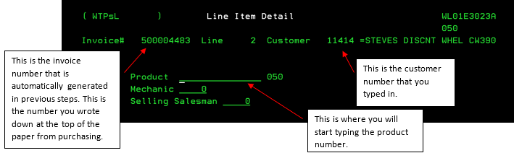

- Enter
- Type Quantity
- Field Exit (Plus) (to bring the quantity to the right of the line)
- Price (leave at current buying price) Unless stated otherwise on the vendor invoice
- F11
- Type 3 (Direct Ship)
- Enter x3 (do same for all products on invoice)
- When done typing all of the products in hit F3 and put a 5 on all lines -hit enter
  - This reviews each product line to ensure you put a 3 on all of the products for direct ship
  - If you forgot to place the “3” on the line, place a 2 on the line you missed and it will let you edit. Go to the section you are supposed to place the “3” on and edit it.
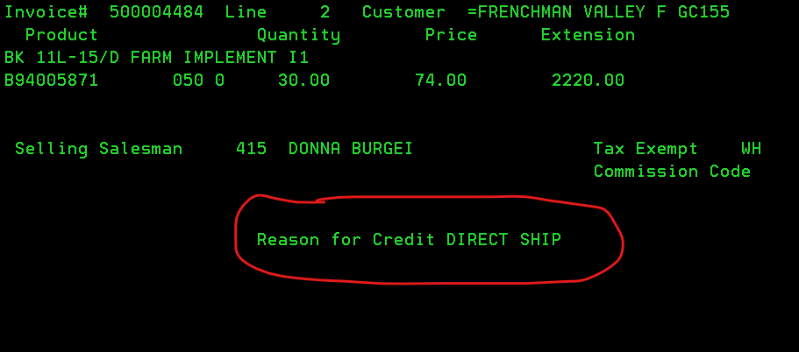
- Once you have verified that each product was given a reason for credit of Direct Ship, hit F3 to exit the product verification screen.
- If there is a discount, hit F6 to enter a new product code - use DISC(percentage number) (Example: For 3% discount=DISC3)
  - Discount is figured on Merchandise price total only (you will have to calculate)
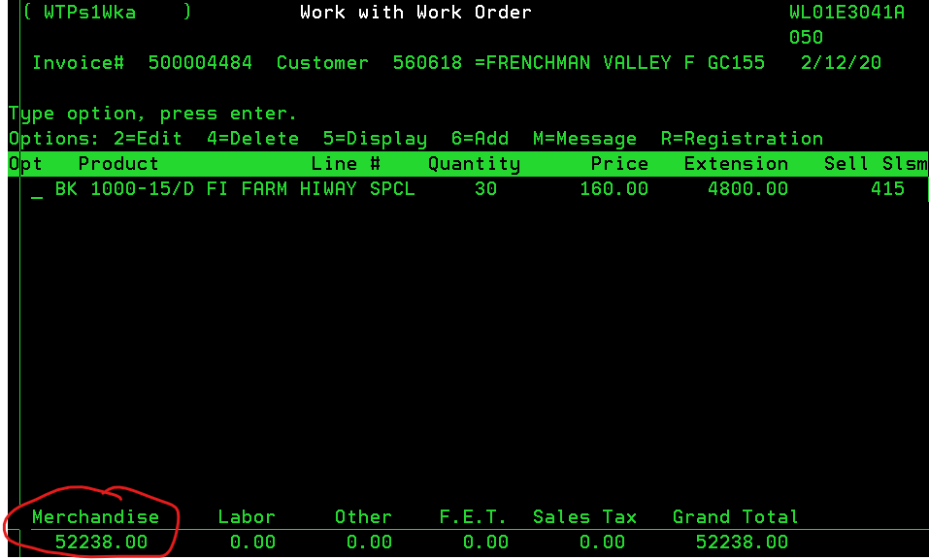
- Enter
- Quantity = 1- (1 minus) then field exit (Plus) (to bring the quantity to the right of the line)
  - On the price line this is where you would put the discount off total
  - The “Reason for Credit” box will pop up again; F3 to exit that screen
- If you have an additional discount being taken out, the second discount will be calculated based on the new Merchandise total amount (the first discount amount will already be calculated out of the new Merchandise amount)
- Hit F7 (message line) and type “Vendor name Direct Ship vendor Invoice #/Order #”
  - Ex. BKT Direct Ship ########
- Enter
- F3 (to exit invoice)
- Enter to indicate Y (Yes) to print invoice
  - If you get to a screen that will not allow you to close the invoice. This is likely due to the direct ship invoice putting the customer over their credit limit. Call the Credit department and tell them you need a credit authorization – they will need the customer number. (You will have to be out of the invoice – hit F3 and “N” to not close the invoice)
- F5 to show it has been invoiced
- Enter (defaults to printer you are assigned to)
- Enter

Extra Tips

Always mail out the invoice that is printed to the printer. In the box below shows some examples of what to do with the papers.
For all Direct Ships
P&P- gets original vendor invoice
A/P- copy of vendor invoice
C&C-copy of vendor invoice & copy of customer invoice
Mail customer their invoice
When typing the product number place these letters before the numbers
BKT-B
KUHMO-K
CARLSTAR-C
BS/FS TUBES-F in front of #’s/B behind the #’s
DOUBLE COIN-DC
GLADIATOR-nothing
TRELLEBORG- T in front

Credit Authorizations
- During a direct ship it may come up that they cannot continue with a direct ship until the Credit department authorizes a credit authorization. You will need to call someone in the Credit department and say “Can I please get a Credit Authorization out of store 50? The customer number is ######.” They will authorize it and allow the direct ship to go through.

Adding freight charges
- On the product line type “UPS”.
- 1 for quantity
- Tab over to price- type price that is on the invoice for freight charges
- Click enter

Events

Gathering the Corporate Christmas Party Attendee List
- Request a list from Human Resources that includes all Corporate and Delphos employees.
- Remove all of the below:
  - All Outside Sales that don’t work out of Delphos.
  - All Inside Sales that don’t work out of Delphos.
- Remote workers that live in Ohio or Indiana should remain on the list.
- Highlight all employees that don’t physically work in Delphos office at least 25-50% of the time.
- Once the above steps are completed, email the list to the President for review.
**If anyone that didn’t get invited asks if they can attend, the answer is yes but any travel or hotel expense is not reimbursed.

Food For Poor

Sponsored Children
- K&M normally sponsors 18 children each year.
  - This can be changed at any time by emailing AnaA@FoodforthePoor.com
    - As of 2025 – Soraya Garcia 800-487-1158 ex.6155
  - A child may drop off, but will be replaced by another child.
  - The cost to sponsor a child is $34.00 per month, per child (Currently K&M sponsors 18 children) $34.00 x 18 = $612.00, $612.00 x 12 = $7,344.00
  - K&M pays this yearly in February.
    - AP has this listed on their sheet to automatically pay.
- All information regarding letters received, sent and new children can be found here: F:\Administrators\Public\Food for the Poor

New Sponsored Child
- When a new sponsored child’s letter is received, a letter including a photo of the new child along with a letter stating which child is no longer being sponsored is included.
- Scan in the new child’s photo to your mail inbox and save here: F:\Administrators\Public\Food for the Poor\Children Photo with the child’s name.
- Add the new child to the children’s name excel file and move the no longer sponsored child to the bottom of the excel file. And highlight green. Example below. 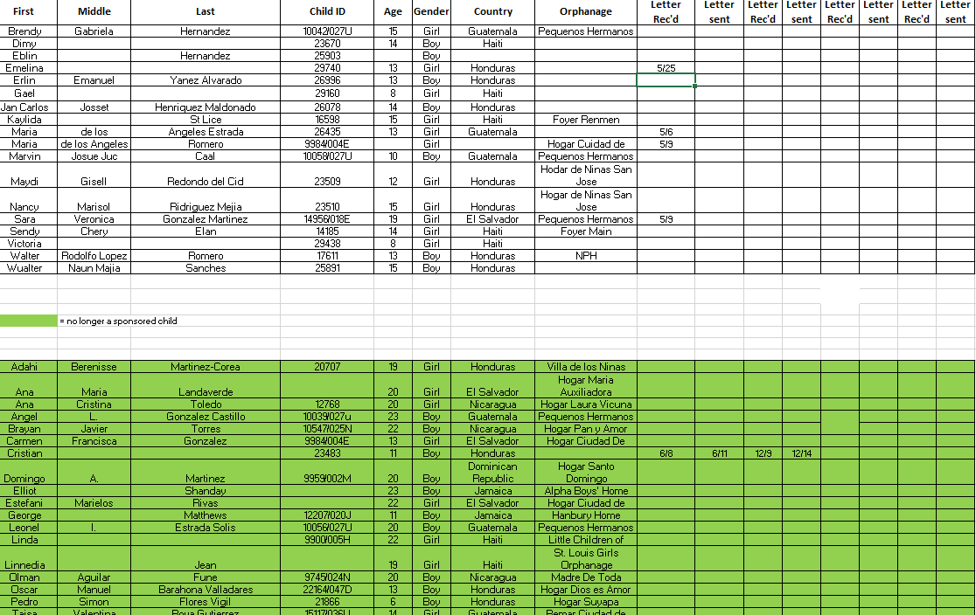

Letters received
- Letters from the children are received via USPS.
  - When a letter is received, the Admin department will write back to them, keeping in mind the below:
    - Keep it simple, be encouraging.
    - Try to avoid things which are exclusive to the United States culture or a high standard of living. These children come from very poverty-stricken
- Email, Facebook, cars, vacations, clothing’s, movies and television. etc.
    - Do not focus on the child’s status as an orphan.
- Living at an orphanage, or asking questions about their past or family circumstances (except if they have other siblings at the orphanage). The child may choose to share this on their own, but please do not probe as this may be a sensitive topic.
    - When they mention their aunt’s, the aunts are their care takers.
    - Keep in mind that they do not have much.
  - Scan ONLY the original letter and the translated letter to your email inbox.
  - Save their letter in the correct file folder under the child’s name, found here: F:\Administrators\Public\Food for the Poor\Letters received
    - Save letter as shown: letter from (child’s full name) (date letter was received)
  - You will also add the letter received date to the correct child’s name on the excel file found here: F:\Administrators\Public\Food for the Poor\Children Names.xls

Writing a letter
- You can find a blank editable PDF here: F:\Administrators\Public\Food for the Poor\Letters sent\01 Blank Letter
  - You can type your letter out on the editable PDF. When finished be sure to SAVE AS to the child’s file folder found here: F:\Administrators\Public\Food for the Poor\Letters sent
  - Be sure to add the child’s information on the two lines on the letter to your child. Ex below:

  - Print letter and give to Administrative Manger to review and approve.
  - Once approved you can mail the letter to Food for the Poor using the envelope provided
- When writing a letter to the child you received a letter from, be sure to limit it to a couple of paragraphs. Food for the Poor has to pay a translator to translate from English to Spanish.
  - Look back at previous letters sent and received so you are not repeating yourself in the letter.
  - If you are not sure what to write them, look on the excel file to see age and google some ideas on what to ask or how to spark a conversation.
  - Suggested topics for your letter
    - Be sure to ask the child open end questions.
      - Ex: what is your favorite color and why? Who is your hero?
    - Daily life:
      - Describe your family members and their ages
      - Describe your work and/ or schooling
      - What does a typical day look like?
    - Weather
      - Do you have a favorite season where you live?
      - Talk about the weather your child may not experience, like snow and sleet.
    - Interest
      - Discuss any favorite hobbies or past times
      - Talk about any instruments that you play
      - Do you have a garden? Is it vegetable or flower garden? What’s in the garden?
      - Talk about games you like to play or used to enjoy playing as a child/teen.
    - Throw in some fun facts about you:
      - Favorite color
      - Favorite flower
      - Favorite school subject
      - Favorite number
    - Food
    - Holidays
      - Mention and explain any traditions your family has, specifically for certain holidays.
    - Sports
      - What sports do you play?
      - What sports do you like to watch or attend?
      - Remember that in many other countries football to them is our soccer.
    - Talk about topics they can relate to:
      - School subjects, sports, making friends, weather and seasons. Like and dislikes.

Front Desk – Best Practices
Visitors to the office, including customers, vendors and the general public will judge our company by the reception they receive. Most times their first impression of the reception they receive is passed on to their friends and associates partly building the reputation of our company by how visitors are treated when entering our building. That is why it is so important to keep the following practices in the forefront at all times.

Greeting Visitors
- Greet everyone that enters the building as if they are the most important person.
  - Guests should be given a friendly greeting of “Good morning/afternoon” and asked “What can I do for you/how can I help you?” (Even if you are engaged in another conversation, excuse yourself for a moment to give a quick greeting to the entering guest assuring them they will have your full attention)
  - If they ask for someone specific, clarify if they have a meeting scheduled or not before reaching out to the person they are requesting.
  - If they have a scheduled meeting with someone, let them know you will contact that person, then do so. Keep the guest updated letting them know if the person they are here to see will be right up, or if there will be a short wait, etc.
  - If they do not have a scheduled meeting, you may want to ask how long the meeting will take so you can verify if the person they are requesting has anything scheduled within that timeframe. If there’s nothing scheduled, let the guest know you will try to get ahold of the person they are requesting and do so. Some employees have schedules that allow pop-up visitor, other may not.
  - If there is a wait involved, keep the visitor updated reassuring them that the staff member will be arriving shortly or engage in friendly conversation for a short time.

- General Tips to ensure a positive first impression on visitors.
- A first impression is the most important impression someone has of a company. Making sure that all visitors have a positive first impression of our business lies with their experience at the front desk. Below are some general tips that will help you along the way.
    - Project professionalism: Remember that you’re one of the company’s most important assets sitting at the front desk, you are a gatekeeper, but you’re also charged with giving visitors their first taste of the office culture. By projecting a professional, capable demeanor, you imply that guests’ experience with the business as a whole will follow suit.
    - Greet all visitors loud and clear: While it seems self-evident, plenty of front-desk workers mumble their salutations. Saying “Good morning” or “Good afternoon” in a steady, audible tone imparts an air of capability sure to be appreciated by all office visitors.
    - Ask visitors whom their appointment is with: By asking, it opens the conversation to provide the answers you need in order to make sure you contact the correct person. As addressed above, you will learn if there is an appointment scheduled or not allowing you to take the proper following actions.
    - Ask for the visitor’s name and note the pronunciation: This way, when you alert a member of your office that their visitor is on site, you’ll also guarantee they know how to address the visitor, in case he or she has a name with a unique pronunciation. The positive effect of accurately pronouncing someone’s name that is often mispronounced will leave a lasting positive impression.
    - Offer refreshments: If your colleague tells you they are tied up on a call or stuck in a meeting and might be delayed in greeting their visitor, offer the guest any refreshment that you might have on hand. Simple acts of hospitality, such as offering a glass of water or a cup of tea, can be a simple gesture that serves to mitigate any frustration a waiting visitor might have.
    - Know the lay of the land: As the person sitting behind the front desk, you’ll be the one who’s asked where the restroom is, where supplies are located, and countless other basic questions regarding the office. Be sure you’re able to easily give directions to the basic parts of the office: restrooms; drinking fountain; copy and fax machines; supply closet; etc.
    - Keep your cool: As the person charged with handling those who come in and out of an office, it’s likely that you’ll be thrown into the occasional stressful situation: multiple visitors at one time; several phone lines ringing simultaneously; questions you might not have answers to. Remaining calm throughout any situation is key in providing top-notch assistance.
    - Know when to ask for help: Though you’re the one charged with offering assistance, it is perfectly acceptable to ask for help if you are overwhelmed or do not have the answer to a question; one person cannot always be all things to all people. Sometimes just knowing that backup is available if needed can help you perform your job more capably. This is, in part, why K&M has two individuals seated at the front desk.

- If you exercise these tips and practices daily, our visitors will surely leave with a positive impression of our company!

GoTo Meeting
You have a couple of options when it comes to joining a GoToMeeting session. You can use a google chrome browser to join online, or even join the GoToMeeting using your ISO or Android device. If you are an attendee joining someone else’s meeting, you do not need a GoToMeeting account and do not need to sign in. See below.

GoTo Meeting – Join
- Join using the meeting link – option A.
  - When you are invited to a meeting, there is usually a unique meeting link included in the session details. This is the join link (marked as (a) below) – you can open it in any web browser to join the session.
  - Once you click on the Join link, you can join using a browser.
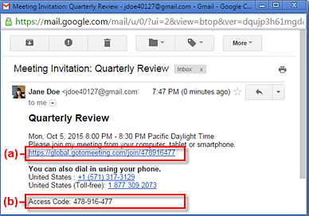
- Join using the meeting ID – option B
  - If you don’t have the join link or are having trouble being launched into session, you can join by manually entering the meeting ID (9-digit number) or meeting room name (e.g., https://gotomeet.me/lizdavis). This is included in the session invitation (shown as (b) in the image above).
  - If you are on a computer, open a web browser (google chrome is preferred) and go to www.gotomeeting.com/meeting/join-meeting. Enter the 9 – digit meeting ID or meeting room name in the field and click Join.
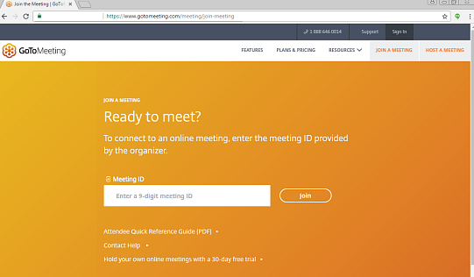
  - If you are on a mobile device, download the IOS OR Android app. Open the app and enter the meeting ID (9 – digit number) or meeting room name (e.g., https://gotomeet.me/lizdavis)
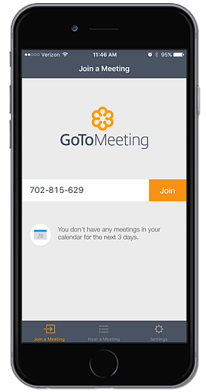

GoTo Meeting – Schedule
GoToMeeting is designed to make it easy for everyone to organize and participate in online meetings and training sessions eliminating the need for travel and social distancing. It also allows you to be more efficient and productive with your time. As an organizer, you have multiple options for scheduling your meeting. Do not schedule your meeting/training session more than 30 days out, as all meeting ID #’s expire 30 days after being created. Below you can learn how to schedule directly from our online account.
- Log into GoToMeeting
  - Username: Donna.burgei@kmtire.com
  - Password: kmtire965
- Click Create Meeting
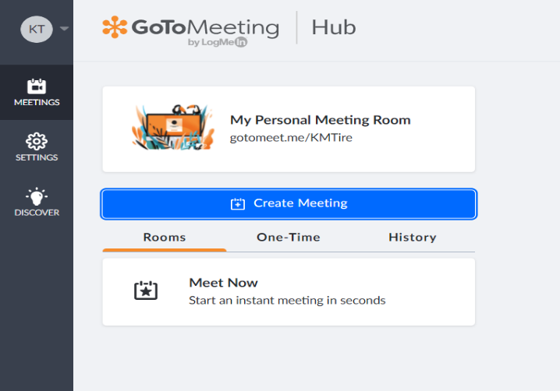
- Use the “New Meeting” window to specify the details for your new meeting.
- Online Meeting Room – You want to use the same meeting ID and link over and over again.
- One – Time Meeting – You want to host a single meeting on a certain day/time.
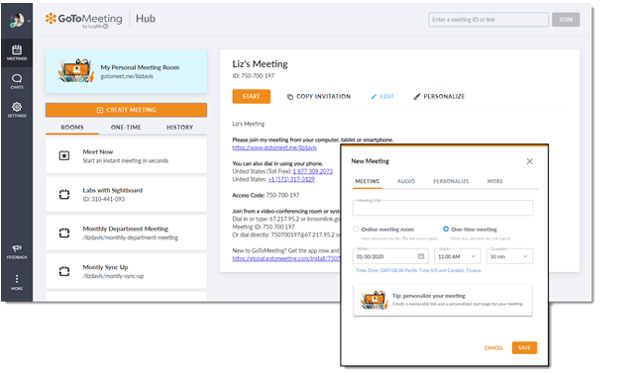

- Enter in meeting Title – this will be the subject of the meeting
- When (date)
- Time (start time)
- When scheduling a meeting, GoToMeeting automatically applies the “Default time zone” currently selected in the account settings.
- To change the time zone for a specific meeting, use the drop-down menu in the scheduling window.
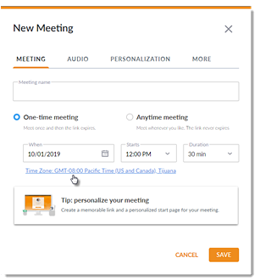
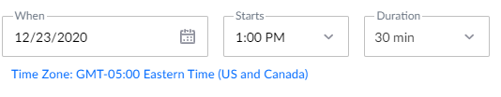
    - Duration (how long will the meeting last)
- Click Save when finished. The new meeting will then be immediately available in your upcoming meetings.
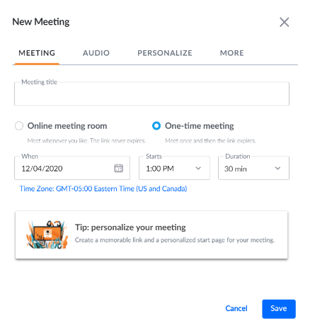
- In the meeting details, click Copy Invitation to copy the information to your clipboard and paste it into an email, calendar invitation. From this screen you can also edit a scheduled meeting any time before the start time.
  - If you decide to change the date and time of the meeting, remember to notify your attendees of the change – the easiest way to let your attendees know of any changes is to send out a new invitation email.

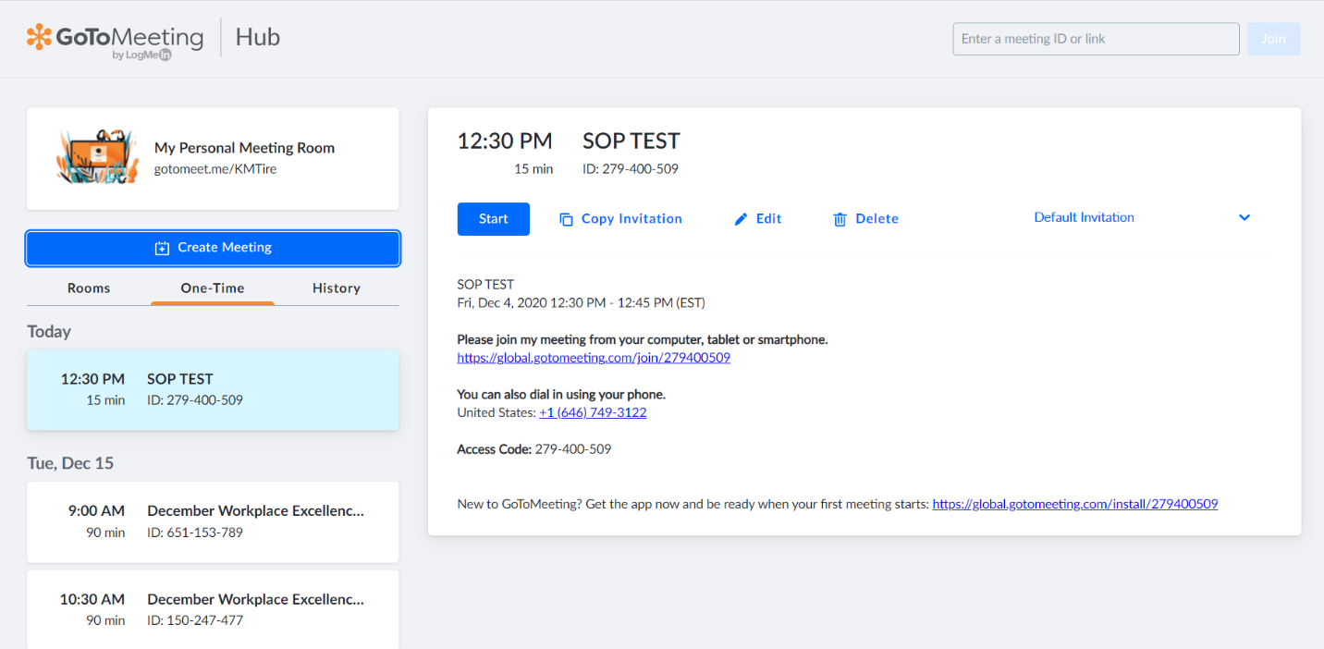

- When scheduling a meeting double check that there is not already a meeting set up for your time or date. You cannot have two scheduled meetings at the same time, if this happens one of the meetings will be kicked out and no longer able to use
- How to join a GoToMeeting
  - When you are invited to a meeting, there is usually a unique meeting link included in the session details. This is the Join link (marked as (a) below) – you can open it in any web browser to join the session.
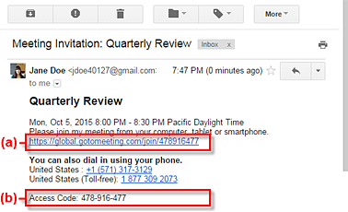
  - Once you click on the Join link, you can choose to download the desktop app or join using a browser.
- Join using the meeting ID (b) in above picture.
  - If you don’t have the Jon link or are having trouble being launched into session, you can join by manually entering the meeting ID (9 – digit number)
    - If you are on a computer, open a web browser and go to www.gotomeeting.com/meeting/joinmeeting. Enter the 9-digit meeting ID or meeting room name in the field and click Join.

    - If you are on a computer and have the desktop app installed, you can join by right – clicking the daisy icon in the system tray (Window) or toolbar (Mac), selecting Join and entering the Meeting ID or name.
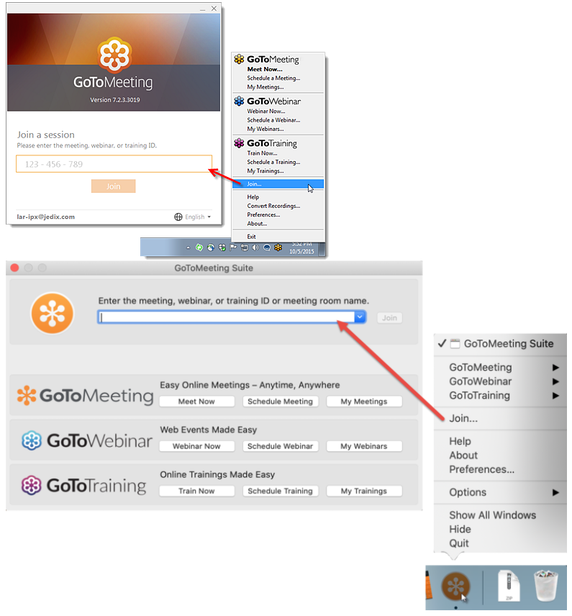

Invoicing for Items Being Put on Transfer Truck
To be able to track items sent on the transfer trucks that are too large for the blue transfer bags we run an invoice out of MaddenCo. Below are the steps to follow.

Creating an Invoice for Transfer Items
- Log into MaddenCo
- 1-Tire Dealer System, enter
- 8-Point of Sale Menu, enter
- 4-Counter Billing, enter
- Store Number will always be the store you are in (Ex: Delphos-Store 1) Field Exit, Enter
- F6-Starts a new invoice
- F6 again Assigns an invoice number
- On the customer number line, F4 allows you to do a search. For all K&M locations search by using ZZZLOC, enter. Page down until you find the location you are shipping to. Always chose the account for that location that says Transfer Stock.
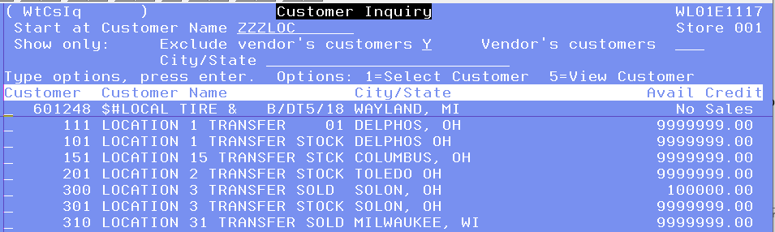
- Place a 1 on the line in front of the account you want to choose. Field Exit, then Enter. Enter again.
- It will then ask for your Sell Salesman. This is your salesman number you were assigned by IT when you started at K&M. If you do not know what it is, IT can help you with that. Field Exit and Enter.
- Product Code will be “Box” Field Exit, Enter
- Quantity will be 1, Field Exit and tab down to the Description Line and edit it to say what is in the box. Field Exit and Enter.

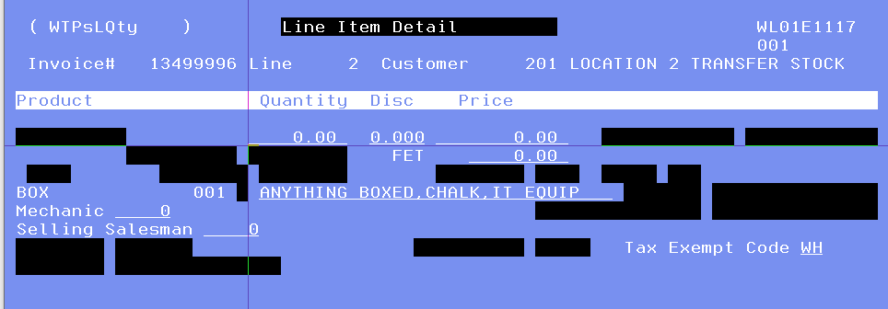
- F3 once to review your invoice. If all is correct F3 again and it will ask if you want to close the invoice. It defaults to Y for Yes, you hit Enter again and it shows that it is a ZERO-dollar invoice. Enter again will close and print the invoice. Tape this on top of the box you are shipping and it then needs to go down to the docks for the second shift guys to place on the transfer truck to be shipped

Daily Mail Routine

Mail Times
- At 8:45am mail is retrieved to be picked up by mail carrier.
- At 3:30 pm afternoon mail is retrieved to be delivered to post office.
- Any FedEx or UPS envelopes that are being sent out cannot be shipped to P.O. Boxes. Be sure to have the physical address.

Morning Mail Procedure
- Around 8:45 am walk back to the mail machine. Open the drawer that is labeled “Mail”.

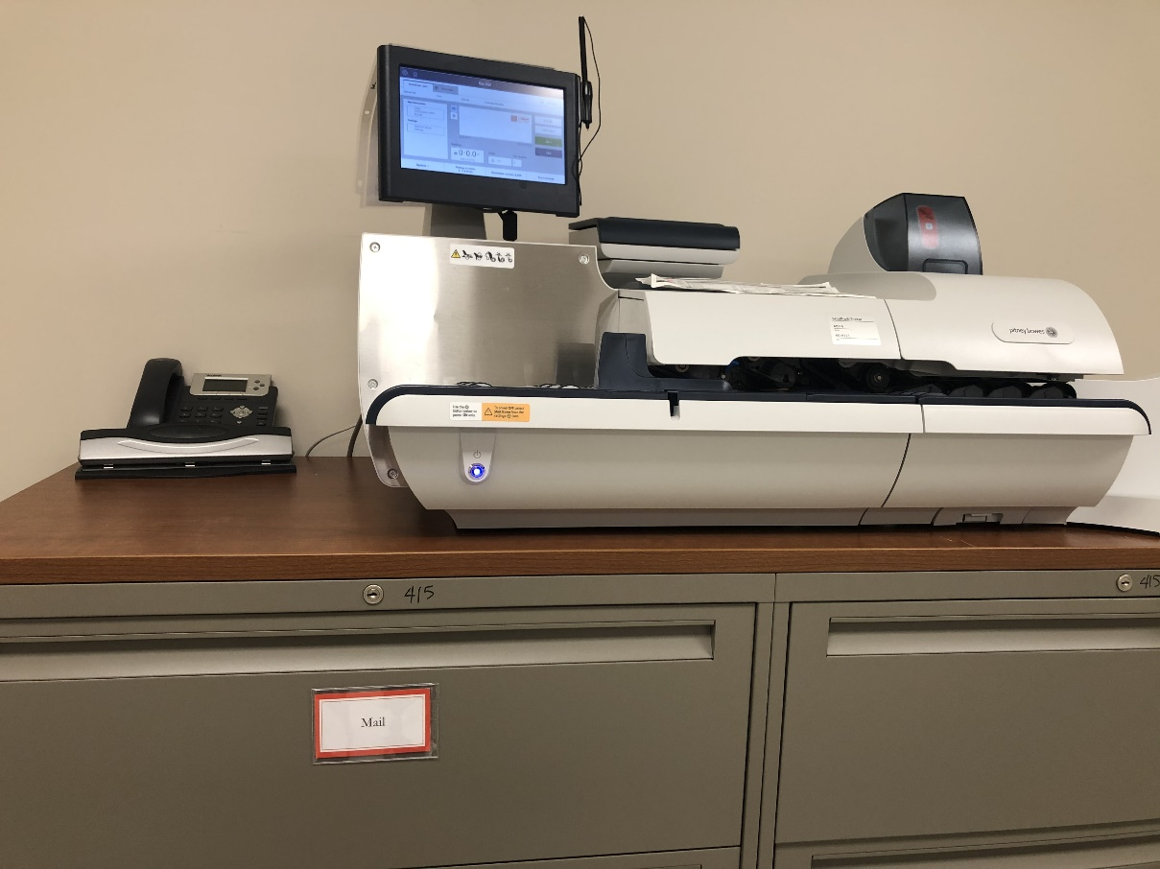
- Pull out all of the envelopes that are in the red tray and make sure they are:
- Sealed
- Have postage “Most common type of postage” see page – 7-8
    - *If postage is not on envelope, add postage.*
    - *If mail is not sealed or does not have postage, be sure to add postage and seal.*
- Once it is verified that all envelopes are sealed and have correct postage, take the mail up to the front. Place the mail between the two front lobby doors for pick up. You will find an outgoing mailbox on the table.

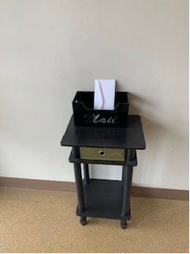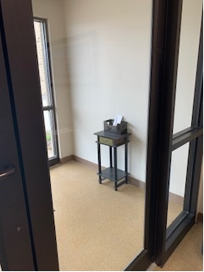

- USPS comes between 9:30-11:00 am to pick up the outgoing mail and drop off the incoming mail. Open all mail but first be sure to tap the envelopes down so whatever is inside the envelope doesn’t get cut along with the top of the envelope. Below is a picture of what the mail opener looks like and also a picture of how to place the envelopes for opening.

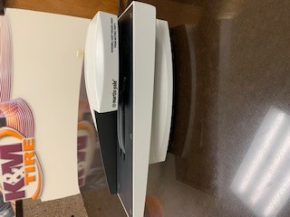
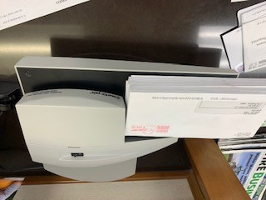

- Sort the Mail by the person / department it needs to go to.

Mail Disbursement
Credit and Collections
Certified mail
Bankruptcy
Return certified Slips.
Yellow return to sender (Unless HR sent, then give to HR)

National Accounts
Government Forms- Emily Coil
National Account Forms- Emily Coil

Human Resources
Payroll mail
Ohio Jobs and Family Services
Child Support
Workers Comp
Unemployment
Mass Mutual

Loc. 15- Columbus
My Tire Place -PO Box 514
Custom Cap & Tire
Credit cards/pin #’s for My Tire Place (Keith Schleper) Send an email

Accounts Payable Manger
New Credit Card and pin #
(cc: in email to employee)

Affiliates- Give to Donna
C Realty
CZ3 Holdings
KLD Realty
Langhals Air
Langhals Enterprise
LL Realty
Tribune
Fundraising

Accounts Payable
Invoices

Accounts Receivable
ALL Checks- Accounts Receivable

Staff Accountants
Chase
Wells Fargo
Huntington Bank

Logistics
All Vehicle Items/Tolls
Tribune- Anything dealing with vehicles.

Executive Vice President
IRS/Tax information for K&M Tire

- *When company credit cards arrive in the USPS morning mail delivery, distribute what was received to the recipient by mail or Fed Ex. Send an email to the recipient and ask them where they would like their credit card sent. Be sure to Cc the accounts payable manager onto the email being sent so they are also aware of the distribution.

- Afternoon Mail Routine Run – Around 3:30pm pull any mail that was put in the mail drawer throughout the day. Check to see if mail is stamped and sealed. If not see Mail Machine Procedure and this will show how to seal or put postage on.

- Once afternoon mail is collected from the mail drawer flip the sign down so nobody stamps anything else for the current day.

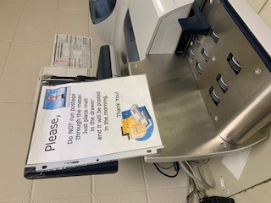

- Take all the mail to the front desk and put it in the black and red striped bag. The Accounts Receivable Supervisor will have bank bag(s) that will need dropped off at the bank on M/T/T/F, on Wednesday, bank bag(s) will be dropped off at the drive through (knock on the door and hand the bag to one of the two people that will be in there). (First Financial Bank corner of Main & Second Street) Put the bank bag(s) in the black and red striped bag also. The warehouse will also have a deposit bag they will drop off at the front desk. It will need to go to First Financial Bank.

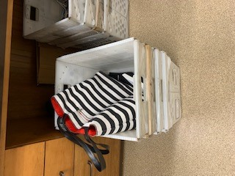

- At roughly 4:00 pm take the bank bag(s) to First Financial Bank on the corner of Main & Second Street and the mail to the post office. The bank is located on 202 N Main St, Delphos, OH 45833. Walk in and give the bank the blue zipped bag(s) from Accounts Receivable. The bank will have a bag to give back. Put the zipped bag back in the black and red striped bag. Go to the post office which is located at 127 N Main St, Delphos, OH 45833 and drop off any mail that needs to be mailed out. You can also drop the outgoing mail at the drop boxes located at the exit of the city parking lot that is next to the old firetruck in between Main Street and Canal Street. When you get back to the office take the blue bank bag(s) to Accounts Receivable and put the black and red striped bag back under the front desk.
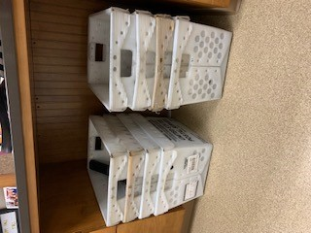
- *If you have a lot of mail that needs sent out put it all in a mail bin and take it around back of the post office and sit it on the brown table and ring the doorbell.

If there are any UPS or FedEx items that need sent out the drop box for both of those locations are below: Last daily pickup for both is 4:45 pm
UPS: Located on 230 E 2nd St. Delphos, Ohio 45833—next to The Premier Bank – Cannot ship to P.O. Box
FedEx: Located on 335 N Main St. Delphos, Ohio 45833—Next to Eagle Printing – Cannot ship to P.O. Box

- Most Common Types of Postage
- Certified Mail click on the “Open a job tab”.
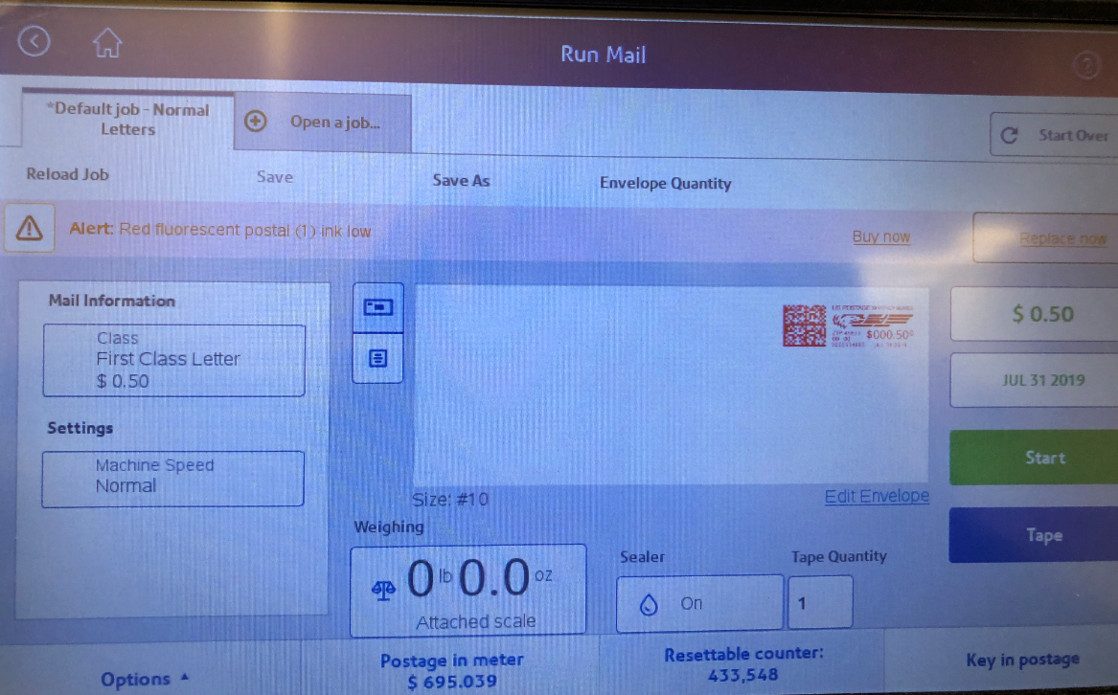

    - From the screen below choose “Certified” from the list. There are 2 pages of choices as shown below.
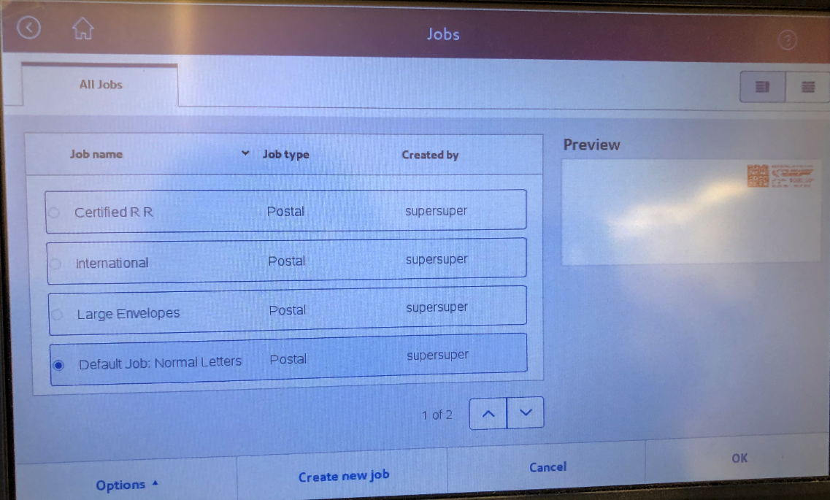

- Choose the desired postage option and choose ok, it will change the main screen to the correct price for the desired mail choice, then choose the “Tape” button and it will print the postage on a tape for you to put on the envelope.
    - Flat Rate Priority Mail labeled (Pro F R Env.) on the screen and follow the same steps.
    - Priority Flat Rate Legal Size envelopes that are not the same price as a regular flat rate envelope pricing is on the wall by the mail machine and highlighted.
    - Parcels can be chosen from this list as well. They are anything that is thicker than ¼” and can’t be bent at least 1” without damage. Decide if it’s a parcel and select the “Parcel” icon, then place on the scale to weigh it, the correct price will show on the screen. Print the postage on tape.
    - Postage stickers – When too many postage stickers are printed, lay them below the spot where postage stickers are printed out to be used for later envelopes.
    - Wrong $ amount of postage – When wrong postage amount is applied to an envelope, we have to ask the Post Office for a form to fill out for reimbursement. We are charged for every label that is printed and envelopes that is stamped.
    - Personal Mail – If mailing personal mail and need a stamp. That is allowed, you just need to pay the dollar amount of postage you use. There is a spot in the “mail drawer” to put your monies.
    - All postage increase will be updated automatically.

- When needing to add money to postage meter (machine will alert you when balance is $500.00) – contact admin department. Admin will add increments of $5,000.00. Send a mail to add funds to the Staff Accountant and ask for confirmation that it was done. Staff Accountant will then send an ACH payment to Pitney Bowes - postage amount will be added directly to the machine. See below. Be sure to always have an emergency back of $5,000.00 on the account.
- Select postage meter.
- 2. Select refill my meter - $ amount will automatically be uploaded.
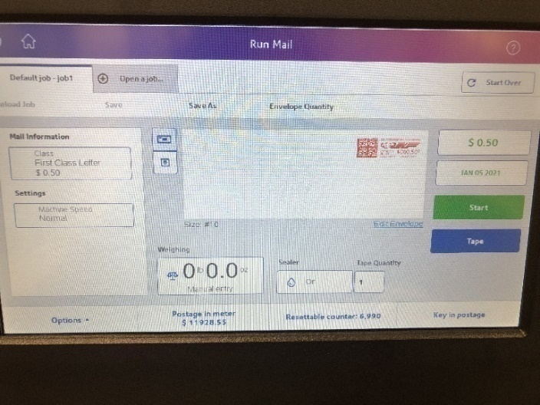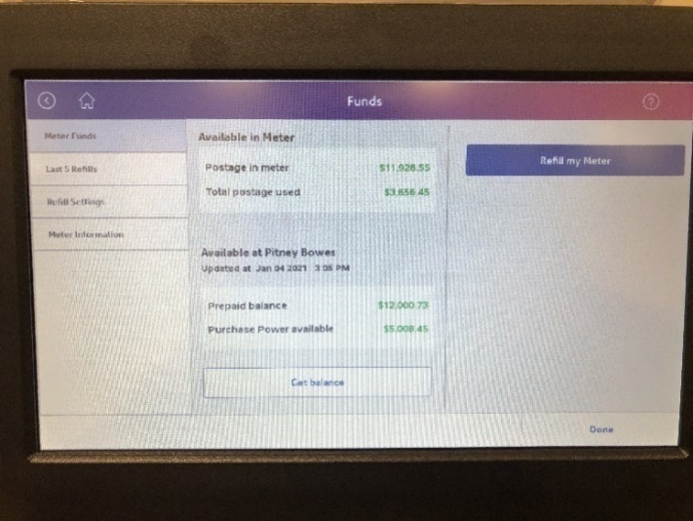

Mail Machine Routine

Procedures
- If the postage machine is not on press the power button. Located on the front, left side of the machine.
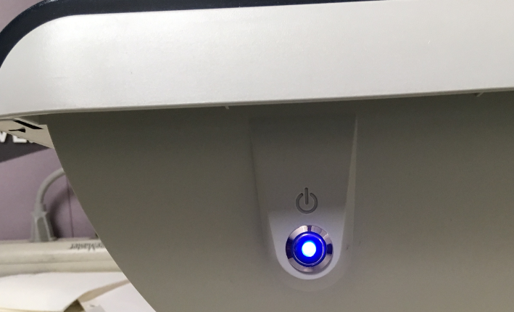
- The home screen (pictured below) will come up after a few minutes.
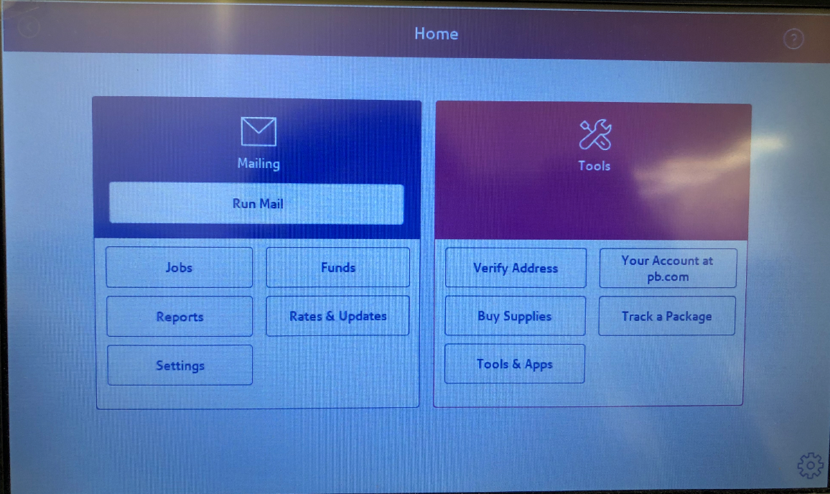
- To put postage on an envelope, choose the “Run Mail” icon. The next screen that comes up will look like the picture below.

- For a regular sized letter envelope that is an ounce or less it will need regular postage and sealed. Place the envelopes on the mail machine below and make sure the sealer is turned on.
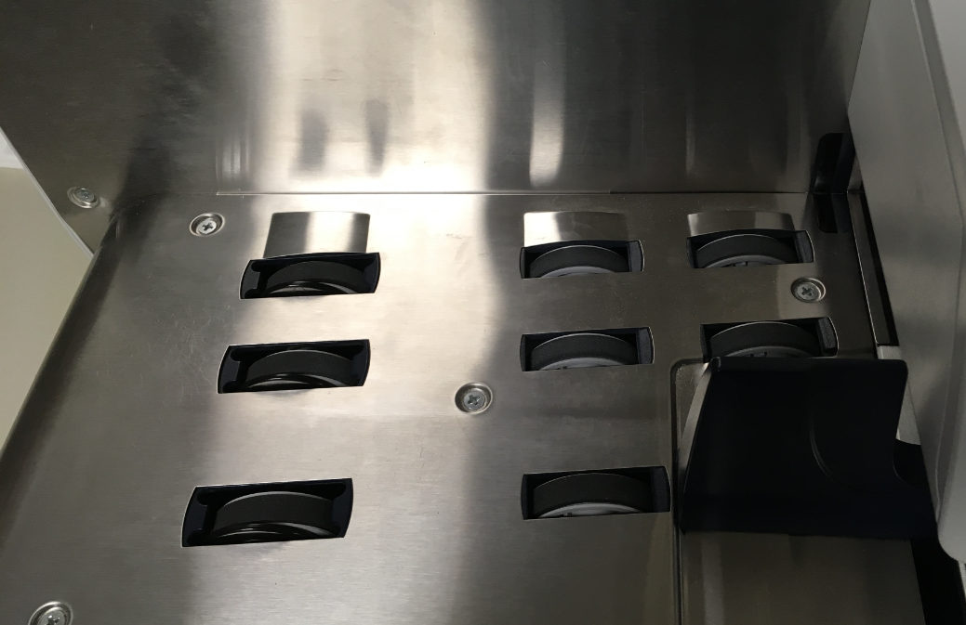
- Next choose the “Start” button

- Once the mail has all been run through choose the “Stop” button.
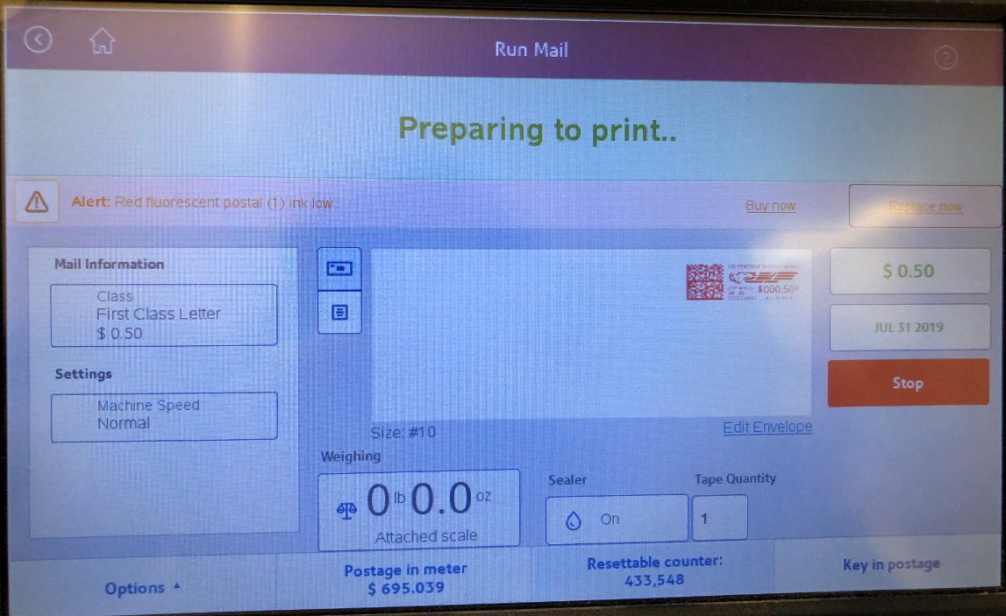
- If you have a regular size envelope that is an ounce or less that is already sealed choose the “Sealer” icon.


- Choose the “Sealing Off” icon, then choose the ok icon.
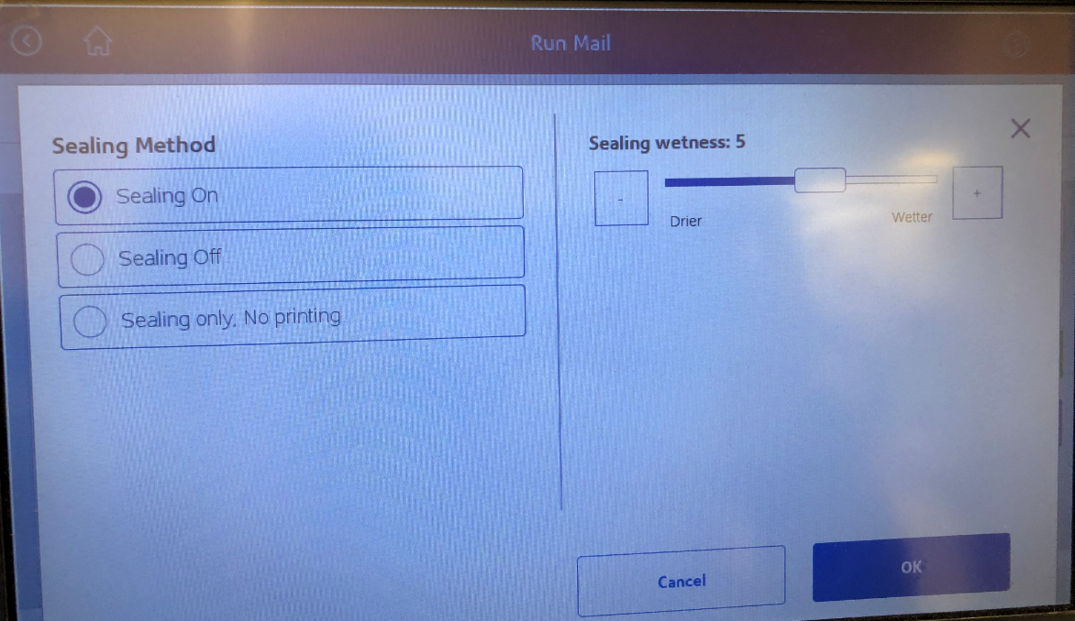
- How and when to add postage
- Run the mail in the steps above for a regular sized letter envelope of an ounce or less.
- If envelopes only need to be sealed, they can just be sealed without postage by choosing the “Sealer” icon as stated above and then choosing “Sealing only, No printing” from the picture above then click ok.
- For a regular sized letter envelope, that weighs more than an ounce place it on the scale pictured below.
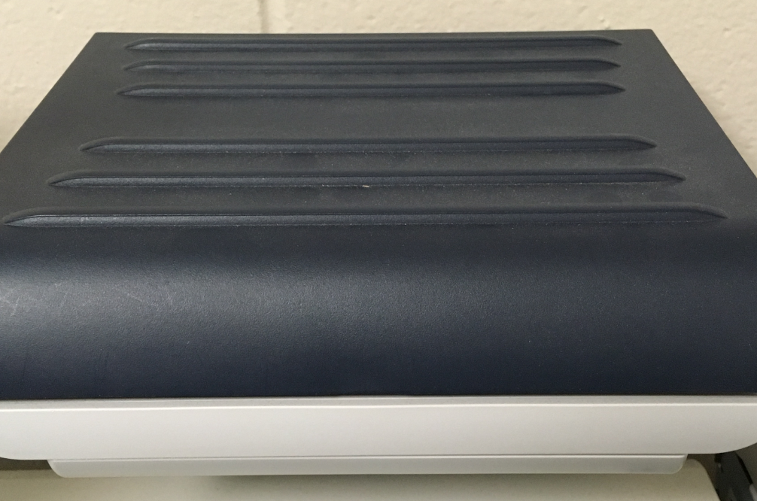

- Large Envelopes such as K&M manila envelopes, choose the class button.

    - The below screen will come up, choose the large envelope, and then choose ok.
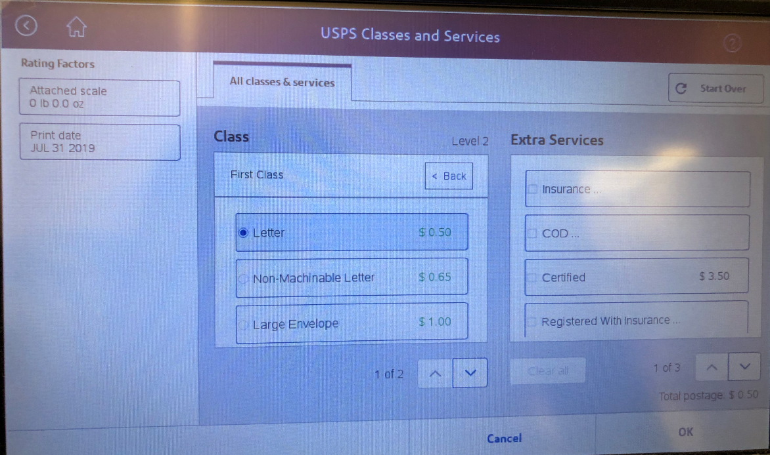
    - Place the envelope on the scale and it will change the postage to the correct price. If it needs sealed make sure the sealer is on, if not turn the sealer off. If it is too thick choose to print the postage out on a tape by choosing the “Tape” button pictured below.

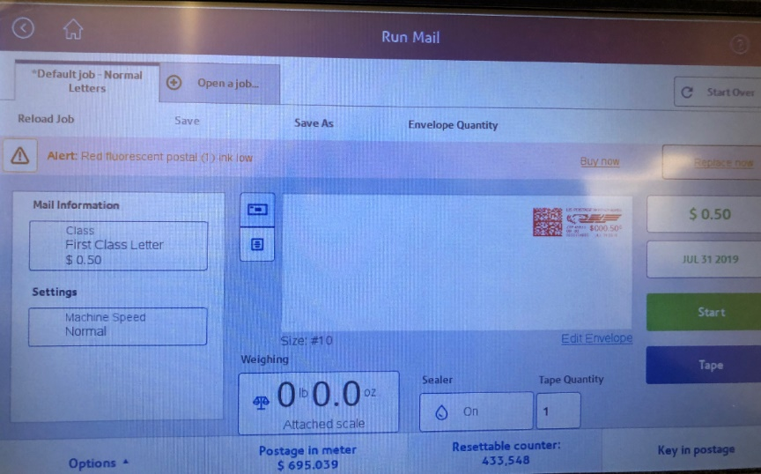
- Most Common Types of Postage
- Certified Mail click on the “Open a job tab”.

    - From the screen below choose “Certified” from the list. There are 2 pages of choices as shown below.

    - Choose the desired postage option and choose ok, it will change the main screen to the correct price for the desired mail choice, then choose the “Tape” button and it will print the postage on a tape for you to put on the envelope.
    - Flat Rate Priority Mail labeled (Pro F R Env.) on the screen and follow the same steps.
    - Priority Flat Rate Legal Size envelopes that are not the same price as a regular flat rate envelope pricing is on the wall by the mail machine and highlighted.
    - Parcels can be chosen from this list as well. They are anything that is thicker than ¼” and can’t be bent at least 1” without damage. Decide if it’s a parcel and select the “Parcel” icon, then place on the scale to weigh it, the correct price will show on the screen. Print the postage on tape.
    - Postage stickers – When too many postage stickers are printed, lay them below the spot where postage stickers are printed out to be used for later envelopes.
    - Wrong $ amount of postage – When wrong postage amount is applied to an envelope, we have to ask the Post Office for a form to fill out for reimbursement. We are charged for every label that is printed and envelopes that is stamped.
- Personal Mail – If mailing personal mail and need a stamp. That is allowed, you just need to pay the dollar amount of postage you use. There is a spot in the “mail drawer” to put your monies.
    - All postage increase will be updated automatically.
    - Fed Ex & UPS are mailing options as well.
    - Both require a physical address (No PO Box)

Refill Red Ink on Postal Machine
Login to Pitney Bowes to order red ink-https://www.pitneybowes.us/signin/logon.go?request_locale=en_US#/account/login
Username: Donna.burgei@kmtire.com
Password: 237609Jz
When ordering new red ink for postal machine- 787-1

- Open lid located on the side of the machine.
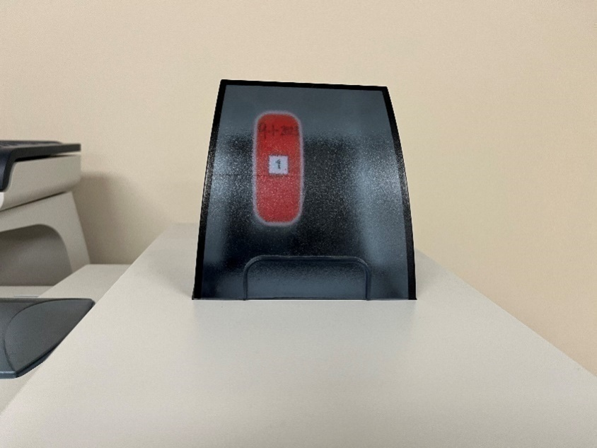

- Pull the old ink cartridge out of machine.
- Open the new cartridge from the pastic bag.
- Write the date on the front of the cartridge. As shown below.

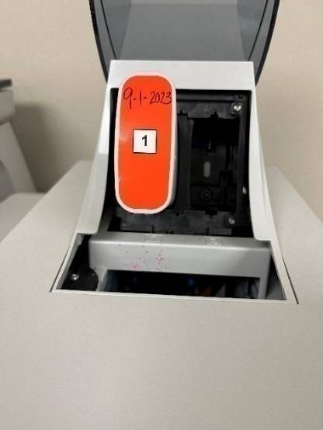

- Match the bottom of the cartridge to the insert on the machine.(The number should be facing you.)
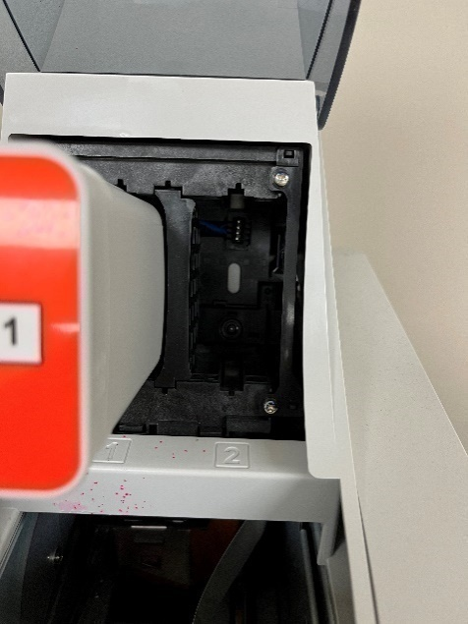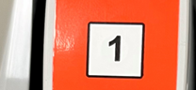

- Push in the ink cartridge until you hear a click then the machine will make a running sound.
- Close the top lid.

Trouble Shooting
- How to fix a jam: open door and slowly and lightly pull-out jammed envelope.
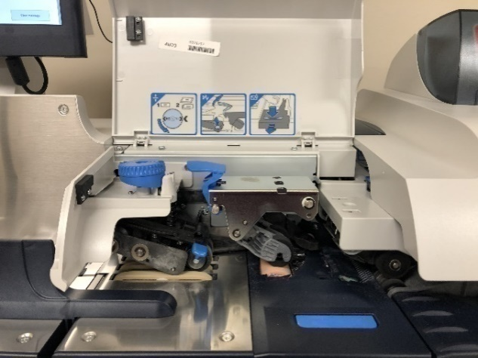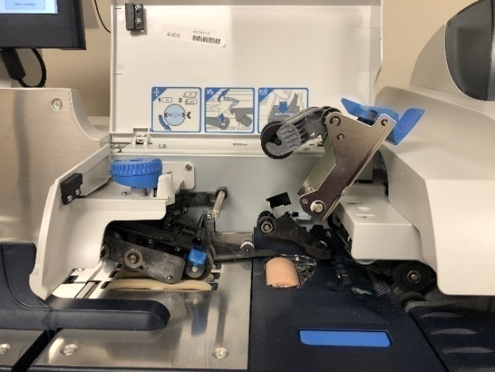
- If the envelope prints without postage:
  - If the envelope is not sealed, run the envelope back through the machine.
  - If the envelope is sealed you have two options.
    - Use an extra printed postage sticker (if there is one)
    - Turn off “Sealer” and run envelope through.
  - If the machine needs ink, contact the admin department. Admin will install a new ink cartridge.
  - If there are any service issues bring issues to the Admin Departments attention.

Certified Mail
- To send certified mail you will need the below forms.
- The forms are in the top draw under the postal machine.
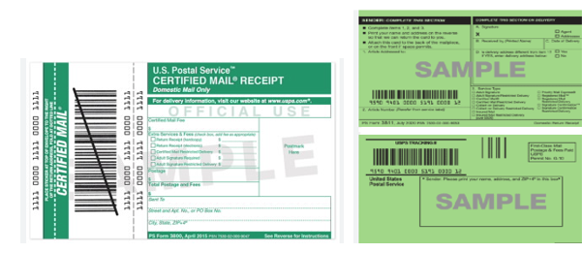
What steps to take when sending out certified mail on postal machine.

- Mail Information

a. Click on first class letters.

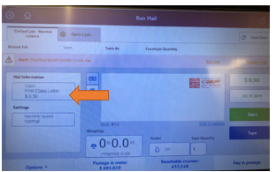

- Pick the correct size of envelope that is being sent.

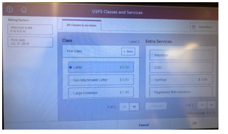
- For envelopes that weigh more than an ounce, place it on the scale pictured below.

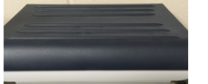

- After the weight has been completed. Click on extra services and hit Certified Mail $4.40 fee for any size of envelope being sent. When it is completed, it will look like the picture below.
    - If the person sending the certified mail is wanting a mailing receipt, it will be in the same location under “extra services.”

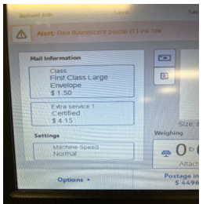

- Print or run envelope through postal machine.

How to fill out certified mail forms
1. U.S. Postal Service Certified Mail Receipt (White and Green Form)
  - Fill in Certified mail fee $4.40.
    - That amount is the same for every size of envelope.
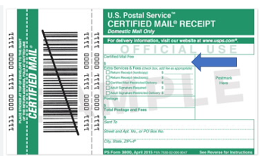

  - Extra Services & fees- If sender is wanting a return receipt, add $3.66 on the line and check the box.

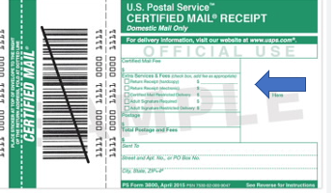

  - Postage- After weighing envelope, write the amount on the line.
  - Total Postage and fees- Add all amounts together to get total.
  - Sent to- Fill out the persons information.

- Domestic Return Receipt form (Green form)
    - If the person sending out the mail doesn’t want a receipt back this form is not needed.

  - Article Addressed- fill in person’s mailing address.

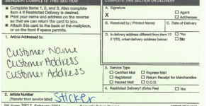

  - “Sender’s name”- Fill in sender name and address.
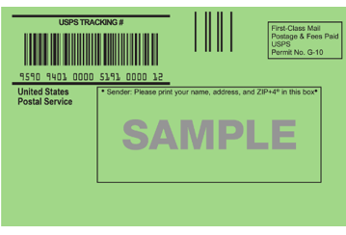
  - Article Number- Sticker located on certified mailing receipt (white and green form) needs to be transferred from service label. As shown on the picture below.
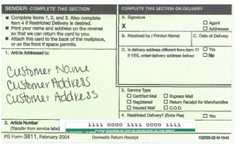

  - Service type- Check the Certified Mail and Return Receipt

  - Sender- Fill in K&M Tires address.

K&M Tire
P.O. Box 279
Delphos, Ohio 45833

- How to attach forms to envelopes

  - Certified mail- goes in the middle of the envelope with the scan code in front. Fold at the top on the dotted line.
    - Note: Be sure that the form is not covering the postage stamp or the return address.

  - Return receipts- Place at the top, on the back of the envelope.

Monthly Newsletter
Each month a company newsletter is designed for the viewing of the company staff. The newsletter is distributed to keep all employees informed of changes and upcoming news/celebrations (ex: Spotlight Article, WISE Installs, Company Updates, Safety Message, Word of the Month, Insurance Information, Accomplishments, Employee of the Month and a Birthday, Anniversary and New Hire list.

Newsletter Purpose and Structure
- The front-page Spotlight Article is theme based for the year. (Ex: department highlight, location highlight, etc.)

- When possible, the newsletter is completed by the 20th of each month so it can be reviewed by the Admin Executive Assistant before sending to the President for the final review and approval.
- The newsletter should be approved by the President and printed in color on 11x17 paper by Tuesday of the week that the newsletter will be sent to warehouses.

First Day of Each Month (Sending)
- Send a PDF of the newsletter to the Company Email List and be sure to Cc Jeff House jhouse@chaplain.org

- Ask Marrae Prowant to post the Newsletter on Paylocity.

- Print the new newsletter to hang in all corporate bathroom stalls. (20 one sided card stock printouts) **Print; HR Color, Portrait, One sided, Bypass Tray, Photo**

First Day of Each Month ( Composing)
- Send an email to the “Company Email List” encouraging outstanding employee nominations and information from employees within the company for important topics they would like to suggest be included (announcements, weight loss accomplishments, marriage, etc.). In the email, include a date you would like to receive this information by. Typically, use a date that is 1 week prior to the date you want to have the newsletter completed by so you have enough time to create the articles. Email Example below:
- Good morning,

If there is an employee who you would like to nominate as an Outstanding Employee for the newsletter, please send the information to me by
September, 14th 2020. (Be sure to update the month date and year)

Also, please send us any other story items from your location that could be included in the newsletter. Examples include the following:
Birth announcement
Wedding announcement
Family milestone
Human interest story
Smoking cessation story
Weight loss accomplishment
Graduation Announcements
We are proud of the employees who work at K&M and we want to share your stories!! Warehouse Managers: Please post this near your time clock or on your communication board so employees who do not have an email account are also able to include information in the newsletter. *

Outstanding Employee Nominations
- If an employee is nominated for Outstanding Employee and the nomination was not submitted by their manager, be sure to email their manager to ask for approval to include the info in the next newsletter.
- On the last Monday of the month, print the “Outstanding Employee Letter” (after inserting the employee’s name and the newsletter month) and send it in an envelope to the employee along with one token (use company transfer if the employee is from another location).
- Anyone who is nominated as Outstanding Employee should be logged on the “Outstanding Employees by Month” spreadsheet. \..\..\Human Resources\Newsletter\Outstanding Employee\Outstanding Employees by Month.xlsx
- Send an email to the appropriate person to gather information to write the front-page Spotlight article.
    - Request that they send you all the information/pictures they can provide to write an informed article.

Completing The Newsletter
- Open the most recent newsletter in Publisher (..\..\..\Human Resources\Newsletter ).
For example, if you’re about to begin working on December’s newsletter, you’ll open November’s newsletter in Publisher.
- Change the Volume & Issue numbers (top corner(s) to the appropriate numbers (Volume # changes when the year changes; Issue # should be the number of the month)
- Change the month (top, corner(s) to the appropriate month.
- Save the document as the appropriate month in that month’s newsletter folder.
For example, if you’re working on January’s newsletter, you’ll want to save the document as “January Newsletter” at ..\..\..\Human Resources\Newsletter\2021\01-2021
- Prioritize the topics you’ll be writing articles about and begin with the most important.
- The Associate Director of Communication will provide information regarding the Word of the Month for each newsletter.
- Safety Support Manager, will provide information for the Safety Message for each newsletter.
- The K&M Cares team will provide an article for every newsletter. This article will come from a representative of the board.

- Human Resources will provide you with reports (15th of the month) that list New Hires, Work Anniversaries and Birthdays. This information should be included on the last page of the newsletter. – be sure to email HR a few days before the 15th for a reminder.
- Each quarter, include a Location Safety Achievement article. All locations that had no at-fault vehicle accidents and work-related injuries should be included.

- Email Logistics for any locations with no at-fault accidents
- Email HR for any locations with no work-related injuries
- Fill in the Certificates for applicable locations & email to ROM’s of locations so they can give them to the Manager

- Human Resources will also send any articles they feel should be included because of its’ importance to employees to be aware of such as: insurance info, wellness requirements, 401k enrollment, holiday schedules/pay, etc. A gentle reminder - Last December you included something about “Profit Sharing” is appreciated.

- IT will provide a monthly insert.

- If space allows in the newsletter, try to include articles regarding employee benefits such as: Employee Purchase Program, Employee Referral Program, Company Discounts and Suggestions Program.

- If any important company announcements are sent out or there are important company events, include an article about them in the newsletter. (Ex: opening new locations, Trade Show, Dealer Trip, etc.)
- When you’re finished completing the first draft of the newsletter, email it to the VP of HR and Admin Executive Assistant manager as a PDF file. Make any recommended changes.
- Once it has been approved by VP of HR and Admin Executive Assistant manager, email it to the President for her final approval. Make any recommended changes. If there are major changes, resend to President for approval. If changes are small, it is not necessary to re-send to her.

- Also save the newsletter in PDF form to ..\..\..\Human Resources\Public\Newsletters\2021\01-2021 Newsletter.pdf

- Once newsletter is approved you will print copies and send to each warehouse **Print publisher newsletter; Printer type; HR color; Printer Properties; My tab: original orientation (Landscape), Orginal Size (11x17), Print type (2-sided); Layout tab: Print Type (2-sded); Finish Tab: Select Fold (Half -Fold (by copy job); Quality: Color Settings (Photo); OK; PRINT as many copies needed**.
  - Before printing newsletter contact Marrae Prowant and ask for an employee count for each location. The number of paper newsletters to be sent to each location should be half the amount of employees in that location, or less.
  - Print the correct amount.
  - You will then send newsletters in interoffice envelopes on transfer to each location.

- K&M Tire PMS colors (These are the colors to choose to get the K&M orange & purple)
- Orange – 1665C
- Purple – 262C
- Admini

Morning Error Log Report
The error log (SYERRP151001) is a report generated through MaddenCo during the nightly update. Accounts Receivable will email Admin@kmtire.com (Administrative Assistant’s department) the report each morning. The report provides a list of potential issues from the prior day’s entries into MaddenCo. The report needs reviewed, and potential issues need to be sent to the proper departments for further review.

Analyzing the Error Log

- The error log will consist of (sometimes multiple) pages that look like this:

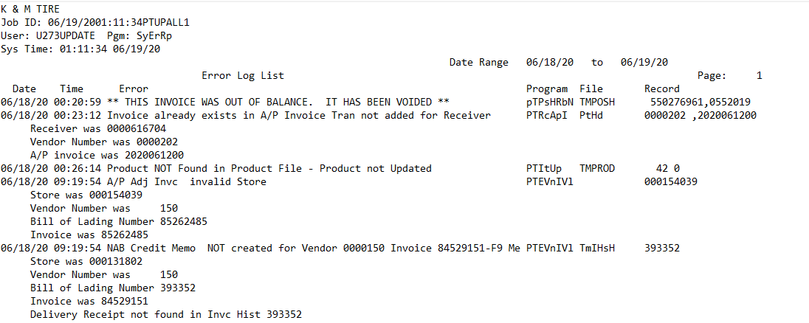

- Each line beginning with a date is a new potential issue. The below list tells you what messages that do not need any action:

Error Message | Action
(Anything with) NAB | Ignore
(Anything with) Inventory | Ignore
A/R Remittance | Ignore
Broadcast Change Status to Delete | Ignore
EOM (or End of Month) | Ignore
EOY (or End of Year) | Ignore
Error occurred in the transfer of [code], no customer info updated | Ignore
Error occurred in the transfer of [code], no customer special instructions | Ignore
Error occurred in transfer of [code], no delivery receipt rejects proc | Ignore
File could not be cleared | Ignore
File Created Empty | Ignore
Key Not found intCO Receiver not created | Ignore
NAB or AP invoice already exists | Ignore
No Action Required | Ignore
Product number change ran. See report.
Vendor Invoices have FAILED edit validation, use work with option to R | Ignore

- The list below tells what to do for specific error messages:

Error Message | Action
######### Order not closed, Invalid Tender | Give copy to Inside Sales Manager
(Anything with) ASN Receiver | Give copy of page to AP Supervisor with line highlighted
(Anything with) FTP / User Profile | Email IT Systems and Network Support Representative
**INVOICE CONTAINS DUPLICATE LINES. IT HAS BEEN VOIDED**  **INVOICE WAS OUT OF BALANCE. IT HAS BEEN VOIDED. ** | Give a copy to Inside Sales Manager.
Anything dealing with GL | Give copy to Controller and cc: Executive Vice President
Anything with GL Master Record | Give copy to Controller and cc: Executive Vice President
Attempt to Update M with L | Give copy to Inside Sales Manager
Backorders canceled on order. | Give copy to Inside Sales Manager and Assistant Sales Manger
Sales Tax control Key | Give copy to the Controller and cc: Executive Vice President
Control key GLS missing or invalid | Give copy to the Controller and cc: Executive Vice President
Duplicate invoice for Vendor in A/P master | Give copy to the AP Supervisor with line highlighted
Invoice contains duplicate lines. It has been voided. | Give copy to Inside Sales Manager & Assistant Manager with the Invoice Number (located in the top far right corner) and the Customer Number (located along the left side of the page)
Invoice exists in AP invoice tran not added for receiver | Give copy to AP Supervisor with line highlighted
Load Sheet Processing: Order skipped… Customer is over their credit limit | Give copy to Inside Sales Manager & Assistant Manager with the Invoice Number (located in the top far right corner) and the Customer Number (located along the left side of the page)
This invoice was in use. It has been voided | Email Inside Sales Manager & Assistant Manager with the Invoice Number (located in the top far right corner) and the Customer Number (located along the left side of the page)
Workorder IN USE reset to active workorder | Look Invoice up in MaddenCo:  If Invoice isn't closed in MaddenCo (or is, but it's a voided invoice) Email Inside Sales Manager & Assistant Manager with the Invoice Number (located in the top far right corner) and the Customer Number (located along the left side of the page)
Backorders canceled on order | Email Inside Sales Manager and Assistant Sales Manager.
Workorder IN USE reset to available | Look up invoice in MaddenCo:  If Invoice isn't closed in MaddenCo (or is, but it's a voided invoice) Email Inside Sales Manager & Assistant Manager with the Invoice Number (located in the top far right corner) and the Customer Number (located along the left side of the page)
Broadcasting Change Status to Delete, Invalid with Inventory On – Hand | Give to Dave German - Purchasing & Pricing Supervisor
Product NOT found in product file - product not updated | Give to Mark Knippen (VP of Purchasing) and Dave German (P&P Supervisor)

- If a new message shows up that is not listed, check with your supervisor or the Director of Finance to make sure it is not something that will affect the daily business for a different department.

- Some of these “Actions” require an email to be sent if an invoice has not closed in MaddenCo. To figure out if the invoice is closed in MaddenCo, first open the program by clicking the below icon from your desktop:

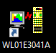

- Once logged into MaddenCo, click enter until you reach this screen:

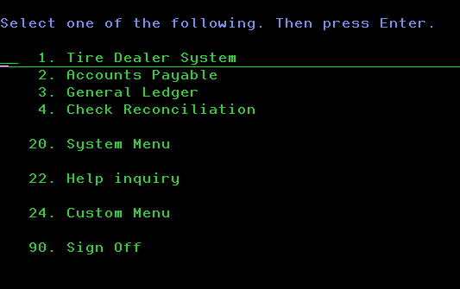

- Click the “escape” key on your keyboard. This will pop up the operations window which looks like this:

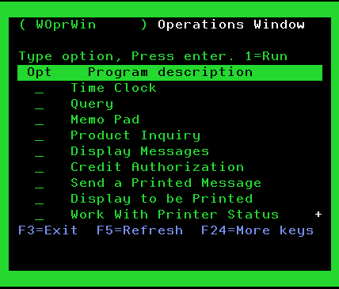

- Hit “page down” on the keyboard until “Invoice History Inquiry” is located. Place a “1” on the line:

- Hit enter. This brings up the below screen: Input the Store #000 for all locations to be searched.

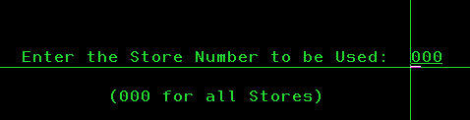

- Hit enter. This will bring up the below screen:

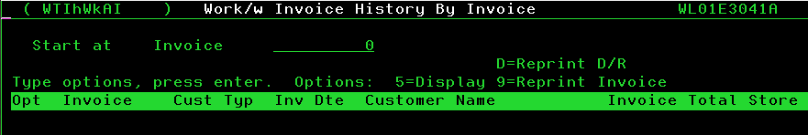

- Enter the invoice number from the report on this line, then click the “+” key from the 10-key section of your keyboard (this key is referred to as a “field exit” in MaddenCo and it will clear out anything behind the last typed number and bring the entry to the end of the line).
- Hit enter. MaddenCo will pull up existing invoices in chronological order starting with the invoice number entered. If the invoice number entered does not exist in MaddenCo, the first invoice listed will be the next sequential number after the entry.
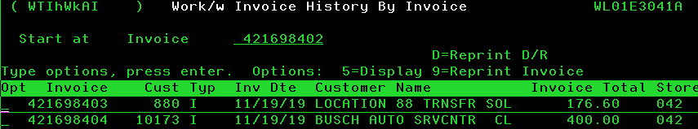

If the invoice you entered has been voided, you will be able to tell by this little “V”:
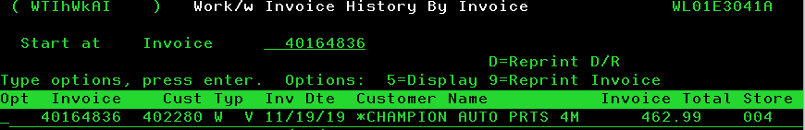

    - Highlight the error message if there is a “V” or the invoice number is not there at all.

- An Error Log Email will be sent out daily to all of the departments that have a specific error message (detailed above).

    - Once completed, place this report in the file that is stored in the Morning Report drawer in the admin office. The current month’s “Error Log” is filed accordingly with the current month’s “A/R Balance register” and current month’s “Daily Sales Update” in a folder in the drawer labeled “Morning Report”.
    - 60 days of “Error Log”, “A/R Balance Register” and “Daily Sales Update Report” retention is filed accordingly in a separate folder in the Morning Report drawer and then recycled.

Error Log Email
- An email will be sent out Monday through Friday to all the Department VP’s, Directors, Managers or Supervisors that need to address an Error message in the Morning Report. On Monday the Morning Report will include Friday, Saturday, and Sunday’s reports.
- On the 1st of the month, you should receive two reports for the A/R Balance Register. The second one will be the adjustment for service charges for any accounts that are past due at the month end. We will receive this information from the Accounts Receivable Team Lead. If the service charges are not found in the report, ask the controller to follow up with the Accounts Receivable Team Lead.
- You can set up a quick step for your Error Log email:

- Please follow the guidelines for Highlighting the Error Messages:
    - Pink – A/P Invoices
    - Orange – IT Support Supervisor
    - Blue – Inside Sales Manager/Assistant Inside Sales Manager
    - Yellow – Inside Sales Manager
    - Green –Controller and cc: Exec. Vice President
    - Purple – VP of Purchasing/Purchasing and Pricing Supervisor
- See example below of the Error Log Email and corresponding attachment:

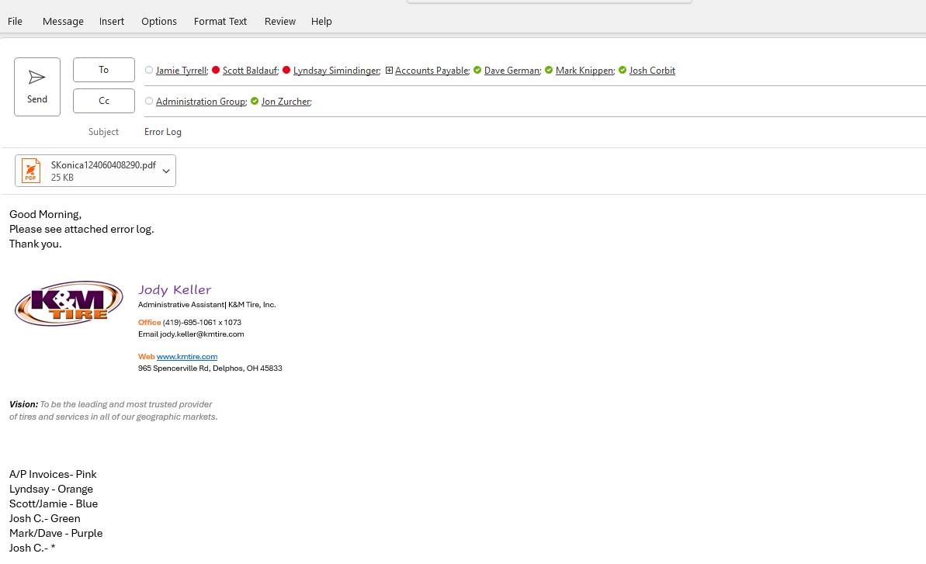

    - Attachment example:

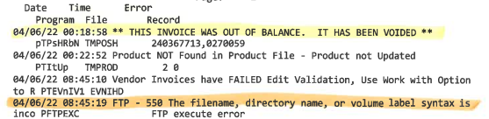

Office Supply Order – Passwords – Websites
Office supplies are ordered from various companies.
Follow up on all ordered items, be sure items have been received.
Amazon
Birthday/Anniversary - Part # (C0198)
- Order 6 boxes when needed
Amazon Business Prime
Ryan Cohen - rycohen@amazon.com
- Username: Joni.zerkel@kmtire.com
- Password: 237609Jz

Avery
https://www.avery.com/
- Username: Admin@kmtire.com
- Password: Kmtire1970
BrandCrowd
https://www.brandcrowd.com/logo-maker
- Username: joni.zerkel@kmktire.com
- Password: 237609Jz
Canva
https://www.canva.com/
- Username: rene.metzner@kmtire.com
- Password: kmtire1970
CDW
https://www.cdw.com/
Maintenance Kits for printers are ordered from CDW. You can find all kit models here: F:/InformationTechnology/Public/PrinterToner
- Username: accountspayable@kmtire.com
- Password: Zerke!1070
**When checking out you need to provide a PO#.
Example: Loc. ## - Maintenance Kit
Delta Sky Bonus
https://skybonus.delta.com/content/skybonus/corporate/us/en/home.html
- Username: Kmtire
- Password: Kmtire965
FEDEX Supplies
https://www.fedex.com/en-us/home.html
Fedex labels and built-in pouch envelopes are purchased here. Order qty. 25-50
Envelopes with built-in pouch 9 ½ x 12 ½ - Part # 155475
Fedex US Package Airbill (Preprinted) labels - Part # 163134
- Username: kmtire
- Password: Happy2day
2 Day FedEx Shipments (Express) From Website
https://www.fedex.com
- Username: kmtire1135
- Password: Welcome1$
Friends Office
Kassandra Price - kassandra@friendsoffice.com - 8000-427-1704 ext. 1021
- Username: joni.zerkel@kmtire.com
- Password: 237609Jz
Grammarly
www.grammarly.com
- Username: admin@kmtire.com
- Password: 237609Jz
Litho Printing
lithoprinters@lithoprinters.net
When you get down to 2 boxes with any forms, order 2 boxes of the ones you are low on.
- K&M scratch pads
- Sorry I missed you sticky notes
- Manilla K&M return address envelopes
- White window K&M return address envelopes and non-window (Make sure there are 8 cases of Window envelopes for statement day which is the last week of the month.)
- Adjustment forms, Return forms, Limited warranty claim forms.
LucidChart
https://www.app.lucidchard.com/
- Username: joni.zerkel@kmtire.com
- Password: 237609Jz
O’Reilly
https://www.firstcallonline.com/FirstCallOnline/
Brian Holdcraft - bholdcraft@oreillyauto.com
- Username: km1558360
- Password: kmtire1790
- Security Question: Wisewell

Perry Protech
https://www.perryprotech.com/servicemeters/supply-request
Email: CCC-supplies@perryprotech.com- ccc-servicerequests@perryprotech.com
Account Manager: Scott Hittepole (419)-879-9848
Most Corporate office printers are on a service contract with Perry Pro Tech. They will send toner when needed. If toner would not arrive see below for Printer Model numbers:
- Konica 3 - Accounts Receivable – #J7176
- Konica 4 - Accounts Payable –# M4730
- Konica 5 -Human Resources #M8222 / you will order Magenta, Cyan, Yellow, and Black.
- Konica 1 - Purchasing and Pricing - #G7196
- Konica 6 – Sales – J7175/ 458e
- Konica 7 – Marketing Color – C458
- Konica 8 – Marketing B&W – 454e
- Warehouse 1 Scanner-M6403
  - Invoice printer-M5592
Service request for printers - https://www.perryprotech.com/service-request
Pitney Bowes
https://www.pitneybowes.com/us
- Username: joni.zerkel@kmtire.com
- Password: 237609Jz
- Red ink for postage machine:
- Tape for machine
- Be sure to keep gallon water in the drawer at ALL times (this is for sealer) can be purchased at dollar stores.
PosterMyWall
https://www.postermywall.com/index.php/poster/mine#/designs
- Username: joni.zerkel@kmtire.com
- Password: 237609Jz
Quill Office Supply
Kennedy Bryant – kennedy.bryant@Quill.com – Customer Service 1-877-413-0011

End of year file folders and banker boxes:
- 3 / 12 box banker boxes - order # 00703 (3 boxes)
- 3 ½ Expansion heavy duty file pockets: Reorder # - 7C1524 / Product - # 901-7C1524 (Quill Brand)
- 5 ¼ Expansion heavy duty file pockets: Reorder # 7Q1534 / Product - #901-7Q1534 (Quill Brand)
- Heavy duty 2 ply file folders - Reorder # -710434 / Product # - 901-710434 (Quill Brand)
Items to keep in supply closet at all times:
- Keep three boxes of file folders in the supply closet and one in supply draw at all times.
- Keep two boxes of blank non window envelopes at all times.
- 4 boxes of each brand and color of pens in bins at all times.
All office supplies for each location are ordered from https://www.quill.com/ - Email will be sent out every Tuesday morning to all location warehouse managers. Example of email below:
Good morning,
If you are in need of office supplies for your location, please send me (your name) your request by Thursday, 0/00/0000.
Thank you.
Smart Signs
https://www.smartsigns.com/
- Username: Emily.coil@kmtire.com
- Password: leters1
Uline
https://www.uline.com/
- Username: joni.zerkel@kmtire.com
- Password: 237609Jz
- Zip handle bags - 3 Mil, 13x18”, Clear - Model # S-10713C / These are used for employee uniforms.
- Employee jacket bags -2 Mil, 18x24”, Clear - Model # S-10824
- Order 1 box as needed.
USPS
https://www.usps.com/
- Username- K&MTIRE
- Zerke!1070
Select Postal Store to order supplies or go to activity history under name.
Items ordered from USPS website:
- Dual: use priority mail / Priority mail express tubes - size medium and small.
- Priority Mail Legal Flat Rate Envelopes (SKU - EP1L) (5x)
- Priority Mail Padded Flat Rate Envelopes (SKU - EP14PE-XV) (4x)
- USPS Tracking Label 400 (SKU - LABEL400) (4x)
- Certified Mail Receipt - Form 3800 (SKU - FORM3800) (1x)
- Domestic Return Receipt - Form 3811 (SKU - FORM3811) (1x)

Quill Rewards
When ordering supplies from Quill for each purchase you will earn points that can be used on future orders. When redeeming points use them towards cash off K&M’s orders.

- On Quill’s main page click on “Rewards & Coupons”
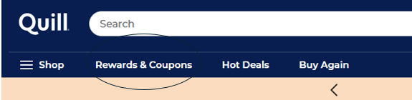

- On the Rewards & Coupons page, click on coupons with the $ sign.

- This will take you to different options that can be redeemed for a center number of points.
  - It will show how many points are available at the top right-hand side of the page.
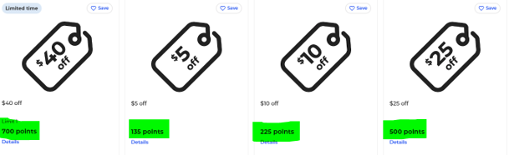

- Hit “Redeem” on the coupon that is being used. After redeeming a pop up on the right -hand side will tell a summary of what is being used and how many points are remaining.
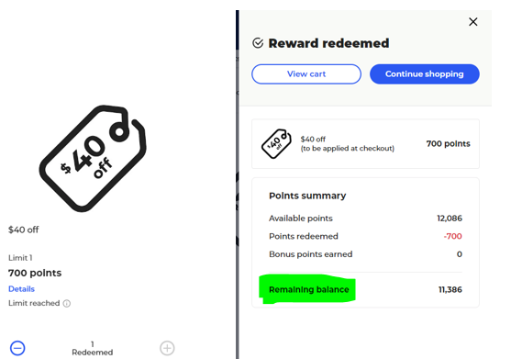

- Once the coupon has been redeemed, it can go toward any order at check out. The rewards and coupons that are being used will be shown under the items being ordered.
  - More than 1 coupon can be used if there are enough points.
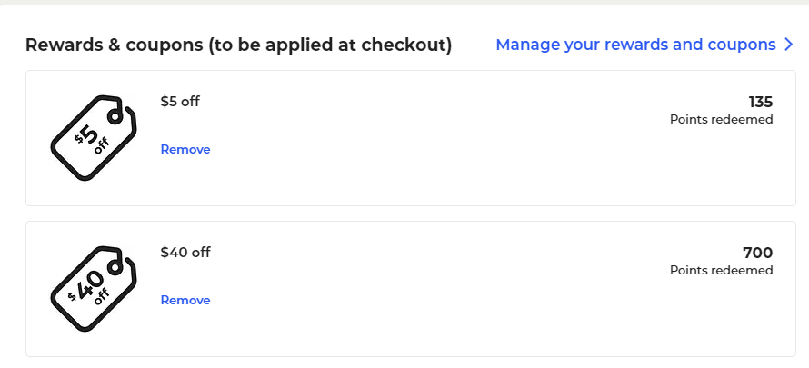

Ordering printer supplies
IT is currently transitioning all company printers over to a service contract with Perry Pro Tech.
- All printers that are already on the service contract are set up with auto ship for supplies. The printer sends a message to Perry Pro Tech when supplies are needed, and they are shipped directly to the location.

- All toner, imaging units and waste toner containers are ordered on-line from Perry Pro Tech regardless of if they are already on the service contract.

  - If a warehouse is needing a Maintenance kit -Have them contract the IT department. Once, IT reviews the locations printer if they need a kit they will have you order one for that location.

- Check the Admin list to see if the location requesting a toner, imaging unit, or waste toner container is on Perry Pro Tech Service Contract. If they are on the service contract supplies will be auto shipped to them, if not you will need to place an order.

- The list is located at the below path:
F:\Information Technology\Public\Printer toner\Admin Toner List.xlsx
  - It’s recommended to ask the Warehouse Manager for the model number if not given. In case of Admin toner list not being updated.
  - **Verify with IT every couple of months to be sure that updates have been made on spreadsheet. **
- Look under Equipment ID row I on the spreadsheet. If there is not an ID number, then it is not on the service contract.
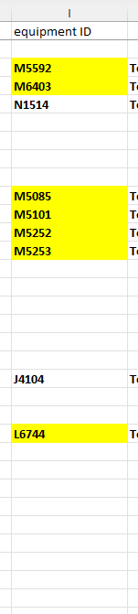

- To order supplies Email supplies@perryprotech.com and CC the Warehouse Manager -In the email give them the printers model number and the toner number. Also, the quantity and tell them it’s for a printer not on our service contract. Give them the address of the warehouse it needs shipped to.

Below is an example:
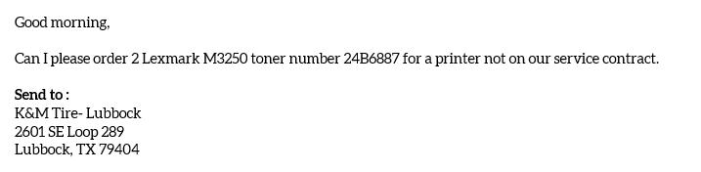

- Once, they receive the email request and get the order processed they will email you the below:
    - This email will confirm where the supplies will be shipped to. At times they will send the supplies to the corporate office, and we will have to send them out on transfer.
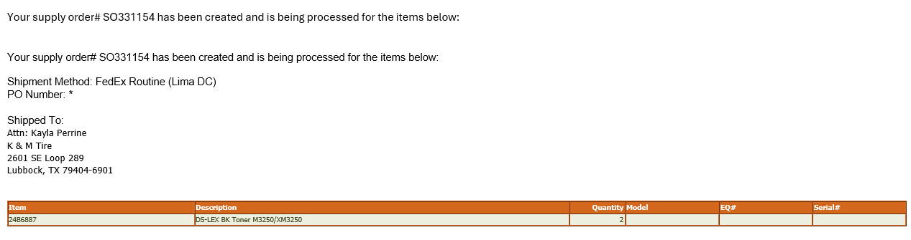

Yearly Quill Calendars
At the end of each year, reach out to the Quill Manager and ask them for a quote on Wall/Desk Calendars.
- Ask about oversized fees
- If orders need to be over a certain amount to not receive a fee
- The year of 2024 we have decided not to order tractor Calendars. We bought (Small Wall) Calendars from the dollar tree for the corporate office.
Send out an email to all Warehouse Managers and Corporate employees.
Example of email used:
I will be placing an order for 2023 desk calendars.
Please let me know by November 2nd if you will be wanting a 2023 Desk Calendar.

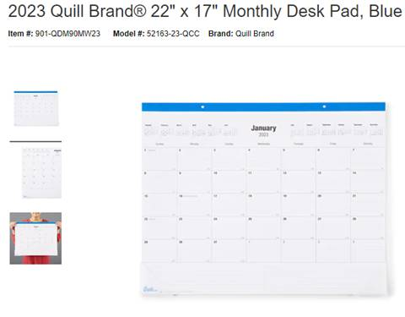

Below are some examples of the past years:
2023: Desk Calendar $7.29 each
- We order 40 desk calendars for corporate
- This year to save on shipping and handling big items we had them sent to Delphos and sent them to the Warehouse’s by transfer.

2023: Wall Calendars $15.29 each
- Mostly the Warehouse Managers will use these Wall Calendars.
- Inside Sales Manager in Delphos uses 2 Wall Calendars

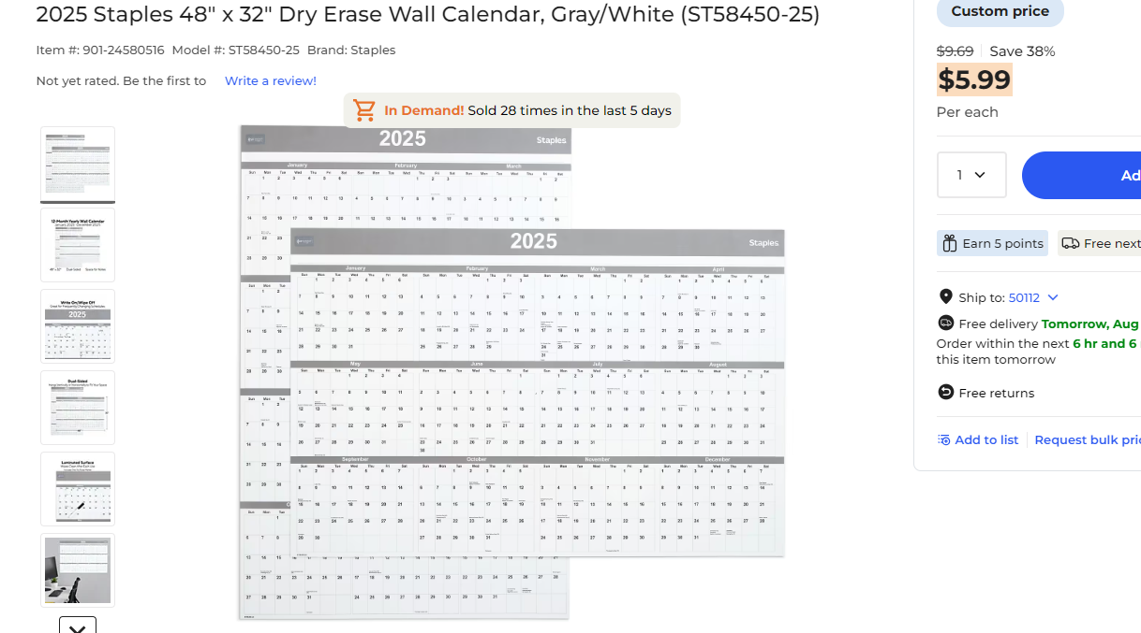

2024: Desk Calendar $4.99
- Ordered around 35 for corporate *Have 1 in the supply room for new employees. m
- We were able to ship warehouses their calendars, had to spend over $25 to avoid fees
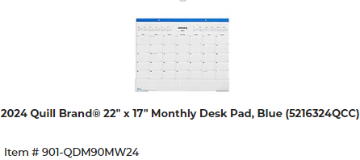
2024: Wall Calendars $14.25
- We were able to ship warehouses their calendars, had to spend over $25 to avoid fees
- Inside Sales Manager in Delphos uses 2 Wall Calendars
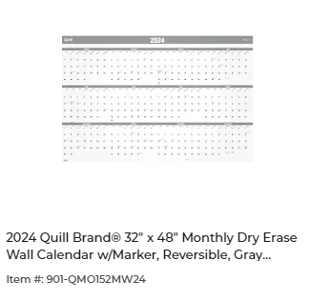

2025: Desk Calendar $2.99
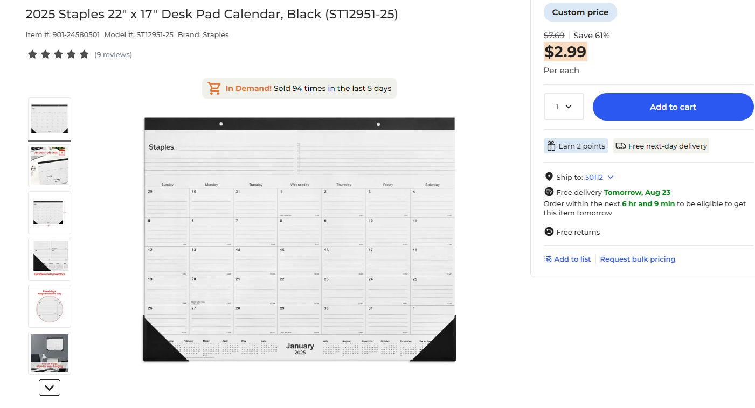

2025: Wall Calendar: $5.99


Getting Calendar quotes from Quill
- On the Quill website at the top right-hand side of the page select your name and a dropdown will appear. It will show your Account number and Account Manager. Click on your Account Managers email.
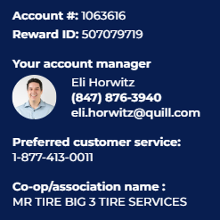

- Example of email for Quill Manager.
Hello,
K&M Tire wants to place a large order for calendars. We have multiple locations and would like to be able to send the calendars to each location when ordering. What options do you guys have for doing so? Below is an example of the calendars we have used in the past.

Account #: 1063616
If you have any questions, don't hesitate to ask.
Thanks
- The Quill Manager may call you to go over different calendars. We are looking for the cheapest, best quality they have. K&M will get a 10% discount on items by ordering from Quill.
  - When looking up any item on Quill. They go by the Item number.
(901-24580516)
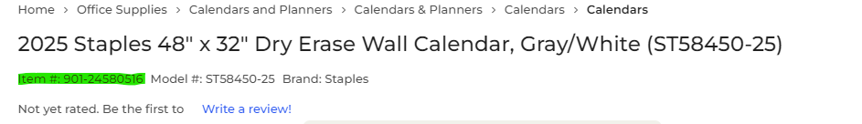
- After deciding on the best choice of calendars the Quill Manager will put them on the Special pricing list. It will take up to a day for it to show up on the list. When the items are there, you can send them to any location when needed.
  - Keep in mind if there is a certain amount that needs to be spent to avoid any fees.

Ordering Logoed Paper Items Through Litho Printers
Below is a list of the items we order from Litho Printers:
- K&M scratch pads
- Sorry I missed you. sticky notepads.
- 9x12 Manilla K&M return address envelopes
- White window K&M return address envelopes and non-window envelopes
  - (Make sure there are 8 cases of (#10) Window envelopes for statement day which is the last week of the month.)
- Adjustment forms, Return forms, Limited warranty claim forms.
  - When you get down to 2 boxes with any forms, order 2 boxes of the ones you are low on.
Ordering from Litho Printers
K&M orders multiple boxes of these supplies at a time. The supplies have the K&M logo on them. When ordering window and non-window envelopes to cut back on shipping costs, our Grandville location 6 will stop and pick them up on their route and then send them on transfer to Corporate. Litho printers have their vendors print out the other supplies to help keep the cost down for K&M. Once they are finished, they ship it too Corporate.
- Email lithoprinters@lithoprinters.net or call 269-651-7309.
- Let them know exactly how many cases you need.
Example of email below:
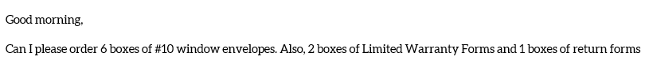
- When ordering envelopes the person from Litho Printers will email you when the envelopes are ready for pick up and will let you know what day’s work best for pick up.
- After receiving the days for pick up, email the Grandville Manager, and let them know that envelopes are ready for pick up at Litho Printers.
  - For the #10 envelopes if you order over 8 boxes. They will send the boxes of envelopes to Delphos for free.

Example of email sent to Warehouse Manager:
Good afternoon,
We have envelopes ready for pick up at Litho printers. They will be there all week 8-5 except Friday 8-12.
- Once the envelopes are at the Grandville warehouse the Manager will scan over the delivery receipt to Admin.
- When they arrive too corporate. Confirm that all items are there and send the delivery receipt that was sent from the warehouse Manager to the Accounts Payable for it to be paid. When sending the delivery receipt to Accounts Payable be sure to tell them it needs to be posted under corporate GL 5440 1-1.
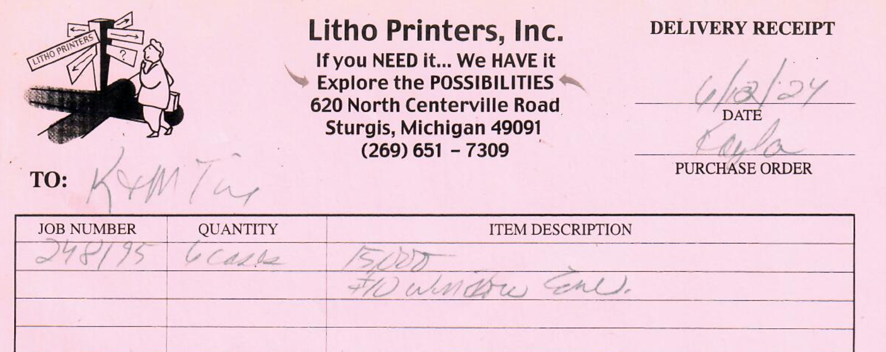

Defective envelopes
At times we run into defective envelopes. It’s always recommended to reach out to Litho printers in case something on their end isn’t working correctly.
Below are some examples:
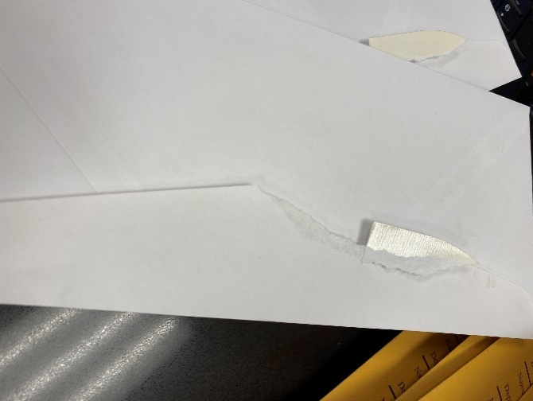

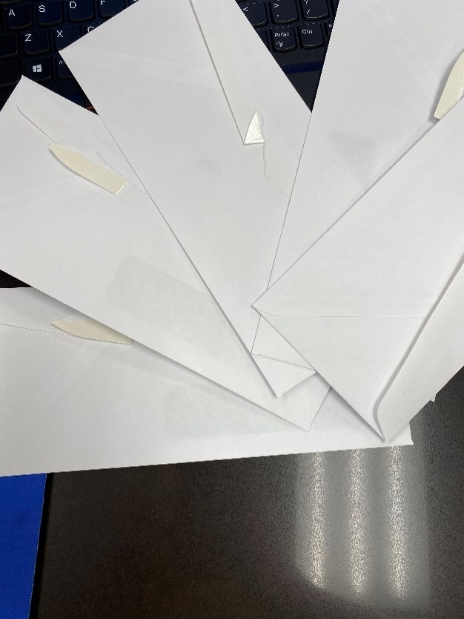

Scheduling a Car Rental for Ken
Once you have the K&M plane scheduled for the desired flight you can arrange the car rental to be at the airport ready and waiting.

Information Needed to Schedule
- Before calling the car rental you will need the below information to reserve a car rental.
- Emerald Number (Membership # with National/Enterprise Car Rental)
    - Drivers’ member number with National/Enterprise Car Rental, they are the only one authorized to drive. F:\Administrative Assistants\Shared\Travel\Emerald Numbers.xlsx
    - Date & time the car needs to be at the airport for pickup
    - Date & time the car will be returned to the airport
    - What size of vehicle is needed (Economy, Standard, Full Size, SUV etc.)
    - Airport ID (ex: Harrisburg is MDT) ask the pilot if you don’t have it
    - FBO (ex: Harrisburg is AVFLIGHT) ask the pilot if you don’t have it
- F:\Administrative Assistants\Shared\Travel\Airport Identifiers & FBO's.xlsx
- Tail # of the plane
    - Large plane is N345NX (up to 10 passengers)
    - If a different plane is being used because of repairs, the pilot can give you this information
- Pilot Kenny Paoni P: 217-416-5530 or k.paoni@comcast.net
    - DO NOT BOOK ONLINE CALL 1-877-421-3722 TO BOOK RENTALS FOR K&M FLIGHTS
- When calling they will ask for all the information listed above.
    - Once a rental car has been secured have them email the confirmation to you so you can forward it to the driver.

Scheduling a Conference Room
It is important to schedule conference rooms and invite your attendees to ensure that all attending are available and as they accept the invitation it will automatically post it on their calendar for them. This also ensures that there is no double booking of the conference room.

Scheduling and Inviting
Open your Outlook calendar
- Choose New Appointment at the top left
- A new window will pop up
- Click on Invite Attendees and fill in the below boxes
  - To (Add everybody that you want to attend)
  - Subject (ex; Team Meeting)
  - Location (Click the room button to the far right and the list of room to choose form will pop up) Double click on the room of your choice
  - Select the Start Date & Start Time
  - Select the End Date & End Time
  - Add any notes into the body of the box
  - Click send
    - This will add it to your calendar and the room calendar you have chosen. All attendees will have to accept the invite for it to post to their calendar.

Scheduling a Conference Room for Others
- This will not add the meeting to your calendar
  - Open the room calendar from your outlook by clicking Calendar (1) in Outlook.
  - Choose the conference room you want to book under Rooms (2). That will open the entire month for the selected conference room.

Scheduling a Flight on K&M Plane
Scheduling a flight should only be done by the Executive Administrative Assistant or Real Estate Administrative Assistant, so if you are needing to schedule a flight you will need to contact one of them.

How To Schedule
- Log on to: https://calendar.google.com/calendar/
  - User: DonnaB@kmtire.com
  - Password: Delphos01$
- Check the date for the desired flight to make sure the plane is available.
- If the date you need is available, click on “Create” in the top left corner.
- The box below will pop up for you to fill in all the details.
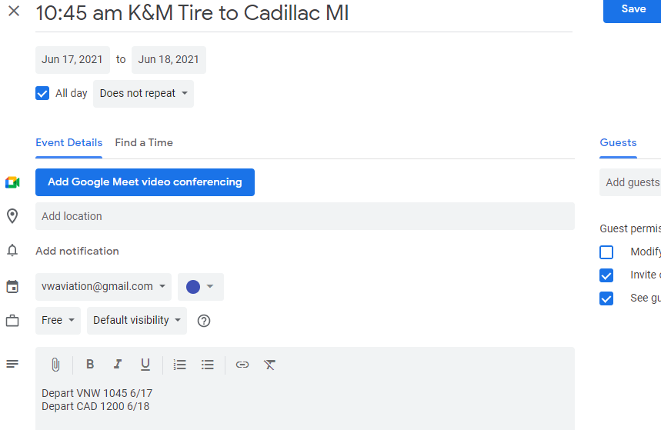
- Make sure you choose Blue-VW Aviation Tail# N345NX-holds 10 including the pilot 
- Add title-is your Flight Time, Company Name & Destination (ex:11am K&M Tire to Tea, SD)
- List possible flights by adding TBD (To Be Determined) at the beginning of the description (ex: TBD 11am K&M Tire to Tea, SD). Once flight is confirmed remove the TBD.
- Under “Add Description” put the names of the people on the flight, a contact name and # so the pilot can call them to verify all details of the flight (roughly 3 days prior to flight) and in the event the pilot needs to inform of a weather delay or any change to the flight, the time they will be leaving and where they will be leaving from, also list time and where they will be leaving to come back. Ex: see below
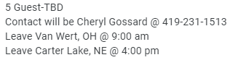
- When scheduling a flight, set a reminder 5 days before the flight to call the pilot and verify that there are no changes to where the plane is leaving from. This step will only need completed until the new hanger is completed in the Fall 2022.
- Then “Save”
- If the flight is scheduled within 6 days of the actual flight date, email details to the below email to ensure the pilot is aware a flight has been scheduled.
k.paoni@comcast.net
C: 217-416-5530

Sending out FedEx Express

- Login into FedEx https://www.fedex.com/en-us/home.html
- In the upper right corner, click on Sign in
- Username: kmtire1135
- Password: Welcome1$

- On the drop-down box under “Shipping”
- Click on Create a Shipment
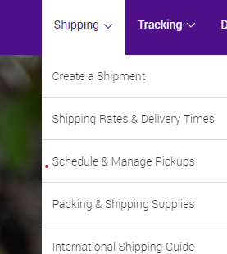

- “Shipment Profiles”
- For the special rate chose a profile that says “FedEx One” as shown below choosing “to” the correct state, or the closest state to the location you are sending to.

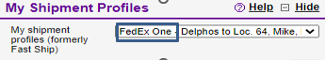

- Edit the “from” to the correct sender.

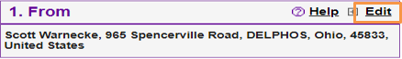

- Under the “To” verify/edit/change the address to the recipient’s
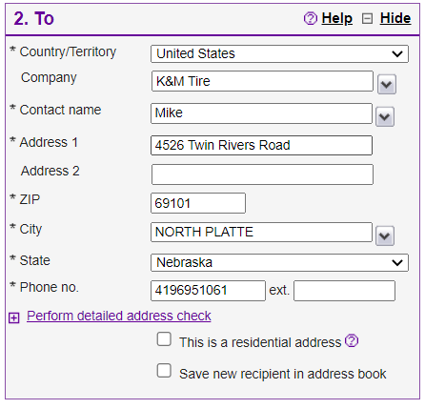
- “Package & Shipment Details”-We have a discounted rate for 2Day/Envelope
- “Service type”-FedEx 2Day (We are able to change “Service Type” using the drop-down box)
- “Package type”- Select FedEx Envelope (We are able to change “Package Type” using the drop down box to best describe what is being sent, if it is different than an envelope.)
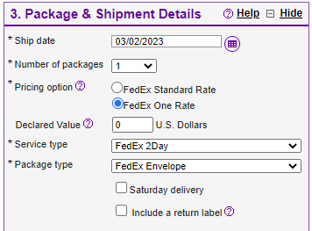

- In section 4 “Billing Details” you must always choose “San Antonio-833” to receive our discounted rate.

- “Rates and Transit Time”
- Click calculate, our current rate is $9.20.

- “Complete your shipment” Click “Ship” in the bottom right corner.

- Confirm that all information is correct click “Ship.”

- Email a copy of the receipt or the Tracking Number to whoever is requesting the package be sent out, so they are able to track it if they need to. When sending out checks for payroll email tracking information to: HR Manager, Payroll Manager, and Payroll Clerk.
- Select the box that says “Label” and print.

- The label will go in the plastic sleeve attached to the back of the FedEx envelope.

- FedEx items must be in the drop box, located on the side of the Eagle Print building on Main Street prior to 4:30pm to ensure it is picked up the same day.

Live pay checks from Marrae must be sent out to be delivered by Friday.

Trade Show & Dealer Trip GL Balancing
The following standard operating procedure is used to balance the GL of the Trade Show and Dealer Trip.

Trade Show & Dealer Trip
- Purpose: To ensure the GL balances.
  - Inform National Account Supervisor, Accounts Payable, and Accounts Receivable of the GL being used. (1590-loc)
  - Check the GL weekly in MaddenCo. Log anything posted to the GL on the credit/debit tabs in the appropriate box. It will then update the Balance Sheet.
  - F:\Administrators\Public\Meetings\Customers\Year Dealer Conference\Balance Sheet
  - Ensure you place the credit/debit in the correct spot and double check formulas.
  - Compare the GL with spreadsheet to ensure it all matches.
    - If you are missing credits from vendors, email Mark Knippen, Jon Schadl, and Dave Miller to contact vendor for payment.
- In the event of something being posted incorrectly.
  - Inform Controller to do a Journal Entry.
  - Run a report the next day to ensure it was corrected.
- Once the GL and Spreadsheet are complete, update the Meeting Cost spreadsheet. F:\Administrators\Public\Meetings\Customers\Meeting Costs
- Send final Meeting Cost sheet to Cheryl Gossard and Jon Schadl (within 60 days of event).

Uniform Tracking & Disbursement
To ensure that we always have an accurate count of inventory, and to always maintain the proper amount on hand we need to track all incoming and outgoing inventory. This will also tell us when we need to re-order. An inventory of all uniforms is done monthly to maintain accuracy. It is very important to track everything as soon as it is ordered, received, or shipped out so nothing is missed.
When receiving inventory in:
First count all uniforms and see if that count matched matches the invoice.
If the invoice is accurate, approve it by signing, dating and writing approved on it then give it to AP.
Bag uniforms in sets of 5
Put the corresponding label on each bag stating the type, size and number of uniforms.
Box the uniforms. Label the box with the correct type and size of uniforms. Count each bag and write the total on the outside front of the box. Tape the box closed.
New uniforms should be placed at the bottom of the corresponding size of the current stack of uniforms.

Example Email and How to Get Started

- Admin will receive an email from Human Resources like the below sample to be alerted that a new employee has been hired. If they are filling the position of Warehouse, Warehouse/Backup Driver, Driver, Warehouse Manager, Maintenance, Will Call, Adjustments or Installer their shirts need to be sent out to the correct location on transfer for them.
  - The email will be sent to multiple people/departments so each department can do their part in making the transition of a new hire seamless.
  - Assistant Managers, Team Lead, Warehouse, Warehouse/Backup Driver, Driver, Maintenance, Will Call, Adjustments, Installers, Inventory Control and Warehouse Clerk will receive 5 T-shirts as a new hire (Gray w/Orange K&M Tire logo).
  - Warehouse Managers will receive 5 Polo shirts as a new hire (Orange with K&M Tire logo).
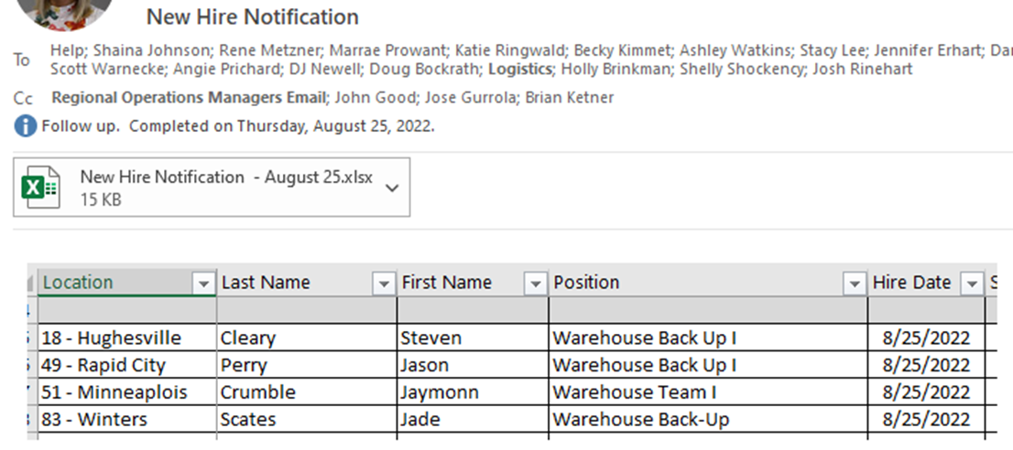
- Immediately after receiving the email send out 5 t-shirts/polos of the correct size to their location on transfer. Their size will be noted on the top right of the new hire email attachment. (Click the attachment of each new hire in the original email that is circled above to see the employee’s information and size of shirt.)
- To maintain an accurate inventory, go to the Uniform Inventory spreadsheet: F:\Administrative Assistants\Shared\Uniforms\Uniform Inventory.xlsx
- Fill out a label with the new employee’s name, location, size and if they are to receive t-shirts or polos.
Anthony Perez Name
Loc 43 Loc#
5-T-L Quantity/T (t-shirt) or P (polo)/Size

  - Once the label is completed, place it on one of the prepackaged bags of uniforms. Verify that you have the correct uniforms (t-shirts or polos) and that the correct size is in the bag.
  - Insert a new employee welcome folder inside the packaged shirts for all new hire employees.
  - Then place the bag in the correct transfer box for that location.
  - Reply to the HR email and copy the Admin. team letting them know the shirts have been put on transfer.

Information and Tabs for the Tracking Sheets
Instructions-This tab has instructions for the function of each tab and what it is used for.

Review the totals tab/reorder section the 1st day of each month to determine if anything needs to be ordered.

Totals Tab-Shows totals of each item by size in the green highlighted area. Scroll to the right and you will be able to see what needs to be ordered in the beige-colored area. Reorder quantities and formulas may need adjusted if turnover is extremely high or at large disbursement times. Never type anything in this tab except pending order quantities and dates. This tab is all formulas pulling from other tabs. When an order is received, delete or adjust the on-order quantities. Delete the date that the order is placed as well.

Sending out items-When sending out items, go to the tab of the item being sent out (T-shirt, Polo, Jacket, etc.) Enter the date, location, position and employee name receiving the uniform item. Put the quantity you are sending under the corresponding size. Before you get to the bottom total line, insert additional lines to keep the formulas intact.

Purchases-When a new shipment of items arrive, update the purchases tab. Enter date, vendor, and sizes of each item received in. Before you get to the bottom of a section where a total line exists, insert additional lines before the total line to keep the formulas intact.

New items-New items may be added. When this happens, several tabs will need updated:
*On the new item tab, rename the tab the name of the new item.
*On the purchase tab, scroll down to the new item and name it the name of the new
item.
*Reorder quantities also will need to be set up for all new items.

- At the employee’s 60-day review, Admin will receive another email from HR prompting admin to send out 5 more uniform shirts.
  - If an employee’s 60-day uniforms were given within 120 days of the Bi Annual disbursement then they do not get more.
  - Assistant Warehouse Manager, Team Lead, Warehouse, Warehouse/Backup Driver, Maintenance, Will Call, Adjustments, Inventory Control Specialists, Warehouse Clerk and Installers will receive 5 T-shirts (Gray w/Orange logo)
  - Drivers will receive 5 Polo shirts (Port Authority K576 Charcoal Heather)
  - Warehouse Managers will receive 5 Polo shirts (S-4XL OG101 Caliber 2.0 Polo Flare Orange and 5XL ST650 Sport-Tek Micropique Sport Wick Polo Deep Orange).
  - If they don’t fit in the blue transfer bags they will be boxed up and an invoice will need to be run out of MaddenCo and taped to the top of the box before it is placed on the transfer rack in the warehouse.
  - SOP for running an invoice from MaddenCo for transfer items can be found at the following link...\SOP's\Invoicing For Items Being Put On Transfer Truck SOP.docx

- Any unworn shirts returned back to Corporate in the event the employee is no longer employed will need to be removed from the tracking sheet and the shirts put back into inventory.
- If a different size is needed the Warehouse manager will contact Admin to exchange uniforms for the requested size. After the uniforms are returned to Admin then the requested size will be put on transfer.
- Warehouse Managers are to return all unworn uniforms to Admin and put back into inventory.

- Bi-Annual distribution of uniform shirts will be according to the below schedule:

January and June Location 1, 2, 3, 4, 15, 18, 22, 24, and 27

February and July Location 43, 55, 56, 57, and 59

March and August Location 6, 7, 31, 33, and 42
(Loc 33 has its own section on disbursement of uniforms)

April and September Location 38, 47, 49, 51, 52, 53 and 64
(Loc 47, 52, & 53 expire 4/23 & Loc 49 contract expires 8/23)
Locations 47, 49, 52 & 53 New Hires are receiving our uniform shirts.

May and October Location 21, 80, 82, 83, 84, 86, and 88

- Polos for the corporate employees are ordered from Fusion Graphics after a successful 60-day evaluation.
An email offering the below options will be sent out when notified by HR.
  - Men’s option:
  - OG101 https://www.sanmar.com/p/3540_ElecBlue#?doScrollToGrid=true

  - Women’s options:
  - L568 https://www.portauthorityclothing.com/p/6674_HotCoral?text=L568
  - LK583 https://www.portauthorityclothing.com/p/9756_VioPrpBlk?text=LK583
  - K576 https://www.portauthorityclothing.com/p/7265_TrpBlHthr#?doScrollToGrid=true
  - LOG101 https://www.sanmar.com/p/3542_ElecBlue#?doScrollToGrid=true

- Annually, in September all Warehouse, Warehouse/Backup Driver, Driver, Warehouse Manager, Maintenance, Will Call, Adjustments and Installers who have completed their 60-day evaluation will receive a jacket.

- Every 3 years, in November, all Salary and Corporate Office employees will have the option to choose 2more polos.
Polos for the corporate employees are ordered from Fusion Graphics after a successful 60-day evaluation.
Each corporate employee can select 2 polos from the below options.
Outside Sales will only receive a one-time disbursement of 2 polos after a successful 60-day evaluation.

Location 33 Uniform Distribution
This location’s distribution is different than that of our other locations.
- New Hire
- A New Hire notification is received from HR.

Warehouse positions will receive 5 uniform t-shirts.
Drivers will receive 5 uniform polos.
The manager will receive 5 manager polos.
If hired between September through March the employee will be given one jacket.

- 60 Day
Upon a successful 60-day evaluation HR will send an email alerting Admin to send out uniforms.
Warehouse staff will receive an additional 5 t-shirts.
Drivers will receive 5 additional polos.
Warehouse staff and drivers will receive 10 pairs of pants each.
The Manager and Assistant Manager do not receive pants; however, the Assistant Manager will receive 5 more t-shirts and the WH Manager will receive 5 more manager polos.

Order uniform pants from Amazon. See below:

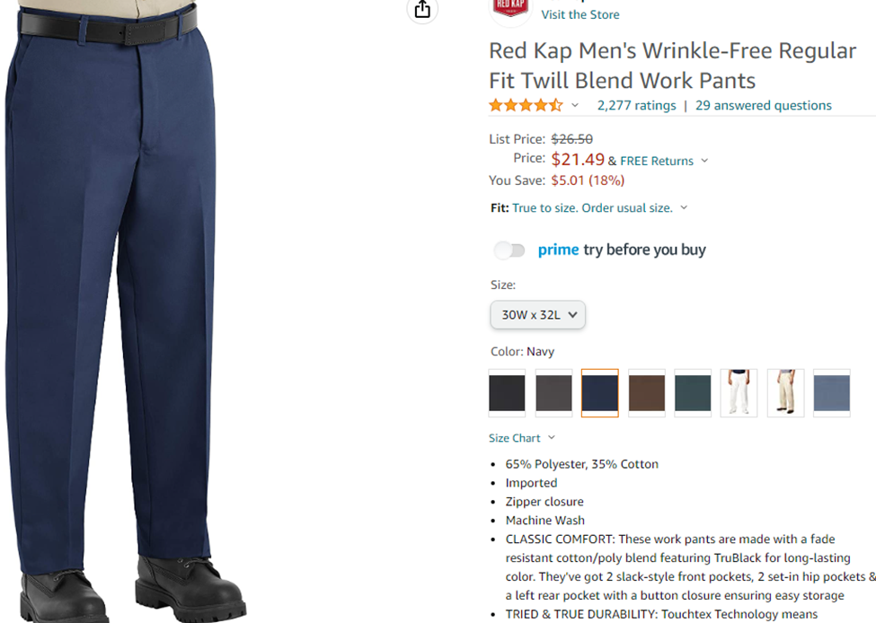

*Uniform pants should be shipped to Admin for distribution.

- Bi Annual distribution
  - The WH Manager and Assistant Manager are the only employees on this schedule.
  - In the March and August distributions they will receive 5 more uniform shirts.

- Yearly distribution in August
One Blue Jacket will go out to all employees.
WH Manager and Assistant Manager only receive Jackets Annually
5 uniform shirts will go out to all the other warehouse employees and drivers.
10 pairs of pants to warehouse employees and drivers.

Verizon Monthly Tracking
The monthly tracking report is a report that states employees’ use of their work phone. It shows the number of minutes, messages, data/GB, and the charges. The excel sheet is sent between several people for review and then finally sent over to the person specified as responsible for its completion to work on and figure out who went over on their minutes, messages, or data. When starting this task, you will need two spreadsheets pulled up: 1) the Usage with Cost Report spreadsheet that is sent to you from A/P Clerk and 2) F:\Administrative Assistants\Public\Verizon Report\2024 Monthly Verizon Report.xlsx

Sorting Through the Usage with Cost Report
- Go to the Usage with Cost Report spreadsheet.
  - Make the columns wider so that you can read and sort them.
  - Delete Column G, it is not necessary.

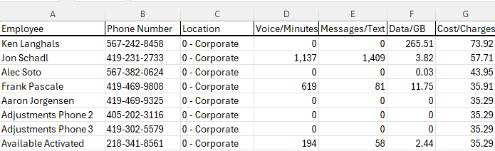
- First complete a Custom Sort for Voice/Minutes Column (D)
  - The Rule for Voice/Minutes: Route Drivers are ONLY aloud up to 300 minutes. Minutes do not matter for any other employees.
    - Highlight all columns A through F
    - Go to the Home tab, select Sort & Filter and Custom Sort.

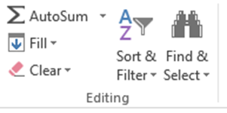

  - Go to the Column Sort by drop down and select Voice/Minutes. Then, go to Order A to Z drop down and select Largest to Smallest. Click OK.

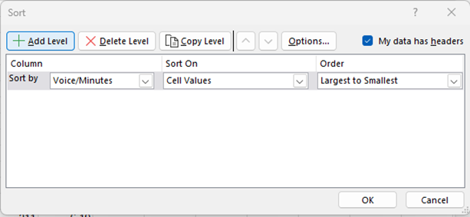

  - You will see something like the spreadsheet below. The Voice/Minutes column has been sorted from highest to lowest.

  - Delete all the Rows that start with TOTALS and the five listed phone numbers due to them being a Cradlepoints for backup internet.
    - 419-905-7486
    - 567-712-9577
    - 419-905-7168
    - 419-905-8234
    - 419-905-6758

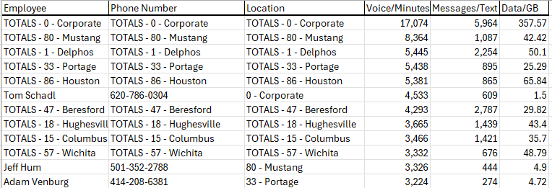

  - Continue through the entire spreadsheet deleting the TOTALS Rows. Row 10 is the next to be deleted.
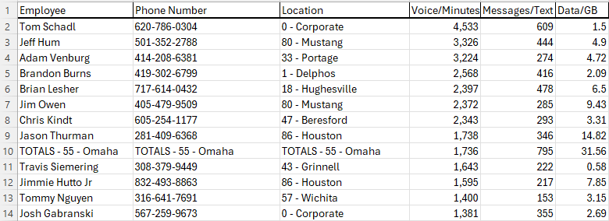

  - If anyone has gone over their minutes, messages, or data/GB you will put them on the Verizon Monthly Report spreadsheet. F:\Administrative Assistants\Public\Verizon Report\2024 Monthly Verizon Report.xlsx

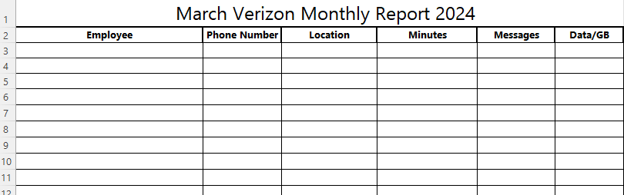

  - After sorting the Voice/Minutes on this Usage with Cost Report, there are NO drivers over 300 minutes. No one will be on the Verizon Monthly Report for Voice/Minutes this month.

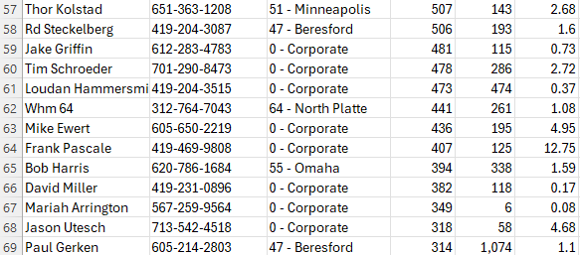

- Second, complete a Custom Sort for the Messages/Text Column (E).
  - The Rule: Route Drivers are only allowed 300 messages, and no one can have more than 2000.

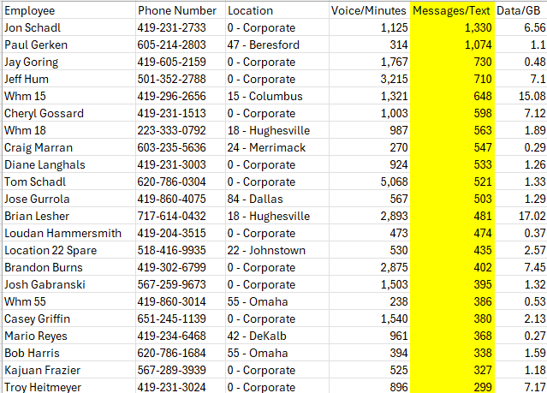

  - No one went over 2000 Messages and there are no drivers over 300; therefore, that column will not be highlighted on the Verizon Monthly Report.

- Third, complete Custom Sort for the Data/GB column (F).

  - The Rule is that Sales can have up to 10 GB and Operations up to 3 GB. Please see the example below.
- From the Blue highlighted row and up (10 GB and higher), names that are not highlighted, will be copied and pasted to the grid at the top of the Verizon Monthly Report. This grid is for Sales and any other employees that are not in the operations section.
- Green Highlights are Route Drivers over 3 GB.
- All the Route Drivers will be copied and pasted to the bottom grid of the Verizon Monthly Report (Operations).

- Once all three columns have been sorted and the employees’ names have been copied and pasted to the Verizon Monthly Report the report will be color coded.

- First the employee names will be color coded according to the chart. See above.

- Second, highlight the employees that have gone over for more than one month consecutively. Look at the employee names in the current report then look at the previous month to see if they are in that report and if they are then going back another month and so on. Refer to the chart below. The color will show you how many months in a row the employee has gone over. Highlight their name with the appropriate color below.
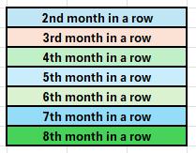

- Email the completed Verizon Monthly Report to the VP of Sales and VP of Operations. Cc VP of Finance and Technology.

Wedding SOP
When an employee at the corporate location is getting married, the Admin Department sends out an email to take up a monetary collection for them. This email is sent out 2 weeks before the weekend of the wedding.
Be sure to send out a reminder email that the collections are still being taken 1 week before the wedding. When creating the email, send it to the Corporate and Delphos email. Make sure to remove the person getting married so the gift can be a surprise.

Below is an example of the email to be sent out:

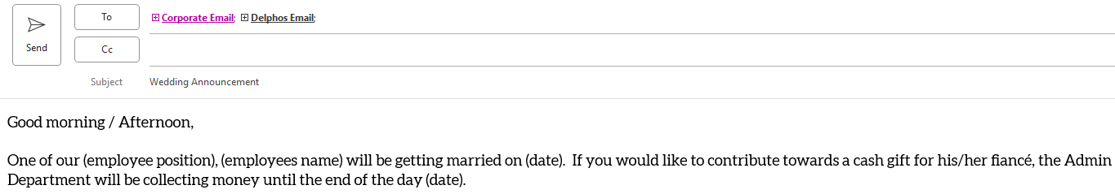

- As the donations are collected, they will be placed in an envelope. On the cash envelope, log their name and amount to ensure donations match the total on the spreadsheet. Add their donation to the total already logged on the spreadsheet.
- F:\Administrative Assistants\Shared\Fundraiser
- Check with their manager to find out when their last day of work is prior to the wedding so the card and monetary donations can be given to them before the wedding.
- To ensure that no weddings are missed, the Admin Department will send out the following email quarterly to department managers:

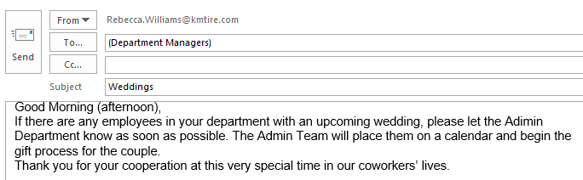

*If you receive a large amount of small bills, Accounts Receivable can switch it out for larger bills. (EX: someone gives 20-$1.00 bills, exchange for a $20.00 dollar bill)

Appendix A: Revision History Tracking
The following table records information regarding changes made to the Operations Binder.

Table 6 - Revision History Tracking
Version Number | Date | Author/Owner | Description of Change
1 | 4/28/2022 | Joni Zerkel | Adding dollar amount to postage machine
1 | 5/9/2022 | Joni Zerkel | Delivery scheduling (LFD)
1 | 5/24/2022 | Shaina Johnson | Credit Card Disbursement.
1 | 7/18/22 | Donna Burgei | Updated the Affiliate Banking SOP
1 | 8/23/2022 | Shaina Johnson | Retention description for Moring Reports
1 | 10/31/2022 | Angie Prichard | Uniform Tracking & Disbursement
 | 1/26/2023 | Shaina Johnson | Updating Newsletter SOP
 | 3/6/2023 | Shaina Johnson | Updated Section 26 with Macy
 | 03/07/2023 | Jody Keller | Added section 10
 | 3/7/23 | Kayla Perrine | Added Sending Out FedEx Express
 | 3/13/23 | Donna Burgei | Updated the Data GB usage to the Verizon Report
 | 03/22/2023 | Jody Keller | Added section 13.2 drop trailer
 | 03/24/2023 | Kayla Perrine/Jody Keller | Added section 21.3-21.4 certified mail
 | 5/31/2023 | Kayla Perrine | Added section 2.2 Adding and Removing a user from Amazon
 | 06/01/2023 | Jody Keller | Added new pictures of intranet and updated wording 9.2 Drop Trailer
 | 7/5/23 | Kayla Perrine | Updated SOP on Mail Disbursement
 | 7/25/23 | Kayla Perrine | Updated 23
 | 8/8/2023 | Shaina Johnson | Error Log Update per Val’s email
 | 12/28/2023 | Kayla | Updated Postage SOP
 | 1/4/2024 | Kayla Perrine | Added 17.2
 | 2/22/24 | Kayla Perrine | Updated 17.5
 | 4/23/2024 | Angie Prichard | 31. Verizon Monthly Tracking
 | 5/10/24 | Jody Keller | Added changes Section 6 Delphos city, 16 Daily mail routine,27 Sending Fed Ex
 | 5/31/24 | Jody Keller | Added changes for Drop Trailer 9.2
 | 6/6/24 | Jody Keller | Added Changes to AR Balance Register, Daily Sales update report, Morning Error Log Report
 | 6/11/2024  6/12/2024 | Kayla Perrine | Added 12.1 and 12.2  Added 2.3
 | 10/22/24 | Kayla Perrine | Updated Verizon Report
 | 12/17/24 | Kayla Perrine | Added Changing address on Amazon and Adding Items to Amazon list & Ordering tire Chalk, Viewing locations tire chalk inventory
 | 1/03/25 | Kayla Perrine | Added Yearly Quill Calendars and Getting quotes from Quill
 | 2-7-25 | Barb Suever | Added Section 2 – Ace Hardware Billing
 | 3/19/2025 | Kayla Perrine | Food for the Poor
 | 3/21/2025 | Kayla Perrine | Updated Quill
 | 4/16/25 | Kayla | Updated Error logs
 | 4/17/2025 | Jody Keller | Updated Scheduling a delivery (confirmation email)

